

Press Release
Monday 26 October 2026
COURTAULD ANNOUNCES NEW ARTISTS ADVISORY COUNCIL
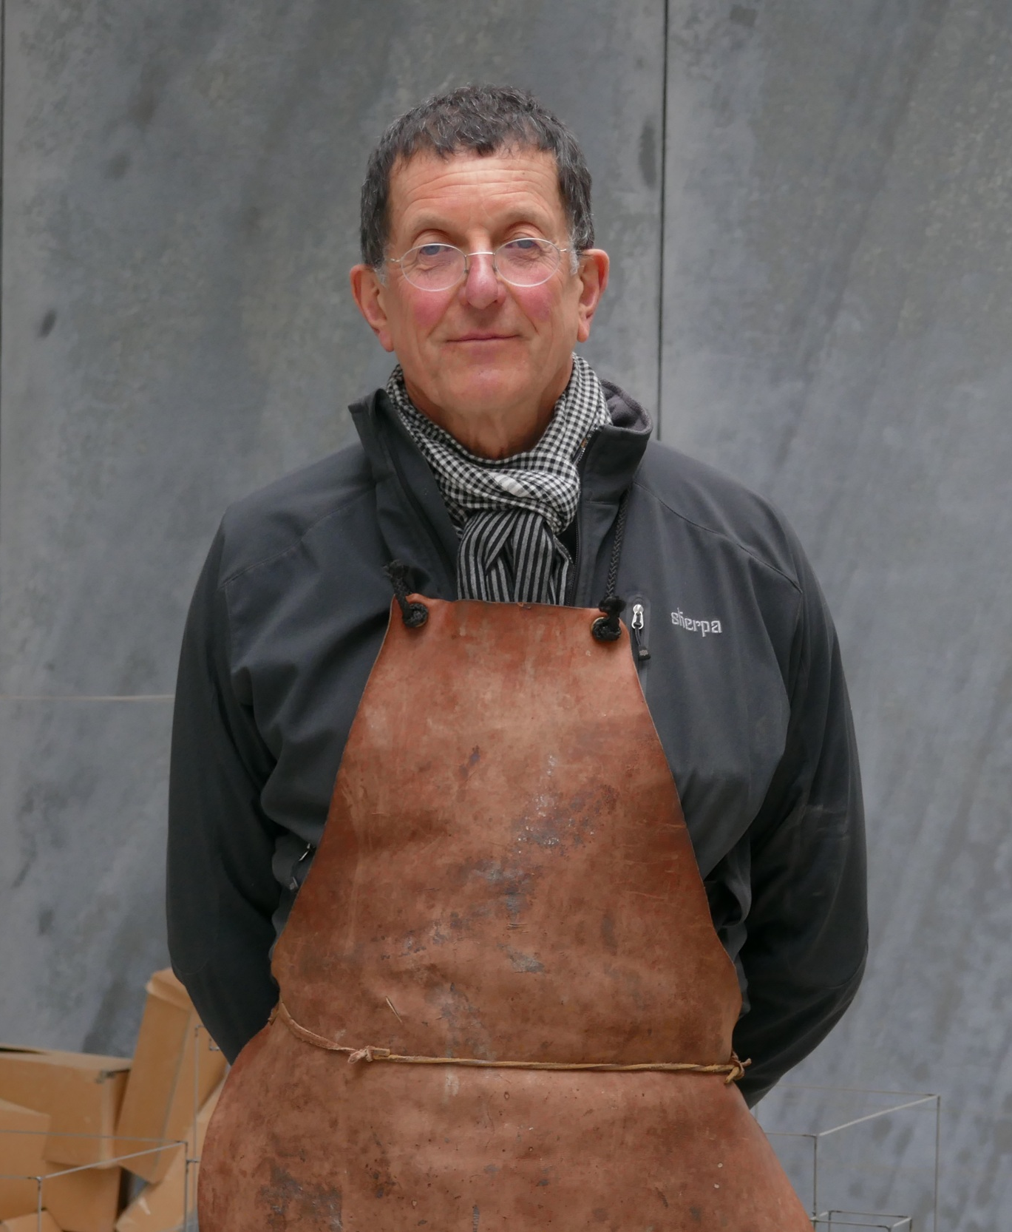
Pictured: Rachel Jones, photo: Eva Herzog; Sir Antony Gormley, photo John O'Rourke
The Courtauld today announced its new Artists Advisory Council (AAC), a group of leading artists, designers and architects who will help to shape and inform the Courtauld’s strategies across the full spectrum of its activities.
The Courtauld’s Artists Advisory Council includes renowned visual artists, Dame Sonia Boyce DBE RA, Sir Antony Gormley, Rachel Jones, Elizabeth Price and Megan Rooney, alongside leading architects Thomas Heatherwick CBE RA RDI of Heatherwick Studio and Stephen Witherford of the award-winning architects Witherford Watson Mann. The AAC is chaired by Tim Marlow OBE (MA, 1988; PhD 1991), Director and Chief Executive of the Design Museum, London.
The Artists Advisory Council will have a particular focus on developing the offering of contemporary art at the Courtauld, which has significantly expanded since the transformation of its Gallery in 2021, with successful exhibitions dedicated to Peter Doig and Claudette Johnson, and a major commission by Cecily Brown. The Courtauld launched a new annual commission for The John Browne Entrance Hall in 2025 with new works by Rachel Jones; the 2026 commission features new works by Ella Walker. The first UK solo exhibition of acclaimed New York painter Salman Toor opened at the Courtauld Gallery on 2 October 2026.
Last year, the Courtauld announced its plans to create a new world-class campus at Somerset House in London, a major development which will strengthen its position as a leading global centre for the visual arts. As the Courtauld approaches its centenary in 2032, this next milestone in its history will see the transformation of its historic Grade I listed building at Somerset House, creating a flexible, state-of-the-art campus and securing the Courtauld’s legacy for the next 100 years.
The Courtauld’s new Blavatnik Contemporary Galleries, opening in 2029, will also provide a distinctive space for visitors and students to experience contemporary art through special exhibitions, commissions, and events. The Galleries will champion advanced and original forms of artistic practice and offer fresh perspectives on the most compelling and influential developments in contemporary art. The galleries will also be a site for experimentation and collective learning for the students on the Courtauld Institute’s MA in Curating, who will play a significant role in delivering the programme.
With a masterplan by the architects Witherford Watson Mann, and designed in collaboration with Purcell and Lawson Ward Studio, the new Courtauld Campus is expected to open in 2029.
Mark Hallett, Märit Rausing Director of the Courtauld, said: “Our new Artists Advisory Council will play a vital role in shaping the future of the Courtauld and in guiding our expanded presentation of contemporary artists’ work within the new Courtauld Campus.”
Sir Antony Gormley, artist, said: “I am honoured to be an inaugural member of the Courtauld’s Artists Advisory Council. The Courtauld is one of our most important cultural institutions and a world-leading centre for the teaching and research of art history. I look forward to helping support and guide their efforts to open up art and art education to the widest possible audience.”
Rachel Jones, artist, said: "It is an honour to be part of the Artists Advisory Council at such an important time in the Courtauld’s history, and to serve as an advocate for the importance of both art history and contemporary art in shaping the Courtauld’s future."
Media Contacts:
Bolton & Quinn
erica@boltonquinn.com
0207 221 5000 | 07711 698 186
Courtauld
https://courtauld.ac.uk/about-us/press-office/
media@courtauld.ac.uk

Notes to Editors:

Courtauld
The Courtauld works to advance how we see and understand the visual arts, as an internationally renowned centre for the teaching and research of art history and a major public gallery. Founded by collectors and philanthropists in 1932, the organisation has been at the forefront of the study of art ever since through advanced research and conservation practice, innovative teaching, the renowned collection and inspiring exhibitions of its gallery, and engaging and accessible activities, education and events.
The Courtauld Gallery cares for one of the greatest art collections in the UK, presenting these works to the public at the Courtauld Gallery in central London, as well as through loans and partnerships. The Gallery is most famous for its iconic Impressionist and Post-Impressionist masterpieces – such as Van Gogh’s Self-Portrait with Bandaged Ear and Manet’s A Bar at the Folies-Bergère. It showcases these alongside an internationally renowned collection of works from the Middle Ages and the Renaissance through to the present day.
Academically, the Courtauld Institute is the largest community of art historians and conservators in the UK, teaching and conducting research on subjects ranging from creativity in late Antiquity to contemporary digital art forms – with an increasingly global focus. An independent college of the University of London, the Courtauld offers a range of degree programmes from BA to PhD in the History of Art, curating, art and business and the conservation of easel and wall paintings. Its alumni are leaders and innovators in the arts, culture and business worlds, helping to shape the global agenda for the arts and creative industries.
Founded on the belief that everyone should have the opportunity to engage with art, the Courtauld works to increase understanding of the role of art throughout history, across all societies and geographies, and to champion its importance in the present day. This could be through exhibitions offering a chance to look closely at world-famous works; events bringing art history research to new audiences; accessible short courses; digital engagement, innovative school, family, and community programmes; or taking a formal qualification. The Courtauld’s ambition is to transform access to art history education, ensuring as many people as possible can benefit from the tools it offers to better understand the visual world around us.
The Courtauld is an exempt charity and relies on generous philanthropic support to achieve its mission of advancing the understanding of the visual arts of the past and present across the world through advanced research, innovative teaching, inspiring exhibitions, programmes and collections.
The collection cared for by the Courtauld Gallery is owned by the Samuel Courtauld Trust.

