

Press Release
Wednesday 7 October 2026

COURTAULD UNVEILS CLOSER LOOK, A NEW ANNUAL MAGAZINE
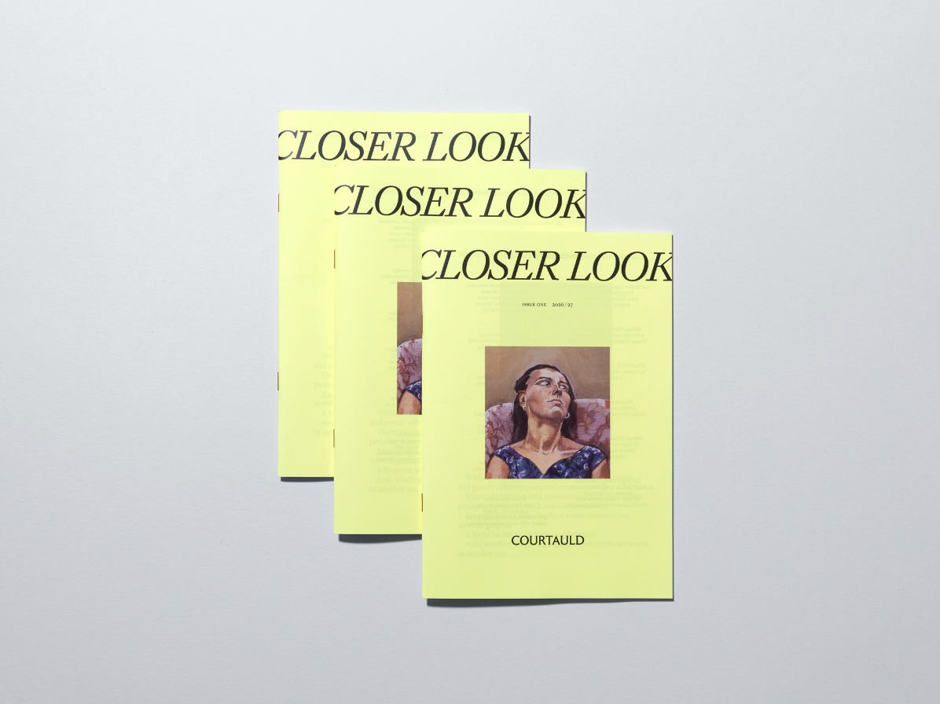
Photo: Thomas Adank
Press Images are downloadable here
The Courtauld today unveils the first edition of its new annual magazine, Closer Look. Edited by writer and curator Hettie Judah, and designed by Kellenberger–White, Closer Look features interviews, essays, poetry and perspectives on the full range of the Courtauld’s activities. The magazine introduces and explores forthcoming exhibitions and curatorial presentations at the Courtauld Gallery, and includes news of the Courtauld's expansive academic programme.
Highlights of the first edition:
- A Sly Nocturnal Green Mood – artist Salman Toor in conversation with author Gemma Rolls-Bentley (MA, 2009) on his major exhibition Salman Toor: Someone Like You, now open at the Courtauld Gallery.
- Unforgiving Marks – artist Claudette Johnson MBE in conversation with Hettie Judah on Paula Rego’s ground-breaking series of Dog Woman pastels.
- Idiosyncratic Female Figures – art historian and writer Philomena Epps (MA, 2014) delves into the inspiration behind Ella Walker’s Courtauld Commission: 2026.
- Men in Smocks - Paul Laib in the Artist’s Studio, reveals the Courtauld’s ambitious project to digitise 22,000 negatives in the Laib Collection from this autumn.
- Ambition and Atmospherics - Professor Mark Hallett (PhD, 1996), Märit Rausing Director and Dr Rachel Sloan (PhD, 2008), Associate Curator for Works on Paper at the Courtauld discuss the artists in The Griffin Catalyst Exhibition: Turner and the Landscape Generation. Journeys in Watercolour, and why we should view them as radicals.
Printed copies of Closer Look are available exclusively to current Courtauld Members, who will receive the magazine by post, and to new members for a limited time only at the Courtauld Gallery ticket desk.
Professor Mark Hallett, Märit Rausing Director, Courtauld, said: “We wanted to create something that would delight our members. Closer Look offers a rich array of art-historical, critical and poetic treats, housed in a beautiful, highly readable magazine format.”
Hettie Judah, Editor, said: "The Courtauld’s diverse activities are united by the act of looking, whether in the close scrutiny of researchers and conservators, the broad overview of a curator, or a visitor’s enjoyment of a much-loved painting. Closer Look brings these perspectives together in a single magazine, offering a diversity of viewpoints on the Courtauld Gallery programme and a survey of the activities of the Courtauld Institute and its alumni.”
Eva Kellenberger, Founding Director at Kellenberger–White, said: 'We designed Closer Look as a literary companion to the Courtauld's brand and the visual identity we established last year. Its smaller format feels good in the hand and invites you to keep reading. Bold, expressive titles link short articles into a longer read, taking cues from italicised artwork captions and the flamboyant design of weekend newspaper supplements.”

Media Contacts:
Bolton & Quinn
erica@boltonquinn.com
0207 221 5000 | 07711 698 186
Courtauld
https://courtauld.ac.uk/about-us/press-office/
media@courtauld.ac.uk
Notes to Editors:

Courtauld
The Courtauld works to advance how we see and understand the visual arts, as an internationally renowned centre for the teaching and research of art history and a major public gallery. Founded by collectors and philanthropists in 1932, the organisation has been at the forefront of the study of art ever since through advanced research and conservation practice, innovative teaching, the renowned collection and inspiring exhibitions of its gallery, and engaging and accessible activities, education and events.
The Courtauld Gallery cares for one of the greatest art collections in the UK, presenting these works to the public at the Courtauld Gallery in central London, as well as through loans and partnerships. The Gallery is most famous for its iconic Impressionist and Post-Impressionist masterpieces – such as Van Gogh’s Self-Portrait with Bandaged Ear and Manet’s A Bar at the Folies-Bergère. It showcases these alongside an internationally renowned collection of works from the Middle Ages and the Renaissance through to the present day.
Academically, the Courtauld Institute is the largest community of art historians and conservators in the UK, teaching and conducting research on subjects ranging from creativity in late Antiquity to contemporary digital art forms – with an increasingly global focus. An independent college of the University of London, the Courtauld offers a range of degree programmes from BA to PhD in the History of Art, curating, art and business and the conservation of easel and wall paintings. Its alumni are leaders and innovators in the arts, culture and business worlds, helping to shape the global agenda for the arts and creative industries.
Founded on the belief that everyone should have the opportunity to engage with art, the Courtauld works to increase understanding of the role of art throughout history, across all societies and geographies, and to champion its importance in the present day. This could be through exhibitions offering a chance to look closely at world-famous works; events bringing art history research to new audiences; accessible short courses; digital engagement, innovative school, family, and community programmes; or taking a formal qualification. The Courtauld’s ambition is to transform access to art history education, ensuring as many people as possible can benefit from the tools it offers to better understand the visual world around us.
The Courtauld is an exempt charity and relies on generous philanthropic support to achieve its mission of advancing the understanding of the visual arts of the past and present across the world through advanced research, innovative teaching, inspiring exhibitions, programmes and collections.
The collection cared for by the Courtauld Gallery is owned by the Samuel Courtauld Trust.

Hettie Judah
Hettie Judah is a writer and curator. She is a contributor to The Guardian, Frieze, The Times Literary Supplement and BBC Radio 4’s Front Row, and writes a monthly column for Apollo magazine. Between 2016 and 2024 she was the chief art critic for the British daily newspaper The i. She was curator of the acclaimed Hayward Gallery Touring exhibition Acts of Creation: On Art and Motherhood which toured the UK and Ireland between 2024 and 2026, and authored the standalone book of the same title published by Thames & Hudson. She is the co-founder, with Jo Harrison, of the Art Working Parents Alliance, a nationwide network and advocacy group. Other recent books include How to Enter the Art World (Hoxton Mini Press, 2026), Tracey Emin (Tate, 2026), How Not To Exclude Artist Mothers (and other parents) (Lund Humphries, 2022) and Lapidarium: The Secret Lives of Stones (John Murray, 2022). Her forthcoming book Looking for Pleasure: Picturing Women’s Desire will be published by Thames & Hudson on 3 September 2027.
Kellenberger–White
Kellenberger–White is a graphic design studio in London. They develop visual languages and creative strategies for people, brands and institutions to communicate with impact. Their work is collaborative, context-responsive and rooted in human touch.
Notable commissions include brand identities for the Courtauld and Goldsmiths Centre for Contemporary Art; wayfinding and exhibition design for the British Museum, Tate, University of Cambridge, and V&A; and publications for MIT Press, Hauser & Wirth and White Cube.
Their work has been acquired by public collections across Europe, garnering awards such as the Swiss Federal Office of Culture’s Most Beautiful Swiss Books and the Tokyo Type Directors Club. They are members of the Alliance Graphique Internationale.
Founded in 2009 by Eva Kellenberger and Sebastian White, the duo work on every project alongside a core team which includes Alma de Juan, Sohee Kim and Anya Tsen.

