

Press Release
24 September 2026
COURTAULD INSTITUTE AND NATIONAL PORTRAIT GALLERY ANNOUNCE NEW PARTNERSHIP
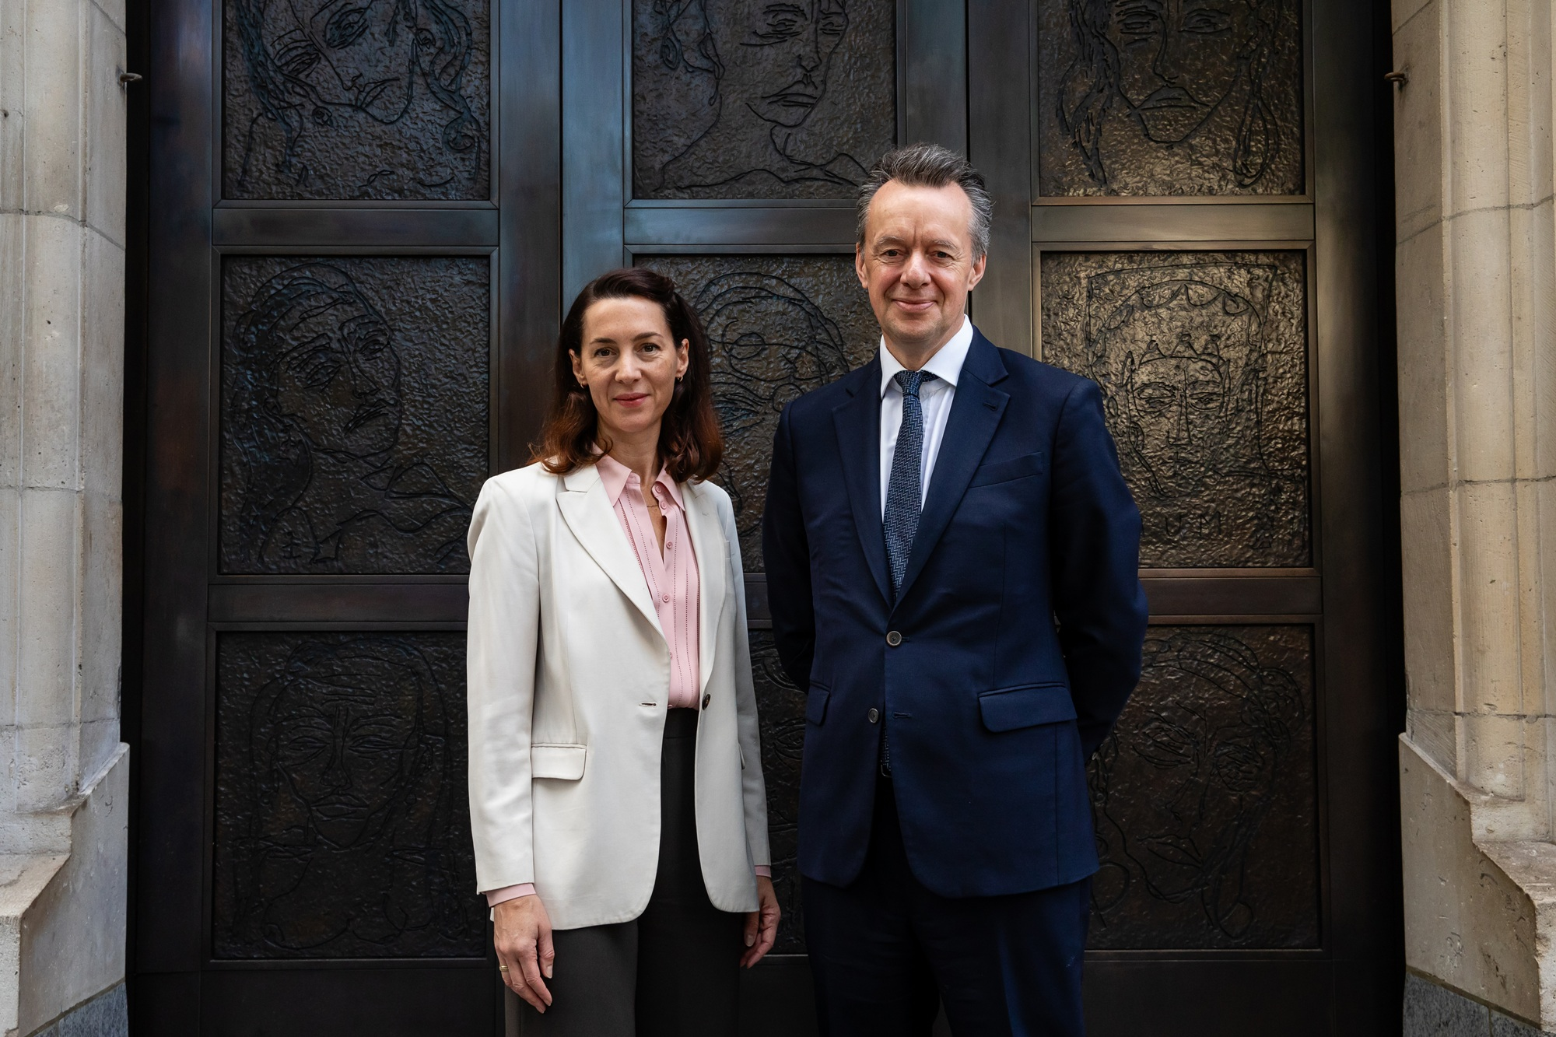
Image: Victoria Siddall, Director of the National Portrait Gallery and Mark Hallett, Märit Rausing Director of the Courtauld © Louise Haywood-Schiefer

To download the press image: https://tinyurl.com/wvczf353

The Courtauld Institute today announced a new partnership with the National Portrait Gallery as part of a long-term strategy to offer its students the opportunity to learn from within leading cultural organisations.
The new partnership will give students in the Courtauld’s MA Curating programme the chance to benefit from the deep expertise of two of the world’s leading visual arts institutions through a collaborative ‘Working within Institutions’ teaching strand, alongside the potential for dissertation co-supervision and future opportunities for postgraduate research collaboration.
The MA Curating programme at the Courtauld offers an unmatched opportunity for students to immerse themselves in the theory and practice of curating in a unique scholarly and professional context, complemented by the Courtauld Gallery's internationally renowned curatorial excellence and the ambitious scholarship underpinning its exhibition programme.
The programme provides intensive training focused on the issues that shape the curatorial field and their practical implications for today’s art world. Its global alumni network spans 83 countries, forming an international powerhouse that influences the arts and creative sectors at all levels. Many of the Courtauld’s graduates have gone on to work in and lead prestigious museums and galleries, including Tate, Guggenheim, The National Gallery in London and The National Gallery of Art in Washington DC, amongst many others.
Earlier this year, students from the programme had the opportunity to curate exhibitions and public programmes at the Nicoletta Fiorucci Foundation, St Mary le Strand Church in central London, Strawberry Hill House & Garden, Twickenham, as well as organise a two-day symposium and a performance in partnership with the Freud Museum.
Dr Devika Singh and Dr Sofia Gotti lead the MA Curating programme at the Courtauld and are both art historians and internationally renowned curators. Singh curates internationally in a diverse range of contexts, recently curating the Voices sector of Paris Photo (2025), and was previously Curator, International Art at Tate Modern. Gotti has worked with institutions and galleries internationally, and she was part of the curatorial team of the Venice Biennale (2024). Both will be guest curating the Spotlight section of Frieze Masters in London’s Regents Park in October 2026.
Students coming onto the MA Curating programme in 2027-28 will have the unparalleled opportunity to learn from leading professionals in the field both at the Courtauld and now also in partnership with the National Portrait Gallery.
Mark Hallett, Märit Rausing Director of the Courtauld, said: “The National Portrait Gallery continues to innovate in the curation and public presentation of art. We are delighted that our MA Curating students will have the opportunity to gain hands-on experience within this world-class context and with experts in their field.”
Victoria Siddall, Director of the National Portrait Gallery, said: “We are thrilled to be launching this collaboration between the Courtauld and the National Portrait Gallery that will support the next generation of curators, researchers and cultural leaders. I hope that this partnership will create meaningful opportunities for students and help to shape the future of our sector, as well as inform our own thinking about what museums can be today.”

Applications for entry to the Courtauld’s MA Curating programme in 2027 open next month. Find out more: courtauld.ac.uk/explore-our-courses/postgraduate/ma-curating/

Media Contacts:
Courtauld
https://courtauld.ac.uk/about-us/press-office/
media@courtauld.ac.uk

Bolton & Quinn
erica@boltonquinn.com
0207 221 5000 | 07711 698 186
Notes to Editors:

Courtauld
The Courtauld works to advance how we see and understand the visual arts, as an internationally renowned centre for the teaching and research of art history and a major public gallery. Founded by collectors and philanthropists in 1932, the organisation has been at the forefront of the study of art ever since through advanced research and conservation practice, innovative teaching, the renowned collection and inspiring exhibitions of its gallery, and engaging and accessible activities, education and events.
The Courtauld Gallery cares for one of the greatest art collections in the UK, presenting these works to the public at the Courtauld Gallery in central London, as well as through loans and partnerships. The Gallery is most famous for its iconic Impressionist and Post-Impressionist masterpieces – such as Van Gogh’s Self-Portrait with Bandaged Ear and Manet’s A Bar at the Folies-Bergère. It showcases these alongside an internationally renowned collection of works from the Middle Ages and the Renaissance through to the present day.
Academically, the Courtauld Institute is the largest community of art historians and conservators in the UK, teaching and conducting research on subjects ranging from creativity in late Antiquity to contemporary digital art forms – with an increasingly global focus. An independent college of the University of London, the Courtauld offers a range of degree programmes from BA to PhD in the History of Art, curating, art and business and the conservation of easel and wall paintings. Its alumni are leaders and innovators in the arts, culture and business worlds, helping to shape the global agenda for the arts and creative industries.
Founded on the belief that everyone should have the opportunity to engage with art, the Courtauld works to increase understanding of the role of art throughout history, across all societies and geographies, and to champion its importance in the present day. This could be through exhibitions offering a chance to look closely at world-famous works; events bringing art history research to new audiences; accessible short courses; digital engagement, innovative school, family, and community programmes; or taking a formal qualification. The Courtauld’s ambition is to transform access to art history education, ensuring as many people as possible can benefit from the tools it offers to better understand the visual world around us.
The Courtauld is an exempt charity and relies on generous philanthropic support to achieve its mission of advancing the understanding of the visual arts of the past and present across the world through advanced research, innovative teaching, inspiring exhibitions, programmes and collections.
The collection cared for by the Courtauld Gallery is owned by the Samuel Courtauld Trust.

National Portrait Gallery
Founded in 1856, the National Portrait Gallery tells the story of Britain through portraits, using art to bring history to life and explore living today. From global icons, to unsung heroes, our Collection is filled with the stories that have shaped, and continue to shape a nation. We celebrate the power of portraiture and offer encounters with some of the world’s greatest and most exciting new artists, promoting engagement with portraiture in all media to a wide-ranging public by conserving, growing and sharing the world’s largest collection of portraits.

