

Press Release: 9 July 2026
SALMAN TOOR: SOMEONE LIKE YOU

FIRST MAJOR EUROPEAN EXHIBITION BY SALMAN TOOR
OPENS AT THE COURTAULD 2 OCTOBER 2026

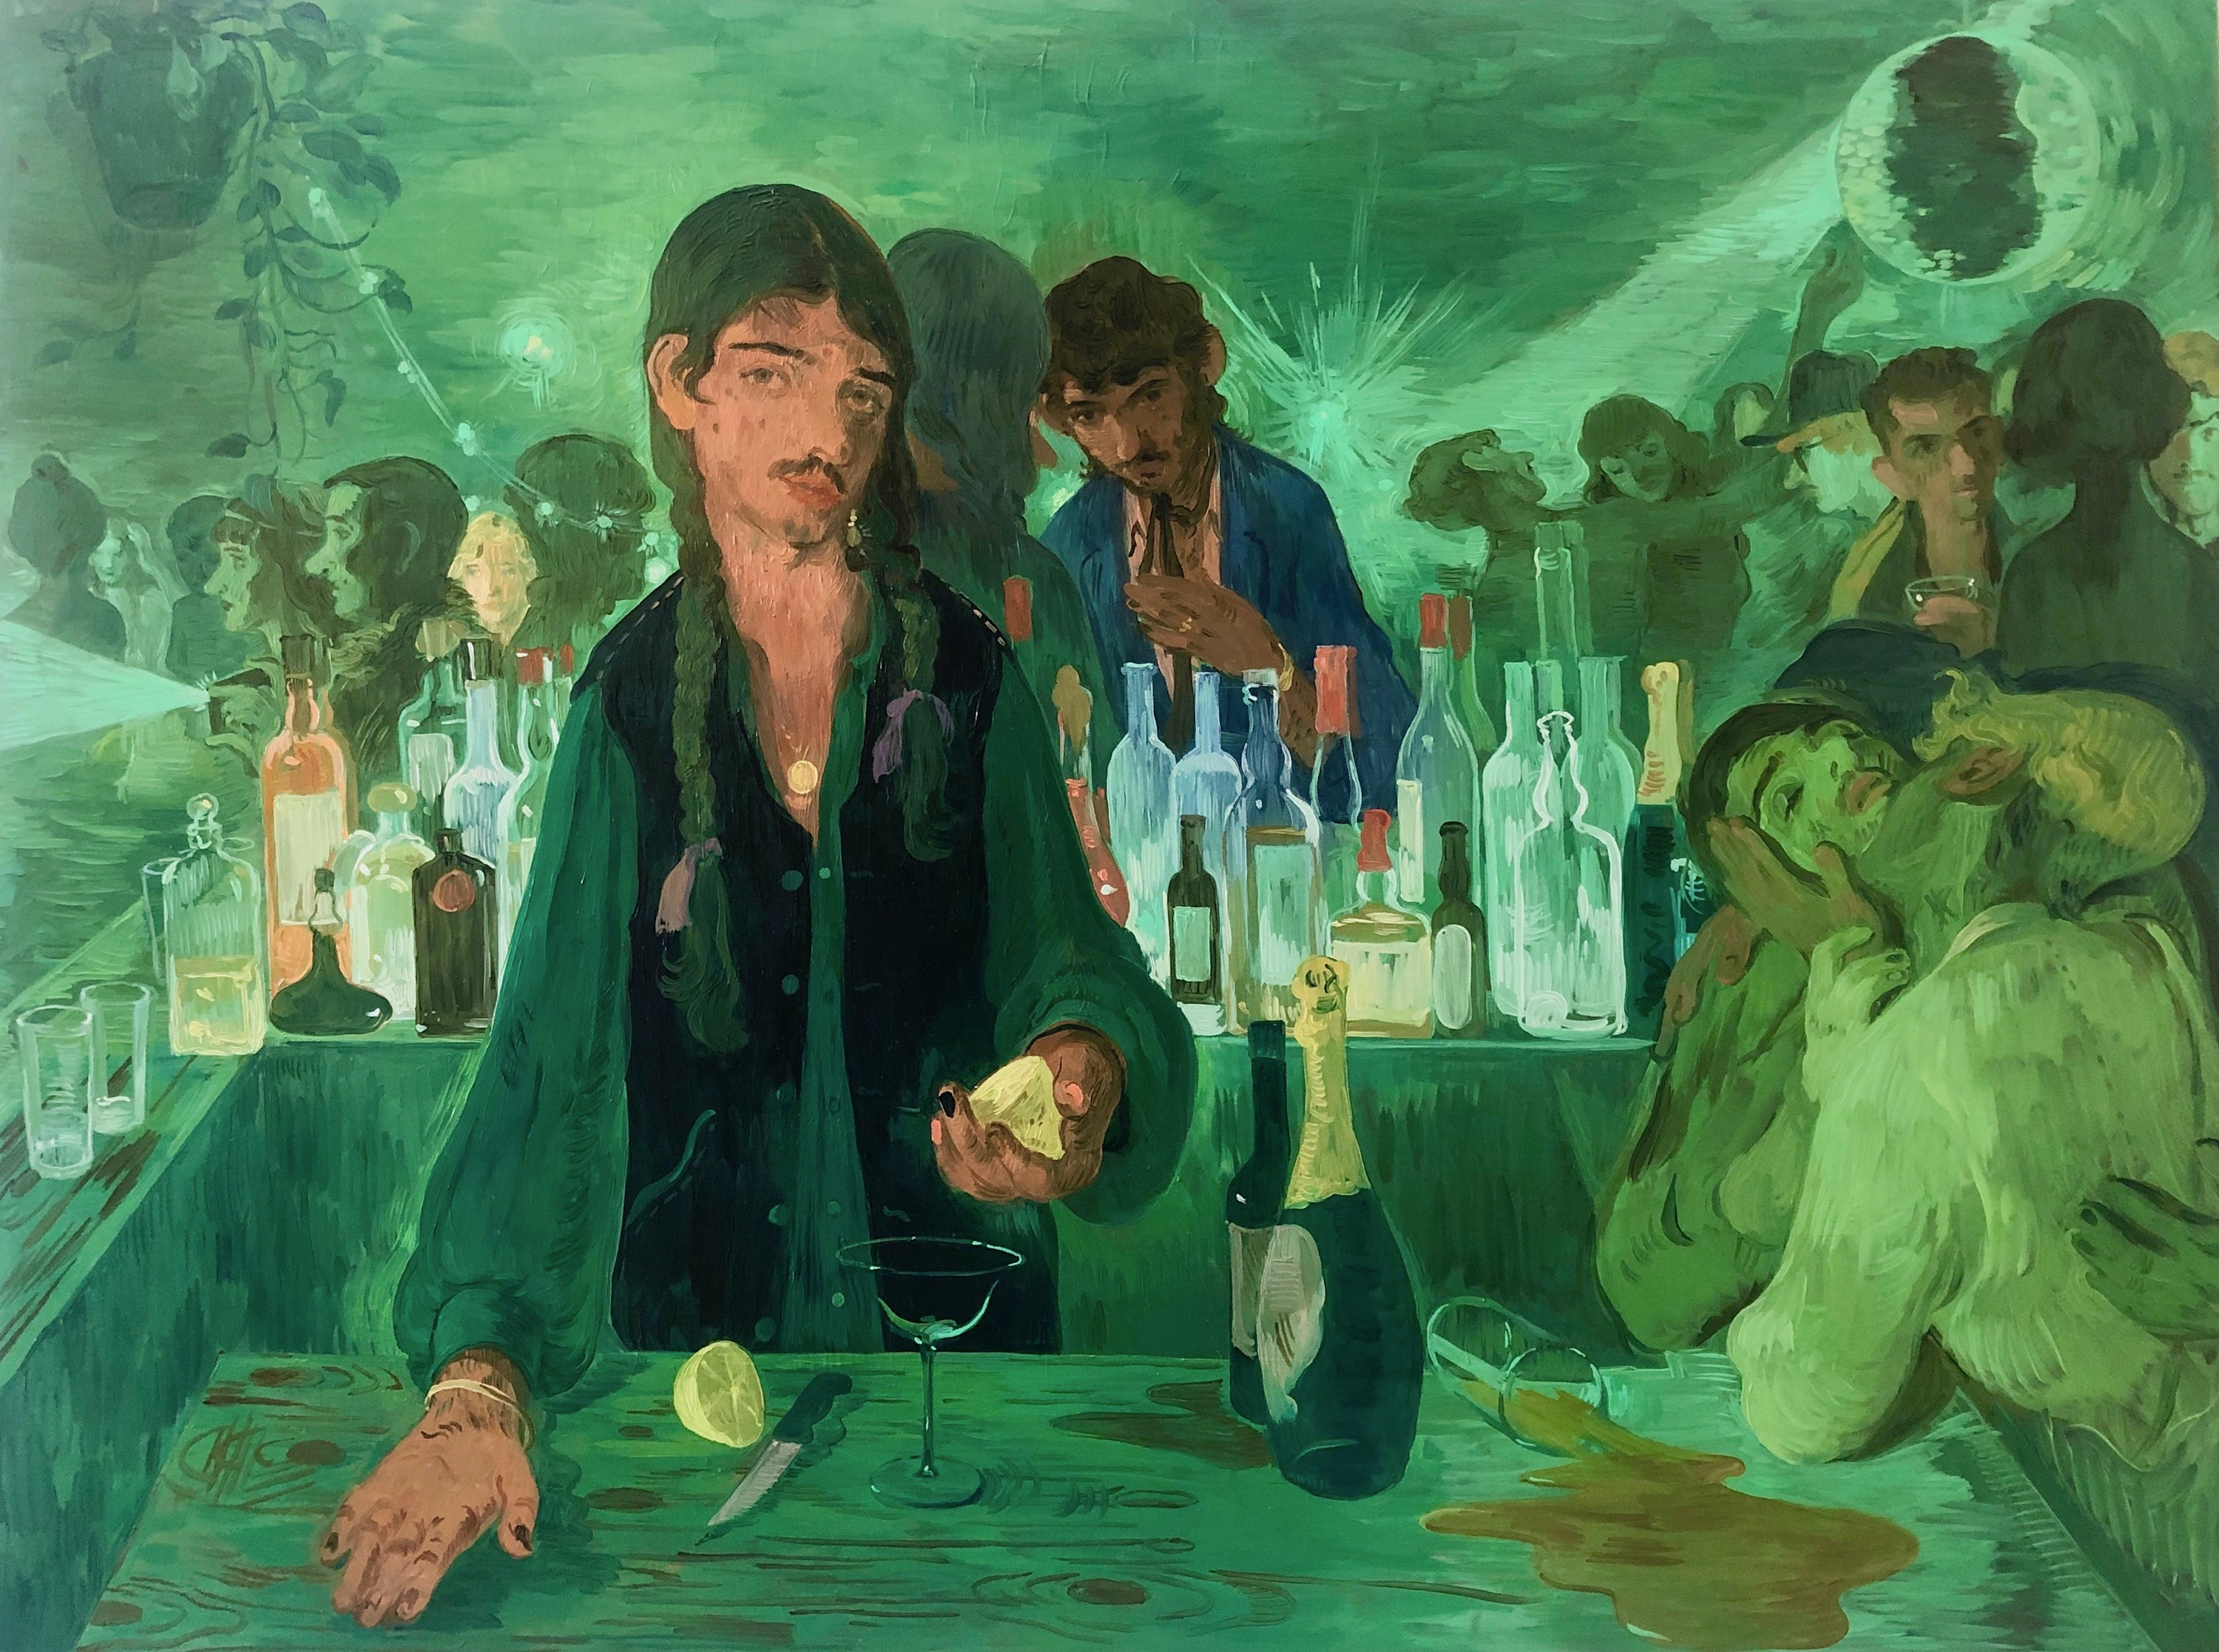
Salman Toor (b. 1983), The Bar on East 13th, 2019, Oil on panel, 36 x 48 inches, 91.4 x 121.9 cm
© Salman Toor; Courtesy of the artist, Luhring Augustine, New York, and Thomas Dane Gallery.

To download press images: https://tinyurl.com/salman-toor-courtauld
The Courtauld presents the first solo exhibition in Europe of the artist Salman Toor, acclaimed for his arresting paintings of the contemporary experience and urban life. The exhibition brings together an outstanding selection of the artist’s most iconic, thought-provoking and at times humorous paintings, never-before-seen in Britain.

Salman Toor (b.1983) was born in Lahore, Pakistan, and lives and works in New York. His paintings capture people in moments of friendship and love, as well as solitude and alienation. The exhibition at the Courtauld will present 19 paintings, all created since 2019, that focus on Toor’s exploration of human interactions and the desire and struggle to experience a sense of belonging, both culturally and emotionally. The exhibition will be complemented by a special display of Toor’s drawings in the Gilbert and Ildiko Butler Drawings Gallery.

While Toor’s figures and scenes are fictional, they are rooted in his personal experiences and memories. Speaking of his works, he says they “depict queer and immigrant lives that straddle different cultures and inhabit the tension between intimacy and exposure, belonging and estrangement. What it means to find a community, but also the daily costs associated with visibility”.

His paintings offering intimate views into the imagined lives of young, queer South Asian men in New York, where he has lived most of his adult life, are tender and sensual representations of cosmopolitan urban life. Evocative colour palettes and references to art history add a fantastical element to his narratives. The Bar on 13th Street (2019) depicts a bartender sporting braids, a gold bangle, nail polish, and ribbons, drawing on different sources, from the dimly lit scenes of 17th century Dutch tavern paintings to the more overt reference to Édouard Manet’s A Bar at the Folies-Bergère, in the Courtauld’s own collection. In Bar Boy (2019), which evokes the nightlife in New York’s East Village, a young man’s face illuminated by his smartphone as he stands isolated and distracted in a bustling club.

Another subject on display is a series that Toor began in 2019, which addresses the experiences of immigrants at border control. Toor’s personal experience has informed these works that depict marginalised individuals’ encounters when crossing borders, and their senses of freedom or restriction. In Man with Face Creams and Phone Plug (2019), a man with his head down awaits a customs official’s inspection of his belongings, laid out on a table. Other portraits are depicted in Group B (2020) and Citizens (2022).

Toor’s work is rooted in a deep engagement with and admiration for the Old Masters, in particular Baroque and 18th century painting, and the Courtauld is a museum he particularly admires. His paintings draw on a broad range of historic and contemporary stylistic references, from European art history to the Mughal School, but also contemporary painting, photography, and graphic novels. The Joke (2024) evokes Parisian fin de siècle nightlife while ironically presenting a contemporary, tourist experience. In Museum Boys (2021), the dandyish fashion on view – a buckled wide-brim hat, a shawl, a pearl earring – recall Vermeer, as two male figures stand looking at a vitrine containing a pink shoe, a half-naked sleeping man, and a Duchamp-like inverted urinal. Ghost Ball (2023), one of the artist’s largest and most ambitious paintings, from the Pinault Collection, presents a group of figures dancing to the sound of musicians, inspired by the masterpiece Dancing Villagers (c.1730), attributed to renowned artist Pandit Seu who worked in India in the 18th century.

Salman Toor: Someone Like You features key loans from major public collections, including the Whitney Museum of American Art, New York; the Solomon R. Guggenheim Museum, New York; National Gallery of Art, Washington; The Baltimore Museum of Art; Dallas Museum of Arts; and the Pinault Collection, as well as private collections.
The exhibition will be accompanied by a display in the Gilbert and Ildiko Butler Drawings Gallery of Toor’s works on paper, including Fag Puddle in Vitrine (2021), acquired by the Courtauld in 2024. The display showcases Toor’s mastery of drawing and the way it informs his practice as a painter.

Salman Toor’s first major museum solo exhibition, Salman Toor: How Will I Know took place at the Whitney Museum in New York in 2020. In 2022 No Ordinary Love opened at the Baltimore Museum of Art, and travelled to the Tampa Museum of Art, the Honolulu Museum of Art, and the Rose Art Museum at Brandeis University, Waltham, MA in 2023-2024. A suite of his works was featured in the 60th Venice Biennale in 2024.

The exhibition is accompanied by a new catalogue, edited by Dr Elena Crippa, Senior Curator of Contemporary at the Courtauld Gallery, with contributions by Richard Meyer, Robert and Ruth Halperin Professor in Art History, Department of Art and Art History, Stanford University, California; and Aziz Sohail, a curator researcher, and Teaching Fellow with the Department of Fine Art, Monash University, Melbourne.
This exhibition at the Courtauld Gallery has received Lead Support from the Bukhman Foundation and the Salman Toor Exhibition Circle, with Additional Support from the Ryan Taylor Collection. The exhibition media partner is Another Man and Dazed.

Courtauld Members can enjoy the exhibition without the crowds at a preview on Thursday 1 October, 14:00 – 18:00, and also get free unlimited entry to all exhibitions, access to presale tickets, priority booking to selected events, advance notice of art history short courses, exclusive events, discounts and more. Join at courtauld.ac.uk/members

Salman Toor: Someone Like You
2 October 2026 – 10 Jan 2027
Denise Coates Exhibition Galleries, Floor 3
courtauld.ac.uk/whats-on/exh-salman-toor-someone-like-you/

Salman Toor: Drawings
2 October 2026 – 10 Jan 2027
Gilbert and Ildik Butler Drawings Gallery, Floor 1
courtauld.ac.uk/whats-on/exh-salman-toor-drawings/

Courtauld Gallery, Somerset House, Strand, London WC2R 0RN
Opening hours: 10:00 – 18:00 (last entry 17:15).
Temporary Exhibition tickets (including entry to our Permanent Collection and displays) from £16. Courtauld Members and 18s and under go free. Other concessions available.

Media Contacts:
Courtauld
https://courtauld.ac.uk/about-us/press-office/
media@courtauld.ac.uk

Bolton & Quinn
Erica Bolton | erica@boltonquinn.com | +44 (0)20 7221 5000
Daisy Taylor I susie@boltonquinn.com | +44 (0)20 7221 5000
Notes to Editors:

Courtauld
The Courtauld works to advance how we see and understand the visual arts, as an internationally renowned centre for the teaching and research of art history and a major public gallery. Founded by collectors and philanthropists in 1932, the organisation has been at the forefront of the study of art ever since through advanced research and conservation practice, innovative teaching, the renowned collection and inspiring exhibitions of its gallery, and engaging and accessible activities, education and events.
The Courtauld Gallery cares for one of the greatest art collections in the UK, presenting these works to the public at the Courtauld Gallery in central London, as well as through loans and partnerships. The Gallery is most famous for its iconic Impressionist and Post-Impressionist masterpieces – such as Van Gogh’s Self-Portrait with Bandaged Ear and Manet’s A Bar at the Folies-Bergère. It showcases these alongside an internationally renowned collection of works from the Middle Ages and the Renaissance through to the present day.
Academically, the Courtauld Institute is the largest community of art historians and conservators in the UK, teaching and conducting research on subjects ranging from creativity in late Antiquity to contemporary digital art forms – with an increasingly global focus. An independent college of the University of London, the Courtauld offers a range of degree programmes from BA to PhD in the History of Art, curating, art and business and the conservation of easel and wall paintings. Its alumni are leaders and innovators in the arts, culture and business worlds, helping to shape the global agenda for the arts and creative industries.
Founded on the belief that everyone should have the opportunity to engage with art, the Courtauld works to increase understanding of the role of art throughout history, across all societies and geographies, and to champion its importance in the present day. This could be through exhibitions offering a chance to look closely at world-famous works; events bringing art history research to new audiences; accessible short courses; digital engagement, innovative school, family, and community programmes; or taking a formal qualification. The Courtauld’s ambition is to transform access to art history education, ensuring as many people as possible can benefit from the tools it offers to better understand the visual world around us.
The Courtauld is an exempt charity and relies on generous philanthropic support to achieve its mission of advancing the understanding of the visual arts of the past and present across the world through advanced research, innovative teaching, inspiring exhibitions, programmes and collections.
The collection cared for by the Courtauld Gallery is owned by the Samuel Courtauld Trust.

