

Press Release
Wednesday 20 May 2026

ELLA WALKER TO UNDERTAKE NEXT COURTAULD COMMISSION

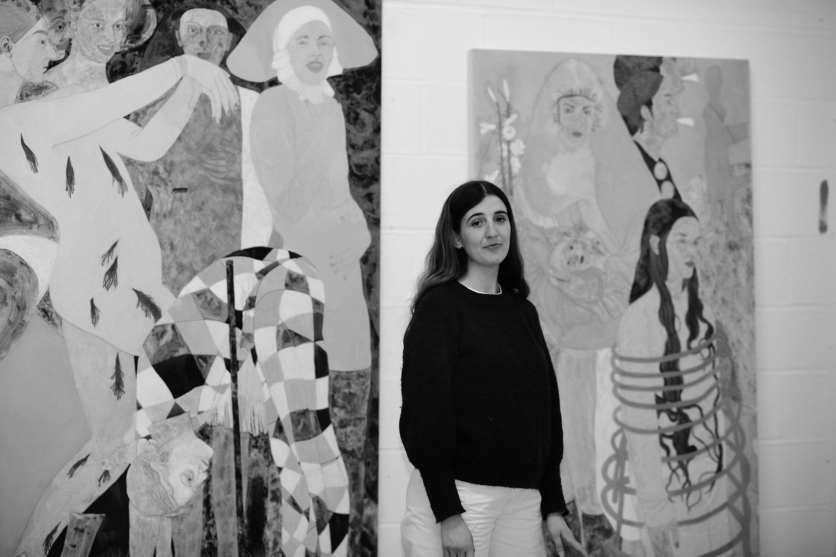
Pictured: Ella Walker © Jon C Archdeacon

Artist Ella Walker (b.1993, Manchester, UK) will create two new site-specific commissions for the Courtauld Gallery. Opening 3 September 2026, the new artworks will be presented in The John Browne Entrance Hall and the Ticketing Hall of the Courtauld Gallery and will be free to visit.
This is the second Courtauld Commission, a series of annual commissions by contemporary artists for the Courtauld Gallery, which launched in 2025 with new works by artist Rachel Jones.

Ella Walker creates monumental canvases that act like dream-like stages. They are dominated by female figures whose gestures and interactions are both familiar and confounding, eschewing expected behaviour and transcending fixed roles.

The new artworks continue the artist’s dialogue with traditional techniques and subjects from the Renaissance period, richly represented at the Courtauld Gallery. Walker is particularly drawn to the Blavatnik Fine Rooms on the second floor of the Courtauld, including The Trinity with Saints Mary Magdalen and John the Baptist altarpiece (around 1491-94) by Sandro Botticelli (around 1445-1510).

Ella Walker said: “The Courtauld Commission is an opportunity to think deeply about the surface of my paintings, the method of applying pigment to an absorbent ground, a ground that is rich with marble and chalk, and is very absorbent and textured. I hope the colours will glow, have transparency and movement within the collection of particles.”
Walker lives and works in London. She studied Fine Art at The Glasgow School of Art and The Royal Drawing School. Recent solo exhibitions include Idolâtrie, Le Château – Centre for Contemporary Art and Heritage of Aubenas, France (2025); The Romance of the Rose, Pilar Corrias, London (2024); After great pain, a formal feeling comes, Casey Kaplan, New York (2024); and Chorus, Kestner Gesellschaft, Hanover, Germany (2023).
This is the second in a series of annual commissions by contemporary artists that will be displayed in The John Browne Entrance Hall and Ticketing Hall at the Courtauld Gallery. Since the transformation of its Gallery in 2021, the Courtauld has significantly expanded its offering of contemporary art, including major exhibitions by Peter Doig and Claudette Johnson, and a major commission by Cecily Brown. The first European solo exhibition of acclaimed New York painter Salman Toor will open on 2 October 2026. In January, the Courtauld also announced it will be creating two new galleries dedicated to contemporary art, set to open in 2029 as part of the development of its new world-class campus at Somerset House
Ella Walker: Courtauld Commission 2026
Opening 3 September 2026
The John Browne Entrance Hall and Ticketing Hall
Free display
Somerset House, Strand
London WC2R 0RN
Opening hours: 10.00 – 18.00 (last entry 17.15)
Weekday tickets from £10; Weekend tickets from £12
Ella Walker: Courtauld Commission 2026 is free to visit
Members, students and Under-18s go free. Other concessions available
MEDIA CONTACTS

Courtauld
www.courtauld.ac.uk/gallery/press
media@courtauld.ac.uk
Bolton & Quinn
Erica Bolton | erica@boltonquinn.com | +44 (0)20 7221 5000
Daisy Taylor I susie@boltonquinn.com | +44 (0)20 7221 5000
SOCIAL MEDIA
Facebook @TheCourtauld
Instagram @Courtauld #TheCourtauld Threads @courtauld
TikTok @TheCourtauld
YouTube TheCourtauld
NOTES TO EDITORS
Courtauld
The Courtauld works to advance how we see and understand the visual arts, as an internationally renowned centre for the teaching and research of art history and a major public gallery. Founded by collectors and philanthropists in 1932, the organisation has been at the forefront of the study of art ever since through advanced research and conservation practice, innovative teaching, the renowned collection and inspiring exhibitions of its gallery, and engaging and accessible activities, education and events.
The Courtauld Gallery cares for one of the greatest art collections in the UK, presenting these works to the public at the Courtauld Gallery in central London, as well as through loans and partnerships. The Gallery is most famous for its iconic Impressionist and Post-Impressionist masterpieces – such as Van Gogh’s Self-Portrait with Bandaged Ear and Manet’s A Bar at the Folies-Bergère. It showcases these alongside an internationally renowned collection of works from the Middle Ages and the Renaissance through to the present day.
Academically, the Courtauld Institute is the largest community of art historians and conservators in the UK, teaching and conducting research on subjects ranging from creativity in late Antiquity to contemporary digital art forms – with an increasingly global focus. An independent college of the University of London, the Courtauld offers a range of degree programmes from BA to PhD in the History of Art, curating, art and business and the conservation of easel and wall paintings. Its alumni are leaders and innovators in the arts, culture and business worlds, helping to shape the global agenda for the arts and creative industries.
Founded on the belief that everyone should have the opportunity to engage with art, the Courtauld works to increase understanding of the role of art throughout history, across all societies and geographies, and to champion its importance in the present day. This could be through exhibitions offering a chance to look closely at world-famous works; events bringing art history research to new audiences; accessible short courses; digital engagement, innovative school, family, and community programmes; or taking a formal qualification. The Courtauld’s ambition is to transform access to art history education, ensuring as many people as possible can benefit from the tools it offers to better understand the visual world around us.
The Courtauld is an exempt charity and relies on generous philanthropic support to achieve its mission of advancing the understanding of the visual arts of the past and present across the world through advanced research, innovative teaching, inspiring exhibitions, programmes and collections.
The collection cared for by the Courtauld Gallery is owned by the Samuel Courtauld Trust

