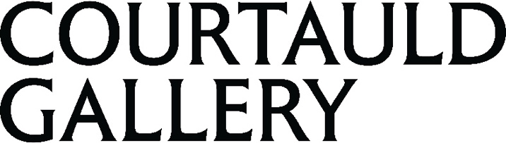

Press Release
Date of Issue: Wednesday 28 January 2026

THE COURTAULD GALLERY SPOTLIGHTS BRITISH WOMEN LANDSCAPE ARTISTS IN NEW DRAWINGS EXHIBITION

A View of One’s Own: Landscapes by British Women Artists 1760-1860
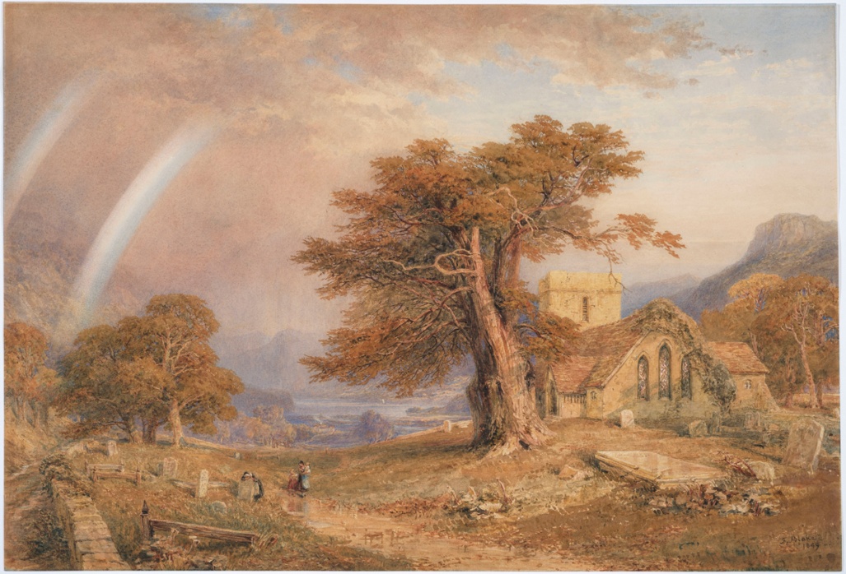
28 January – 20 May 2026

Fanny Blake (1804-1879), A Rainbow over Patterdale Churchyard, Cumbria, 1849, Watercolour and opaque watercolour over graphite, with scratching out, on wove paper. Private Collection, Promised gift to the Samuel Courtauld Trust. Photo © Courtauld

To download press images, visit: https://tinyurl.com/courtauld-a-view-of-ones-own

The Courtauld Gallery presents a new exhibition of landscape drawings and watercolours by women artists working in Britain between 1760 and 1860, shedding light on a new side of the Golden Age of British Landscape art.

When the Royal Academy was founded in 1768, its members included two women, yet there would not be another female academician until Dame Laura Knight was elected in 1936. Despite this institutional exclusion, women artists in Britain continued to train, practice, and exhibit during this period, particularly in the field of landscape watercolours.

The exhibition features 10 remarkable women artists who have remained mostly unknown and their works largely unpublished. They include Harriet Lister and Lady Mary Lowther, who were among the first to depict the Lake District; Amelia Long, Lady Farnborough, one of the first British artists to travel to France following the Napoleonic Wars; and Elizabeth Batty – whose works appearing in the show were only rediscovered a few years ago.

The twenty-four works on paper on display include recent acquisitions and promised gifts and form part of a project to extend and diversify the collection of British watercolours.

The display takes on special resonance at the Courtauld Gallery in Somerset House, once the eighteenth-century home of the Royal Academy of Arts, where several of the featured artists including Amelia Long, Lady Farnborough, and Harriet Lister exhibited work.

A View of One’s Own: Landscapes by British Women Artists 1760-1860 is curated by Dr Rachel Sloan, Associate Curator for Works on Paper, and is accompanied by a new catalogue with contributions by Dr Susan Owens and Dr Paris Spies-Gans.

Entry to this exhibition is included with Gallery Entry.

A View of One’s Own: Landscapes by British Women Artists 1760-1860
28 January – 20 May 2026
Gilbert & Ildiko Butler Drawings Gallery, Floor 1
https://courtauld.ac.uk/whats-on/exh-a-view-of-ones-own/

MEDIA CONTACTS
Courtauld
www.courtauld.ac.uk/gallery/press
media@courtauld.ac.uk
Bolton & Quinn
Erica Bolton | erica@boltonquinn.com | +44 (0)20 7221 5000
Daisy Taylor | daisy@boltonquinn.com | +44 (0)20 7221 5000
SOCIAL MEDIA
Facebook @TheCourtauld
Instagram @Courtauld #TheCourtauld
Threads @courtauld
TikTok @TheCourtauld
Twitter @TheCourtauld
YouTube TheCourtauld

Courtauld Gallery
Somerset House, Strand
London WC2R 0RN
Opening hours: 10.00 – 18.00 (last entry 17.15)
Friends and Under-18s go free. Other concessions available.

Friends get free unlimited entry to the Courtauld Gallery and exhibitions, priority booking to selected events, advance notice of art history short courses, exclusive events, discounts and more. Join today at courtauld.ac.uk/friends

NOTES TO EDITORS

About the Courtauld
The Courtauld works to advance how we see and understand the visual arts, as an internationally renowned centre for the teaching and research of art history and a major public gallery. Founded by collectors and philanthropists in 1932, the organisation has been at the forefront of the study of art ever since through advanced research and conservation practice, innovative teaching, the renowned collection and inspiring exhibitions of its gallery, and engaging and accessible activities, education and events.

The Courtauld cares for one of the greatest art collections in the UK, presenting these works to the public at the Courtauld Gallery in central London, as well as through loans and partnerships. The Gallery is most famous for its iconic Impressionist and Post-Impressionist masterpieces – such as Van Gogh’s Self-Portrait with Bandaged Ear and Manet’s A Bar at the Folies-Bergère. It showcases these alongside an internationally renowned collection of works from the Middle Ages and the Renaissance through to the present day.

Academically, the Courtauld faculty is the largest community of art historians and conservators in the UK, teaching and carrying out research on subjects from creativity in late Antiquity to contemporary digital artforms – with an increasingly global focus. An independent college of the University of London, the Courtauld offers a range of degree programmes from BA to PhD in the History of Art, curating and the conservation of easel and wall paintings. Its alumni are leaders and innovators in the arts, culture and business worlds, helping to shape the global agenda for the arts and creative industries.

Founded on the belief that everyone should have the opportunity to engage with art, The Courtauld works to increase understanding of the role played by art throughout history, in all societies and across all geographies – as well as being a champion for the importance of art in the present day. This could be through exhibitions offering a chance to look closely at world-famous works; events bringing art history research to new audiences; accessible and expert short courses; digital engagement, innovative school, family and community programmes; or taking a formal qualification. The Courtauld’s ambition is to transform access to art history education by extending the horizons of what this is and ensuring as many people as possible can benefit from the tools to better understand the visual world around us.

The Courtauld is an exempt charity and relies on generous philanthropic support to achieve its mission of advancing the understanding of the visual arts of the past and present across the world through advanced research, innovative teaching, inspiring exhibitions, programmes and collections.

The collection cared for by the Courtauld Gallery is owned by the Samuel Courtauld Trust.

media@courtauld.ac.uk

