

Press Release
Date of Issue: Friday 4 April 2025

MASTERPIECES FROM THE BARBER INSTITUTE OF FINE ARTS, UNIVERSITY OF BIRMINGHAM TO GO ON DISPLAY AT THE COURTAULD GALLERY

New display, ‘The Barber in London: Highlights from a Remarkable Collection’, opens 23 May 2025
Including works by Bellini, Rubens, Gainsborough, Turner, Rossetti,
Whistler, Degas and Monet

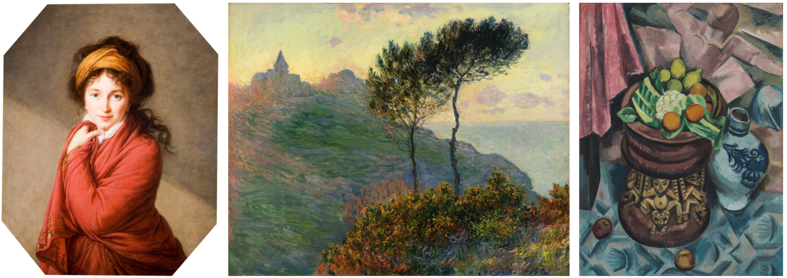
Elisabeth Vigée-Lebrun, Portrait of Countess Golovine, 1797-1800, The Henry Barber Trust, The Barber Institute of Fine Arts, University of Birmingham; Claude Monet, The Church at Varengeville, 1882, The Henry Barber Trust, The Barber Institute of Fine Arts, University of Birmingham; Max Pechstein, Still Life in Grey, 1913, The Henry Barber Trust, The Barber Institute of Fine Arts, University of Birmingham

For further press information and images, please visit: https://tinyurl.com/5n6mduhm

Exceptional paintings from the Barber Institute of Fine Arts, University of Birmingham, go on show at The Courtauld Gallery for an extended display, opening 23 May 2025.

A selection of 18 masterpieces ranging from the Renaissance to the 20th century, including works by Gainsborough, Reynolds, Turner, Degas, and Monet, will be exhibited at The Courtauld Gallery while the Barber undergoes major building improvements.

The Barber Institute of Fine Arts was founded as a university gallery in 1932, the same year as The Courtauld Institute of Art and its collection. Both were intended to encourage the study and public appreciation of art. Today, the Barber and The Courtauld Gallery are home to two of the finest collections of European art in the country.

Highlights of the display will include Saint Jerome in the Wilderness (around 1445-60) – one of the earliest surviving works by Giovanni Bellini – along with Élisabeth Vigée Le Brun’s Portrait of Countess Golovina (1797-1800) and the striking Portrait of a Man with a Skull, (around 1610-14) by Frans Hals. The Barber’s significant strand of landscape paintings will be represented with exceptional examples by artists including Rubens, Claude, Turner, and Monet. Several internationally significant 19th-century works will be exhibited, including Gabriel Dante Rossetti’s sumptuous The Blue Bower (1865) and Edgar Degas’s Jockeys Before the Race (1879). Max Pechstein’s Still Life in Grey (1913)– the Barber’s most recent painting acquisition – demonstrates the museum’s ongoing interest in growing the collection with 20th-century works.
The display will be presented in the Katja and Nicolai Tangen 20th Century Gallery on the third floor. In addition, a handful of paintings with strong links to some of The Courtauld’s own works will be embedded in the permanent collection displays – among them, Joshua Reynolds’s monumental double portrait Maria Marow Gideon and her brother William (1786-87) and Anthony van Dyck’s Ecce Homo (around 1625-26), which will be shown beside The Courtauld’s closely related Man of Sorrows (around 1622-25).

The Barber was founded by Hattie, Lady Barber (1869-1933) in memory of her husband, Sir Henry Barber (1860-1927), a wealthy Birmingham property developer and lawyer. Lady Barber did not possess a significant collection of art. Instead, she created an endowment that allowed its Directors to acquire works that were, in her words, ‘of exceptional and outstanding merit’. For more than 70 years, this founding vision has shaped a carefully selected collection of major works that represent key developments in the history of Western art. Lady Barber’s bequest also financed the construction of an exceptional building on the University of Birmingham’s Edgbaston campus. Designed by the architect Robert Atkinson (1883–1952), it opened to the public in 1939 with just 14 paintings then on display. Intended as a nucleus for the arts and a social hub for the University, the Barber also has an Art-Deco concert hall at its heart, as well as a lecture theatre and art history library, and houses the University’s Department of Art History, Curating and Visual Studies.
The Barber will re-open to the public in 2026.

The Barber in London: Highlights from a Remarkable Collection
23 May 2025 – 22 February 2026
The Courtauld Gallery
Katja and Nicolai Tangen 20th Century Gallery, Floor 3
https://courtauld.ac.uk/whats-on/exh-the-barber-in-london-highlights-from-a-remarkable-collection/

Entry to the display is included in the Gallery admission ticket.

The Courtauld Gallery
Somerset House, Strand
London WC2R 0RN
Opening hours: 10.00 – 18.00 (last entry 17.15)
Weekday tickets from £10; weekend tickets from £12.
Friends and Under-18s go free. Other concessions available

MEDIA CONTACTS

The Courtauld
www.courtauld.ac.uk/gallery/press
media@courtauld.ac.uk

Bolton & Quinn
Erica Bolton | erica@boltonquinn.com | +44 (0)20 7221 5000
Daisy Taylor | daisy@boltonquinn.com | +44 (0)20 7221 5000

SOCIAL MEDIA - THE COURTAULD
Facebook @TheCourtauld
Instagram @Courtauld #TheCourtauld
Threads @courtauld
TikTok @TheCourtauld
Twitter @TheCourtauld
YouTube TheCourtauld

NOTES TO EDITORS

About The Courtauld
The Courtauld works to advance how we see and understand the visual arts, as an internationally renowned centre for the teaching and research of art history and a major public gallery. Founded by collectors and philanthropists in 1932, the organisation has been at the forefront of the study of art ever since through advanced research and conservation practice, innovative teaching, the renowned collection and inspiring exhibitions of its gallery, and engaging and accessible activities, education and events.

The Courtauld cares for one of the greatest art collections in the UK, presenting these works to the public at The Courtauld Gallery in central London, as well as through loans and partnerships. The Gallery is most famous for its iconic Impressionist and Post-Impressionist masterpieces – such as Van Gogh’s Self-Portrait with Bandaged Ear and Manet’s A Bar at the Folies-Bergère. It showcases these alongside an internationally renowned collection of works from the Middle Ages and the Renaissance through to the present day.

Academically, The Courtauld faculty is the largest community of art historians and conservators in the UK, teaching and carrying out research on subjects from creativity in late Antiquity to contemporary digital artforms - with an increasingly global focus. An independent college of the University of London, The Courtauld offers a range of degree programmes from BA to PhD in the History of Art, curating and the conservation of easel and wall paintings. Its alumni are leaders and innovators in the arts, culture and business worlds, helping to shape the global agenda for the arts and creative industries.

Founded on the belief that everyone should have the opportunity to engage with art, The Courtauld works to increase understanding of the role played by art throughout history, in all societies and across all geographies – as well as being a champion for the importance of art in the present day. This could be through exhibitions offering a chance to look closely at world-famous works; events bringing art history research to new audiences; accessible and expert short courses; digital engagement, innovative school, family and community programmes; or taking a formal qualification. The Courtauld’s ambition is to transform access to art history education by extending the horizons of what this is and ensuring as many people as possible can benefit from the tools to better understand the visual world around us.

The Courtauld is an exempt charity and relies on generous philanthropic support to achieve its mission of advancing the understanding of the visual arts of the past and present across the world through advanced research, innovative teaching, inspiring exhibitions, programmes and collections.

The collection cared for by The Courtauld Gallery is owned by the Samuel Courtauld Trust.
About the Barber Institute of Fine Arts
The Barber Institute of Fine Arts is the art gallery, principal art collection and original concert hall for the University of Birmingham. It was founded in 1932 ‘for the study and encouragement of art and music’ by Lady Barber, who stipulated the acquisition of works ‘of that standard of quality required by the National Gallery and the Wallace Collection’. Housed in an elegant, Grade-1 listed building designed by Robert Atkinson, the Barber Institute is home to a National Designated Collection, acquired and owned by the Henry Barber Trust. Its holdings now include some 160 paintings, dating from the early Renaissance through to the late 20th century, more than 800 works on paper, as well as sculpture, decorative arts and one of the most important caches of Roman, Byzantine and Medieval coins in the world. The collection features key works by (among others) Giovanni Bellini, Sandro Botticelli, Rosalba Carriera, Edgar Degas, Thomas Gainsborough, Gwen John, Käthe Kollwitz, René Magritte, Edouard Manet, Claude Monet, Auguste Rodin, Peter Paul Rubens, JMW Turner, Vincent van Gogh, Elizabeth Vigée-Lebrun and James McNeill Whistler.

At the building’s heart is the immaculate Art-Deco concert hall, home to the prestigious Barber Concerts series, which features internationally renowned vocal and instrumental soloists and ensembles, and the Barber Opera.

The building is currently closed for the latest phase of a major building improvement programme, which includes installation of a level access entrance, a new fresh-air ventilation system in the concert hall, a refurbishment of the permanent collection galleries, a new learning wing and enhanced and an enlarged reception, retail and refreshment area.

For more information, visit barber.org.uk and follow @barberinstitute on X (formerly Twitter), Instagram and Facebook for regular updates, news and opportunities to engage with the Barber.

