
Press Release
Monday 24 March 2025
RACHEL JONES CREATES NEW COMMISSIONS
FOR THE COURTAULD GALLERY
New artworks will be unveiled 25 September 2025
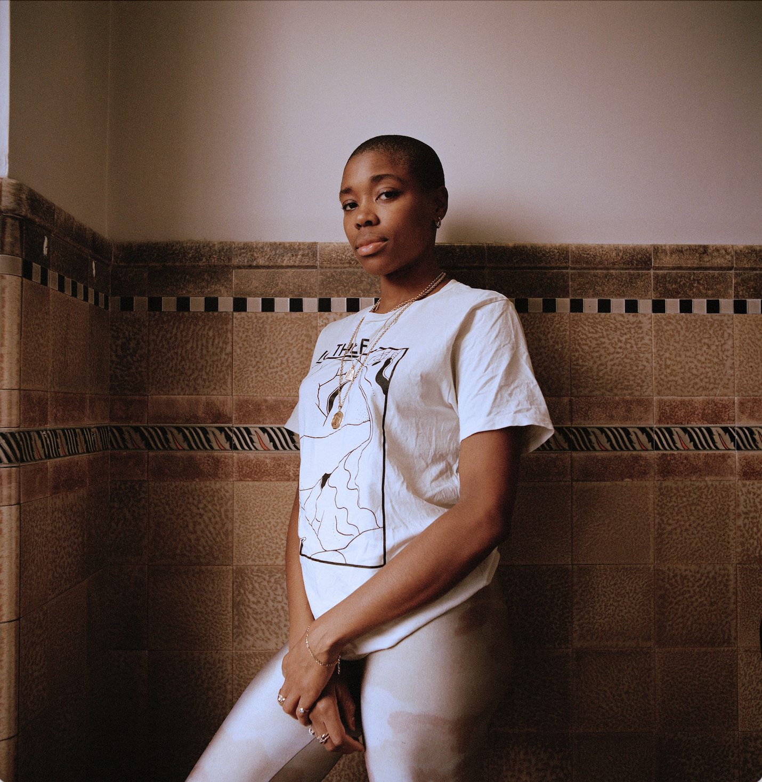
Rachel Jones. Photo © Adama Jalloh

Press image available for download: https://tinyurl.com/2adbt5hy
Acclaimed artist Rachel Jones will create two new site-specific commissions for The Courtauld Gallery. Opening on 25 September 2025, the new artworks will be presented in The John Browne Entrance Hall and Ticketing Hall of The Courtauld Gallery and will be free to visit.
Rachel Jones (b. 1991) is celebrated for her monumental canvases and bold use of colour. Working in pastel and oil stick, she creates large-scale abstract compositions in a kaleidoscope of rich colours and gestural marks. Her paintings often feature motifs of mouths and teeth interwoven in a landscape of natural forms, representing points of entry and connection between the body and the outside world.
The new artworks continue the artist’s dialogue with works in The Courtauld’s world-leading collection of Impressionist and Post-Impressionist art. Jones described Vincent van Gogh’s Self-Portrait with Bandaged Ear (1889) in The Courtauld’s collection as her favourite and most inspiring work in a London public collection, calling it ‘the epitome of how to use colour, texture and a sense of self to create an image’.
Rachel Jones was born and lives in London. She studied Fine Art at The Glasgow School of Art and the Royal Academy Schools. Recent solo exhibitions include Rachel Jones, !!!!!, Museum of African Diaspora, San Francisco, US (2024), Rachel Jones, a shorn root, Long Museum, Shanghai, China (2023), and Rachel Jones, say cheeeeese, Chisenhale Gallery, London, UK (2022). A solo exhibition of Jones’ work, Gated Canyons, will open at Dulwich Picture Gallery on 10 June 2025.
Jones’s 2025 installation is the latest in a series of contemporary art exhibitions and commissions at The Courtauld Gallery across its public programme, including recent major solo-exhibitions by Claudette Johnson and Peter Doig, and a commission by Cecily Brown which was unveiled when the Gallery reopened in 2021.

Rachel Jones: Courtauld Gallery 2025 Commission
Opening 25 September 2025
The John Browne Entrance Hall and Ticketing Hall
Free display
Somerset House, Strand
London WC2R 0RN
Opening hours: 10.00 – 18.00 (last entry 17.15)
Weekday tickets from £10; Weekend tickets from £12
The Rachel Jones commission is free to visit
Friends and Under-18s go free. Other concessions available
MEDIA CONTACTS
The Courtauld
www.courtauld.ac.uk/gallery/press media@courtauld.ac.uk
Bolton & Quinn
Erica Bolton | erica@boltonquinn.com | +44 (0)20 7221 5000
Daisy Taylor I susie@boltonquinn.com | +44 (0)20 7221 5000
SOCIAL MEDIA
Facebook @TheCourtauld
Instagram @Courtauld #TheCourtauld Threads @courtauld
TikTok @TheCourtauld
Twitter @TheCourtauld
YouTube TheCourtauld
NOTES TO EDITORS
About The Courtauld
The Courtauld works to advance how we see and understand the visual arts, as an internationally renowned centre for the teaching and research of art history and a major public gallery. Founded by collectors and philanthropists in 1932, the organisation has been at the forefront of the study of art ever since through advanced research and conservation practice, innovative teaching, the renowned collection and inspiring exhibitions of its gallery, and engaging and accessible activities, education and events.
The Courtauld cares for one of the greatest art collections in the UK, presenting these works to the public at The Courtauld Gallery in central London, as well as through loans and partnerships. The Gallery is most famous for its iconic Impressionist and Post-Impressionist masterpieces – such as Van Gogh’s Self-Portrait with Bandaged Ear and Manet’s A Bar at the Folies-Bergère. It showcases these alongside an internationally renowned collection of works from the Middle Ages and the Renaissance through to the present day.
Academically, The Courtauld faculty is the largest community of art historians and conservators in the UK, teaching and carrying out research on subjects from creativity in late Antiquity to contemporary digital artforms - with an increasingly global focus. An independent college of the University of London, The Courtauld offers a range of degree programmes from BA to PhD in the History of Art, curating and the conservation of easel and wall paintings. Its alumni are leaders and innovators in the arts, culture and business worlds, helping to shape the global agenda for the arts and creative industries.
Founded on the belief that everyone should have the opportunity to engage with art, The Courtauld works to increase understanding of the role played by art throughout history, in all societies and across all geographies – as well as being a champion for the importance of art in the present day. This could be through exhibitions offering a chance to look closely at world- famous works; events bringing art history research to new audiences; accessible and expert short courses; digital engagement, innovative school, family and community programmes; or taking a formal qualification. The Courtauld’s ambition is to transform access to art history education by extending the horizons of what this is and ensuring as many people as possible can benefit from the tools to better understand the visual world around us.
The Courtauld is an exempt charity and relies on generous philanthropic support to achieve its mission of advancing the understanding of the visual arts of the past and present across the world through advanced research, innovative teaching, inspiring exhibitions, programmes and collections.
The collection cared for by The Courtauld Gallery is owned by the Samuel Courtauld Trust.

