
Press Release
Date of Issue: 21 November 2024

MONET MANIA CONTINUES
LATE NIGHT OPENINGS EVERY EVENING FOR THE FINAL WEEK IN JANUARY TO SATISFY VISITOR DEMAND
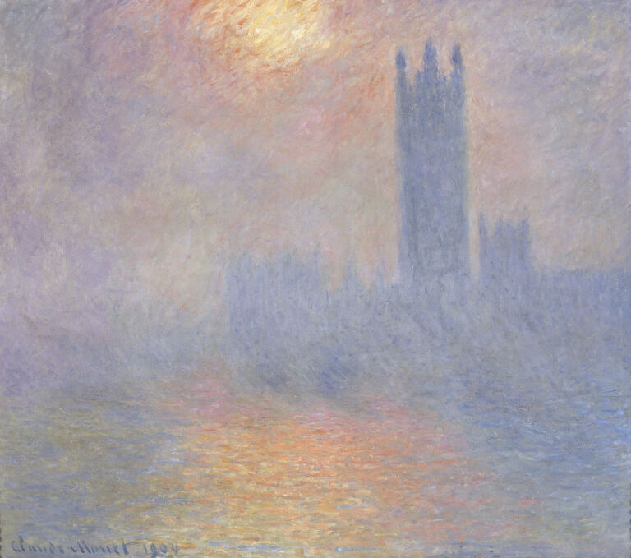
Claude Monet (1840 – 1926), London, Parliament. Sunlight in the fog, 1904, oil on canvas, Musée d'Orsay, Paris,
Photo © Grand Palais RMN (musée d'Orsay) / Hervé Lewandowski
Press images available for download: https://tinyurl.com/4r4tzy4c
More tickets have been released for the final week of The Courtauld Gallery’s blockbuster exhibition The Griffin Catalyst Exhibition: Monet and London. Views of the Thames, due to exceptional demand.
The exhibition brings together for the first time in 120 years Claude Monet’s extraordinary series of paintings of the Thames in London. Begun during three stays in the capital between 1899 and 1901, these extraordinary paintings of the Houses of Parliament, Charing Cross Bridge and Waterloo Bridge were unveiled in Paris in 1904 to great critical acclaim. Monet fervently wanted to show them in London the following year but plans fell through. The Courtauld will realise Monet’s unfulfilled ambition of exhibiting this exceptional series just 300 metres from the Savoy Hotel where the artist stayed and many of the works were painted.
The exhibition attracted the biggest advance ticket sales in The Courtauld Gallery’s history and general tickets sold out a month after the exhibition opened. Due to the unprecedented demand, The Courtauld is extended its opening hours every evening in the final week of the run to ensure visitors don’t miss out.
The exhibition will be open from 10:00 – 21:00 from Monday 13 – Thursday 16 January and Saturday 18 – Sunday 19 January 2025. Additionally, the exhibition will open on Friday 17 January 2025 for The Courtauld Lates until 22:30, including bars, Courtauld Cocktails and a live DJ throughout the evening.
Tickets for the extended hours slots are available to purchase on The Courtauld’s website from Thursday 21 November, 10:00 (GMT).
Once these tickets sell out, no further tickets will be made available. The only tickets available to purchase will be members tickets exclusively for Courtauld Friends.
Courtauld Friends can enjoy the exhibition without the crowds at two exclusive early morning views on Saturday 30 November 2024 and Friday 10 January 2025, from 9:00 – 10:00. Friends also get free unlimited entry to the permanent collection and exhibitions plus The Courtauld Lates, access to presale tickets, members’ tickets, priority booking to selected events, advance notice of art history short courses, exclusive events, discounts and more. Join at the ticket desk in the Gallery or online - courtauld.ac.uk/friends
Dr Karen Serres, Senior Curator of Paintings at The Courtauld, and curator of the exhibition, said: “More than any other Impressionist artist, Monet was very attentive to how his works were displayed. With his series paintings, he created a whole visual experience from multiple canvases of a same subject, what we would call today ‘an installation’. The Courtauld exhibition presents Monet’s paintings as he wanted them to be seen.”
Professor Mark Hallett, Märit Rausing Director of The Courtauld, said: “Monet and London is a unique exhibition: one, in fact, that has been more than a century in the making. It has been worth the wait. Bringing together Monet’s Thames paintings in this way allows us to appreciate their individual and collective brilliance and gives us a thrilling new perspective on both the artist and the city he depicted. We're extremely grateful to the supporters that have enabled this exhibition, and particularly to Griffin Catalyst, Kenneth C Griffin and the Huo Family Foundation for their long term support.”
The exhibition’s lead sponsor is Griffin Catalyst, the civic engagement initiative of Citadel Founder and CEO Kenneth C. Griffin. The exhibition is supported by The Huo Family Foundation, with additional support from the Dr. Lee MacCormick Edwards Charitable Foundation.
The Griffin Catalyst Exhibition: Monet and London. Views of the Thames
27 September 2024 – 19 January 2025
courtauld.ac.uk/whats-on/exh-monet-and-london-views-of-the-thames/

The Courtauld Gallery
Somerset House, Strand
London WC2R 0RN
Opening hours: 10.00 – 18.00 (last entry 17.15)
Temporary Exhibition tickets (including entry to our Permanent Collection and displays) – Weekday tickets from £16; Weekend tickets from £18.
Friends and Under-18s go free. Other concessions available
Exhibition Catalogue
The catalogue to accompany the exhibition is available to purchase from The Courtauld Shop, located on the Lower Ground floor of the Gallery, and online: https://shop.courtauld.ac.uk/collections/books/products/monet-and-london-views-of-the-thames

MEDIA CONTACTS

The Courtauld
www.courtauld.ac.uk/gallery/press
media@courtauld.ac.uk

Bolton & Quinn
Erica Bolton | erica@boltonquinn.com | +44 (0)20 7221 5000
Susie Gault | susie@boltonquinn.com | +44 (0)20 7221 5000

SOCIAL MEDIA
Facebook @TheCourtauld
Instagram @Courtauld #TheCourtauld
Threads @courtauld
TikTok @TheCourtauld
Twitter @TheCourtauld
YouTube TheCourtauld
NOTES TO EDITORS

About The Courtauld
The Courtauld works to advance how we see and understand the visual arts, as an internationally renowned centre for the teaching and research of art history and a major public gallery. Founded by collectors and philanthropists in 1932, the organisation has been at the forefront of the study of art ever since through advanced research and conservation practice, innovative teaching, the renowned collection and inspiring exhibitions of its gallery, and engaging and accessible activities, education and events.

The Courtauld cares for one of the greatest art collections in the UK, presenting these works to the public at The Courtauld Gallery in central London, as well as through loans and partnerships. The Gallery is most famous for its iconic Impressionist and Post-Impressionist masterpieces – such as Van Gogh’s Self-Portrait with Bandaged Ear and Manet’s A Bar at the Folies-Bergère. It showcases these alongside an internationally renowned collection of works from the Middle Ages and the Renaissance through to the present day.

Academically, The Courtauld faculty is the largest community of art historians and conservators in the UK, teaching and carrying out research on subjects from creativity in late Antiquity to contemporary digital artforms - with an increasingly global focus. An independent college of the University of London, The Courtauld offers a range of degree programmes from BA to PhD in the History of Art, curating and the conservation of easel and wall paintings. Its alumni are leaders and innovators in the arts, culture and business worlds, helping to shape the global agenda for the arts and creative industries.

Founded on the belief that everyone should have the opportunity to engage with art, The Courtauld works to increase understanding of the role played by art throughout history, in all societies and across all geographies – as well as being a champion for the importance of art in the present day. This could be through exhibitions offering a chance to look closely at world-famous works; events bringing art history research to new audiences; accessible and expert short courses; digital engagement, innovative school, family and community programmes; or taking a formal qualification. The Courtauld’s ambition is to transform access to art history education by extending the horizons of what this is and ensuring as many people as possible can benefit from the tools to better understand the visual world around us.

The Courtauld is an exempt charity and relies on generous philanthropic support to achieve its mission of advancing the understanding of the visual arts of the past and present across the world through advanced research, innovative teaching, inspiring exhibitions, programmes and collections.

The collection cared for by The Courtauld Gallery is owned by the Samuel Courtauld Trust.

About Griffin Catalyst
Griffin Catalyst is the civic engagement initiative of Citadel founder and CEO Kenneth C. Griffin, encompassing his philanthropic and community impact efforts. Tackling the world’s greatest challenges in innovative, action-oriented, and evidence-driven ways, Griffin Catalyst is dedicated to expanding opportunity and improving lives across six areas of focus: Education, Science & Medicine, Upward Mobility, Freedom & Democracy, Enterprise & Innovation, and Communities. For more information, visit griffincatalyst.org/.
About The Huo Family Foundation
The Huo Family Foundation’s mission is to support education, communities and the pursuit of knowledge. Through its donations, the Foundation hopes to improve the prospects of individuals, and to support the work of organisations seeking to ensure a safe and successful future for all society. The Foundation aims to make art more accessible to all through its support for galleries, museums and centres for the performing arts. For more information, huofamilyfoundation.org/.

