THE SOTIRIS FELIOS COLLECTION RESIDENCY PROGRAMME 2024

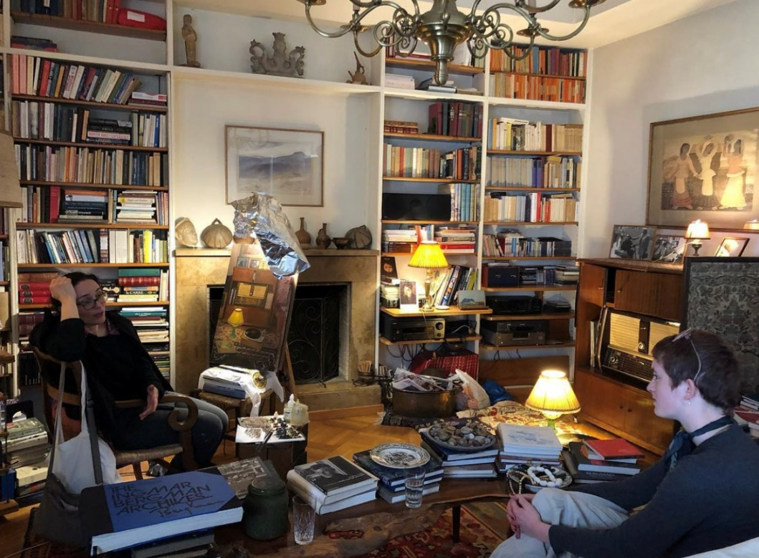
Art Historian in residence Hannah Forman in conversation with Leda
Contogiannopoulou at poet George Seferis’ house.
The Sotiris Felios Collection Residency Programme is a 6-week fully-funded residency in Athens, taking place twice a year, offering current Courtauld PhD candidates, MA students, 3rd-year BA students, and the most recent cohort of graduates the opportunity to develop their practice as art historians and curators, through engaging in academic research and the development of curatorial projects of their own.
Building on a broad network of art professionals from Athens-based institutions and leading practitioners living and working in Greece, the Residency Programme aims to create support channels for emerging curators and art historians, who want to expand academic research around contemporary figurative art and its connection to the international art scene, as well as develop their curatorial practice through engaging in a self-initiated project that builds on themes linked to The Sotiris Felios Collection and the community of Athens.
Residents are invited to spend six weeks in Athens, while developing research related to their proposal through learning about the Collection, meeting the artists associated with it and art professionals from leading museums and galleries.
From the moment residents arrive they will be immersed in the vibrant and unique art scene of Athens while also experiencing the striking diversity of the local community, where the Residency is based. Participants will be provided with accommodation in the historical area of Kypseli, one of the oldest neighbourhoods of Athens. Kypseli is located at the heart of Athens’ cultural community and 3 miles away from most museums, galleries and private collections. Residents will also be provided with a generous daily allowance to cover their daily expenses.

THE COLLECTION
Founded in the 1980s, The Sotiris Felios Collection, based in Athens, is a unique collection of contemporary art focused on the human figure. The Collection belongs to “The other Arcadia” Foundation and offers a rich overview of the most important contemporary artists living and working in Greece, as well as leading artists whose creations forge a link between the past century and the present day.
The Collection has so far brought together over 1,000 paintings, sculptures, drawings, prints, photographs, reliefs, constructions and drawings by 137 artists, such as the painters Yannis Moralis, Chronis Botsoglou, Christos Bokoros, Giorgos Rorris, Tassos Mantzavinos, Alecos Levidis, Kalliopi Asargiotaki, Michalis Manoussakis, Kostas Papanikolaou, Maria Filopoulou, Edouard Sacaillan, Maria Giannakaki, Anna-Maria Tsakali and Emmanouil Bitsakis, and the sculptors Takis, George Lappas, Natalia Mela, Pantelis Chandris, Michalis Kallimopoulos, Vally Nomidou, Kostas Lales, and Andreas Lolis – to name but a few. In addition, its Library and Archives include over 3,000 artist monographs, exhibition catalogues, rare publications and periodicals, and extensive individual files.
All the works of art are the collector’s personal choice.
In the interest of making the Collection accessible to the wider public, Sotiris Felios established “The other Arcadia” Foundation, which organises exhibitions of the Collection’s works both within and outside of Greece, produces the respective catalogues and liaises with other institutions to lend out the Collection’s works for various exhibitions.
In addition to “The other Arcadia” Foundation, the collector has created the 16 Fokionos Negri art space, as a venue to host art exhibitions, organise cultural events and develop collaboration networks, partnerships and exchanges with other cultural organisations.
In 2022 “The other Arcadia” Foundation in collaboration with The Courtauld Institute of Art, London inaugurated the “Residency Programme for Academic and Curatorial Research of Greek Contemporary Art” inviting twice a year art theorists and curators from the University to spend 6 weeks in Athens and develop their research.
Since March 2021 “The other Arcadia” Foundation has partnered with Google Arts & Culture bringing three hundred sixteen artworks and five online exhibits from The Sotiris Felios Collection to the worldwide audience of the digital platform.
THE SPACE
In 2008 Sotiris Felios created the “16 Fokionos Negri” art space in Kypseli, an Athens neighbourhood that is constantly evolving, with the old-time grace of its distinctive bourgeois legacy. The exhibition space 16 Fokionos Negri was designed and constructed in 2009 by architects Maria Kokkinou and Andreas Kourkoulas. It spans an area of approximately 300 square metres. It is the basement of a 1960s’ apartment block and was originally a billiards room. The initiative constitutes a not-for-profit entity.
The venue serves as a welcoming hub for hosting art exhibitions, organising cultural events, developing collaboration networks, partnerships and exchanges with other cultural organisations. Through its activities, “16 Fokionos Negri” has become established as a point of reference for the arts in Athens today, playing an active role in the cultural life and expression of the city.
RESIDENCY PROGRAMME DETAILS
1. Art History Programme:
Applicants with an art history background are invited to submit proposals for a research project that will culminate into a written essay. The resident will have the opportunity to spend time with artists of their choice, visit their studio and receive mentoring from leading art professionals, while developing a new body of research linked to contemporary figurative art and the Athenian art scene through an international lens.
▪ Outcome: 3,000-4,000 words essay on the subject outlined in their proposal, which would be published to a professional standard in an international prestigious art journal or magazine, as well as in the Greek art press. Before submission the essay will be reviewed by the selection panel.
▪ What is offered: Accommodation, working space with a desk and computer, regular visits to the Collection, opportunity to view and study artworks of choice, regular visits to artists’ studios and meetings with curators and other art professionals, visits to chosen heritage sites, 500 euros stipend, presentation of written piece at the exhibition space “16 Fokionos Negri, introduction to the local artistic community of Athens.
2. Curatorial Programme:
Applicants with a background in curating are invited to submit proposals for a new site-responsive project (exhibition, publication, series of talks, workshops etc) that will be presented in Athens at the end of their residency. Curators are encouraged in their application to draw ideas from The Sotiris Felios Collection and the city of Athens, proposing projects that align with the mission of the residency to increase awareness of Greek figurative contemporary art and the research and education happening in the region.
      - Outcome: a curatorial project in the form of an exhibition, publication, discursive event, series of talks, workshops or community project presented at the exhibition space “16 Fokionos Negri”. The curator will also be asked to give a curators’ talk. They will receive production support to help facilitate the final project.

      - What is offered: Accommodation, daily allowances, working space with a desk and computer, regular visits to the Collection, regular visits to artists’ studios and meetings with curators and other art professionals, visits to chosen heritage sites, press and social media support, 500 euros stipend.

ADMISSION PROCESS
Residents will be selected through a written application and interview, with the admission panel consisting of two representatives from Courtauld Institute and two appointed by The Sotiris Felios Collection. The residency is offered to students from the following courses and recent alumni:
- BA History of Art (3rd year students)
- MA Curating the Art Museum
- MA History of Art
- PhD candidates
- Recent Courtauld alumni
DATES
- June/July 2024 (art history programme)
- September/October 2024 (curatorial programme)
(Exact dates of the residency to be confirmed with the participants)
Art History Submission deadline: 18 March 2024
Curatorial Submission deadline: 4 April 2024

CONDITIONS
- Agree to reside in Athens for the full duration of the residency with minimal external commitments
- Commit to an intensive schedule of research, meetings and studio visits
- Commit to fully developing the project proposed

APPLICATION
- Completed and signed application form
- Curriculum Vitae (no more than 2 pages)
- Completed and signed reference form
- List with selected images of previous projects (no more than 2 pages)
- A 500-word proposal on the research willing to undertake while on residency
- A 300-word text on how the residency would benefit your long-term academic or curatorial practice and Athens is your city of choice.

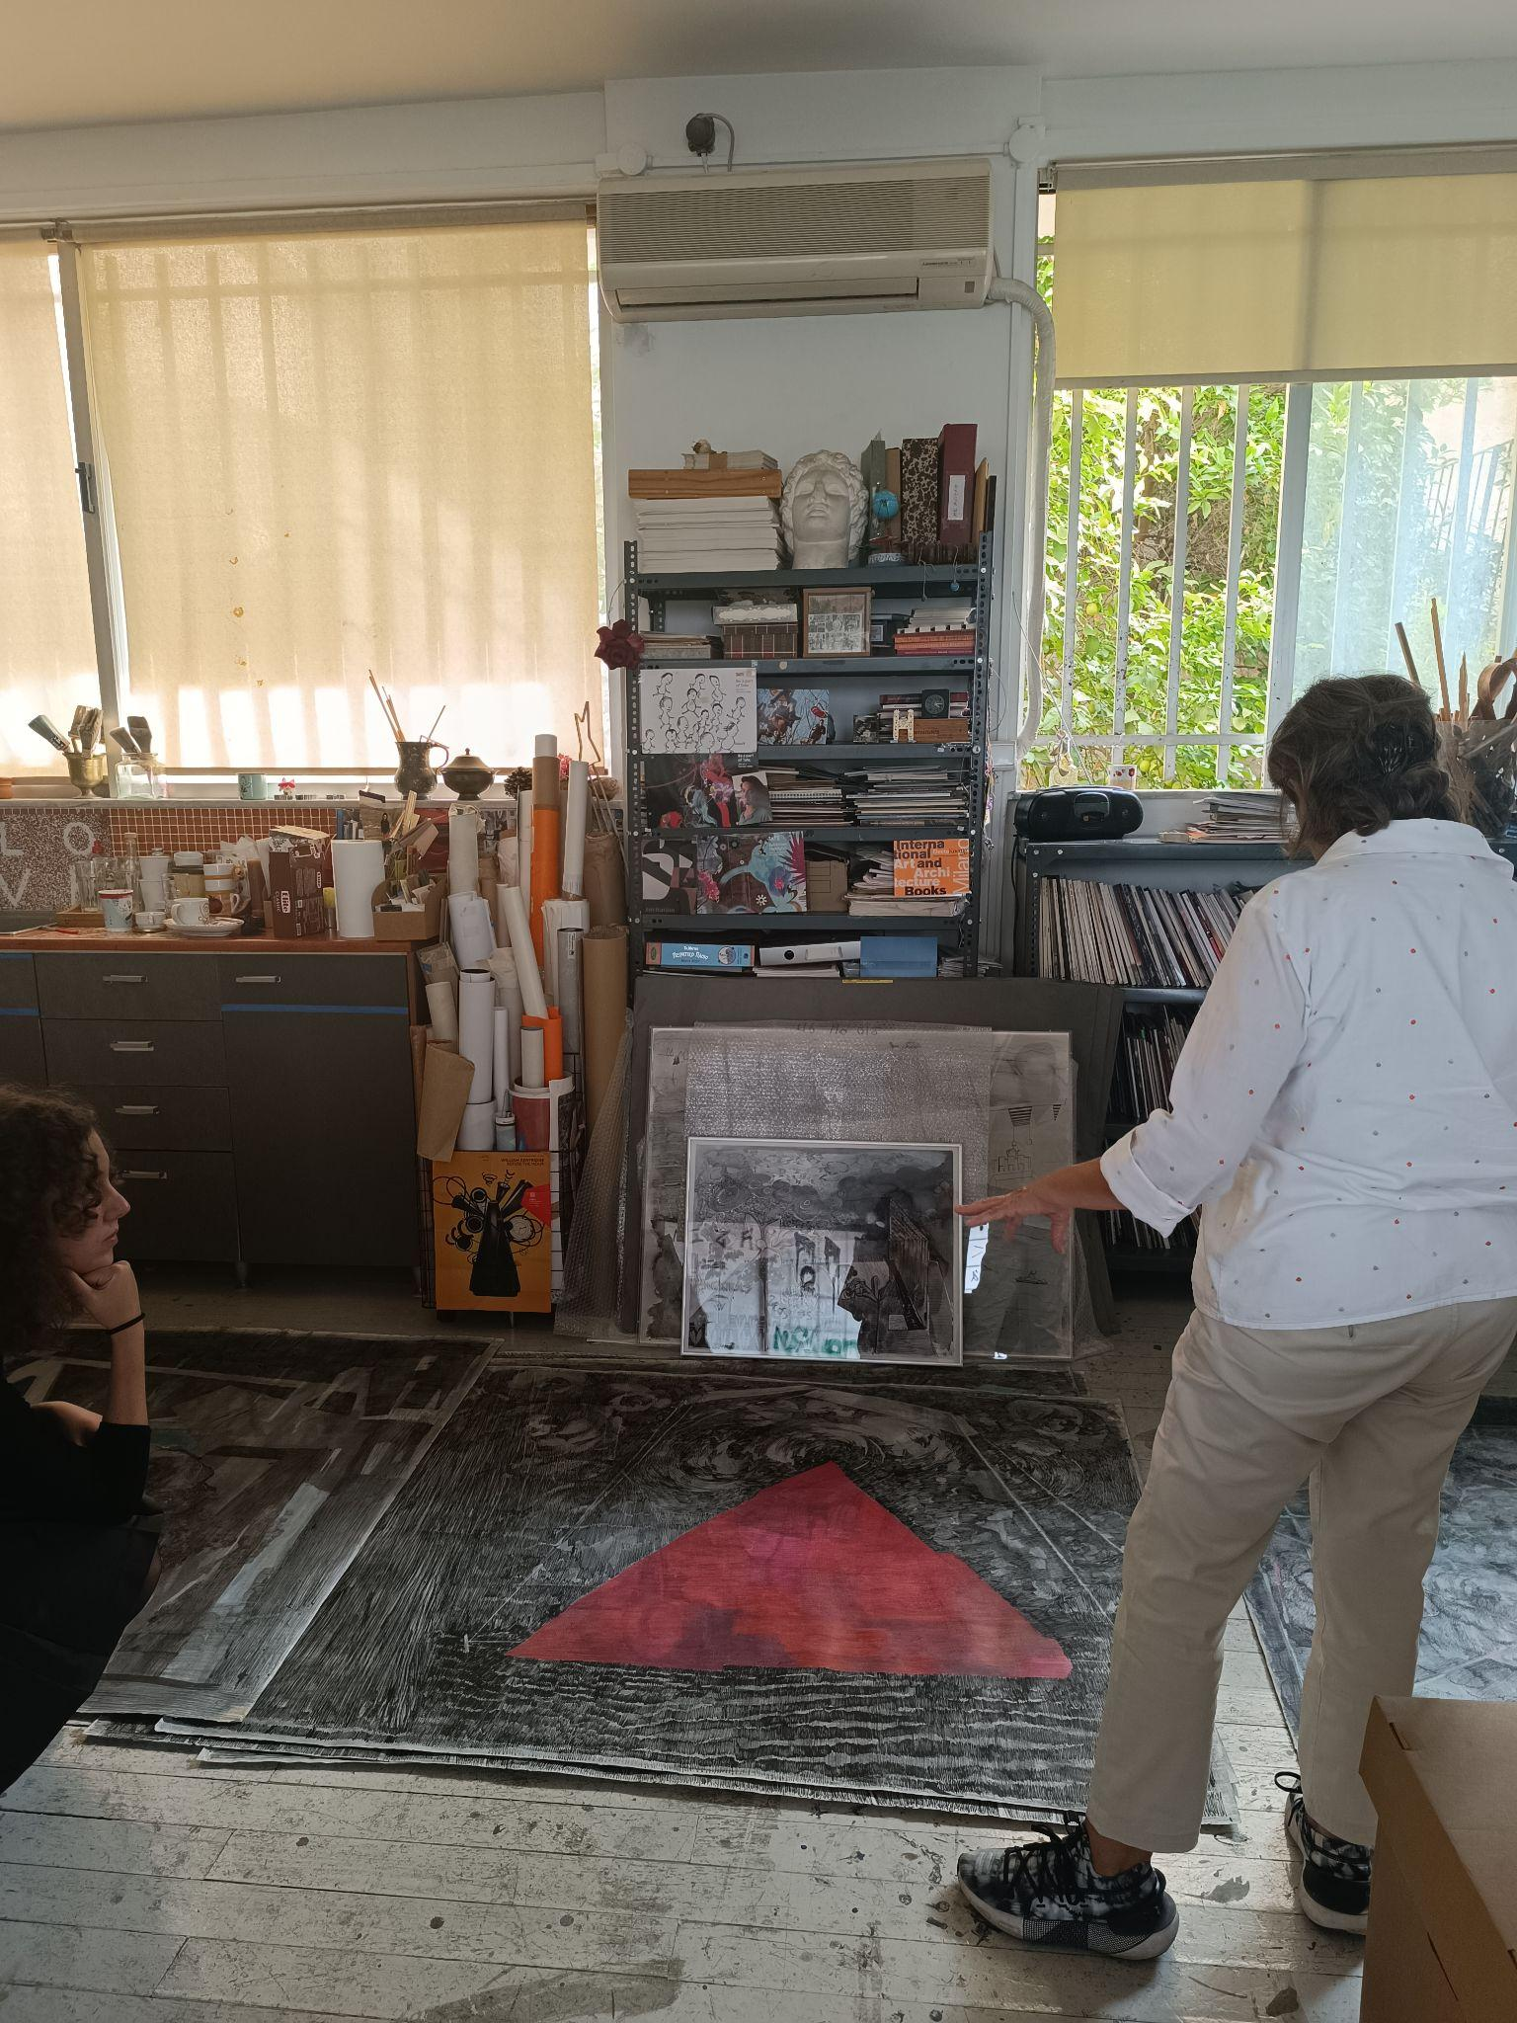
Curator in residence Maria Aleesio with the artist Io Angeli
CONTACT DETAILS
Dora Vasilakou, Collection Manager
residency@felioscollection.gr
info@felioscollection.gr
Collection website
https://felioscollection.gr/en/
Exhibition space website
https://16fokionosnegri.gr/en/
Google Arts & Culture
https://artsandculture.google.com/partner/the-sotiris-felios-collection
Social Media accounts
@felioscollection (Instagram)
@SotirisFeliosCollection (Facebook)

