Press release
Thursday 22 June 2023

THE COURTAULD INSTITUTE OF ART - ‘COURTAULD CONNECTS’
WINS PRESTIGIOUS RIBA NATIONAL AWARD
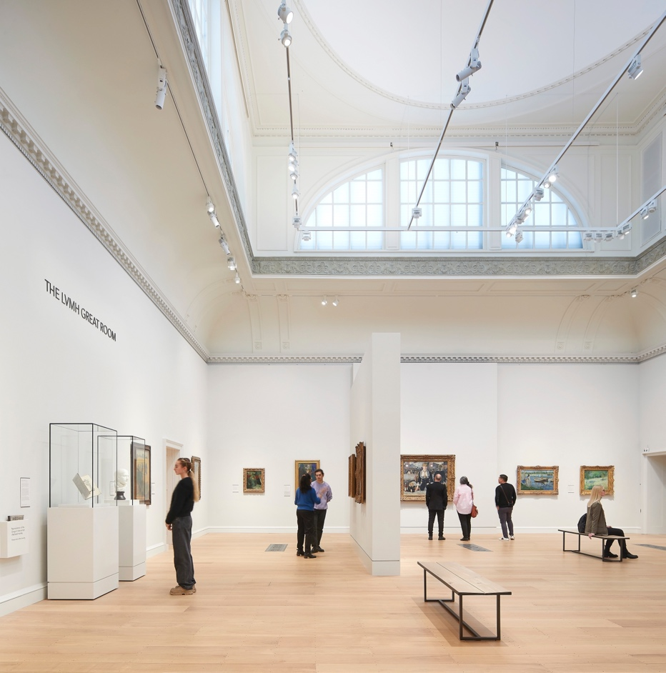
The LVMH Great Room at The Courtauld Gallery. © Hufton+Crow

The Courtauld Institute of Art, located in the North Wing of grade l-listed Somerset House, is amongst the buildings recognised in the 2023 RIBA National Awards, celebrating the best architectural projects of the last 12 months.
Designed by Stirling Prize-winning architects Witherford Watson Mann with gallery design by Nissen Richards Studio, the redevelopment has revitalised and opened up the magnificent building conceived by Sir William Chambers in the late 1770s to create an inspiring setting for the 21st century.
Overall, the Royal Institute of British Architects (RIBA) jury found this “an extremely well-judged project, which lets the spirit of the historic building lead the visitor experience, but uses 21st-century creativity to solve some of its inherent complexities”.
The three-year redevelopment of the Courtauld Gallery was the most significant modernisation project in its history, providing a transformed home for one of the UK’s greatest art collections.
Highlights include the spectacular, newly restored LVMH Great Room, London’s oldest purpose-built exhibition space which is now home to The Courtauld’s world-famous collection of Impressionist and Post-Impressionist art by artists including Cézanne, Degas, Manet, Monet, Van Gogh, and others.
The Blavatnik Fine Rooms, spanning the entire second floor, provide a beautiful setting for works from the Renaissance to the 18th century. New rooms devoted to 20th century art and the Bloomsbury Group showcase lesser-known aspects of the collection, and a new Project Space spotlights temporary projects to connect the public with the institution’s work as a leading centre for the study of art history.
The new Denise Coates Exhibition Galleries on the 3rd Floor have showcased temporary exhibitions since the Gallery reopened, including Modern Drawings: The Karshan Gift; Van Gogh. Self-Portraits; Edvard Munch. Masterpieces from Bergen; Fuseli and the Modern Woman and Peter Doig.
The reopening marked the completion of the first phase of Courtauld Connects, a project to open up the institution both spatially and culturally. Accessibility to the Gallery has been dramatically improved, and new interpretation and display of the artworks has made them more engaging than ever before.
Stephen Witherford, Director of Witherford Watson Mann Architects, said: ‘We hugely appreciate this recognition by the judging panel. If we have done our job well, it is often not obvious to the untrained eye - it can all feel self-evident and seem like nothing much has changed. Yet this project is the outcome of nine years of intense collaboration with client and contractor, with many invisible or very discreet interventions on top of several bolder ones. This is all at the service of a change of culture that is starting to be felt. The Courtauld is certainly the most challenging project that we have realised as a practice to date.’
The Lord Browne of Madingley, Chairman of The Courtauld, said: “The respectful redevelopment by Witherford Watson Mann gives the Collection a great new home. The Gallery is designed to inspire and engage visitors. It is light, practical and beautiful, and affords us a glimpse into the wonder of humankind’s interaction with the world through the prism of art. It is a fitting testament to the centrality of art to the human condition.
Professor Deborah Swallow, Märit Rausing Director of The Courtauld, said: “Witherford Watson Mann have succeeded in realising the potential of this wonderful William Chambers’ building, making it fully accessible by means of strategic architectural interventions and delicate changes – while celebrating the best of its unique features, 18th century proportions and design. They approached our extraordinary Grade 1 listed building, with sensitivity and intelligence giving it and The Courtauld a whole new future. It now works beautifully for our several inter-related purposes - as the home to a great collection which everyone can enjoy, and as set of spaces which inspire study, learning and professional education.”
Ernst Vegelin van Claerbergen, Head of The Courtauld Gallery, said: “One of the central goals of this project was to bring The Courtauld’s great art collection into harmony with William Chambers’s exceptional building, thereby creating an inspiring experience for our visitors. We are delighted that the RIBA judges have recognised the judgement, skill and care with which Witherford Watson Mann responded to this brief.”
The transformation of The Courtauld was supported by £11 million from The National Lottery Heritage Fund and a generous donation of £10 million from philanthropists Sir Leonard and Lady Blavatnik, and the Blavatnik Family Foundation. Additional major support was provided by AKO Foundation, the Deborah Loeb Brice Foundation, The John Browne Charitable Trust, Denise Coates CBE, Crankstart, The Garcia Family Foundation, the Garfield Weston Foundation, Dr Martin and Susanne Halusa, The Linbury Trust, LVMH Moët Hennessy – Louis Vuitton and Oak Foundation. The Courtauld is most grateful to these visionary supporters, alongside others who are making this project and its related activities possible. The collection cared for by the Courtauld Gallery belongs to the Samuel Courtauld Trust.
The Courtauld Gallery
Somerset House, Strand
London WC2R 0RN
Opening hours: 10.00 – 18.00 (last entry 17.15)
Weekday tickets from £9; Weekend tickets from £11
Friends and Under-18s go free. Other concessions available

MEDIA CONTACTS

The Courtauld
www.courtauld.ac.uk/gallery/press
media@courtauld.ac.uk

Bolton & Quinn
Erica Bolton | erica@boltonquinn.com | +44 (0)20 7221 5000
Daisy Taylor | daisy@boltonquinn.com | +44 (0)20 7221 5000

SOCIAL MEDIA
Instagram @Courtauld
Twitter @TheCourtauld
YouTube TheCourtauld
Facebook @TheCourtauld
#TheCourtauld

NOTES TO EDITORS

About The Courtauld
The Courtauld works to advance how we see and understand the visual arts, as an internationally- renowned centre for the teaching and research of art history and a major public gallery. Founded by collectors and philanthropists in 1932, the organisation has been at the forefront of the study of art ever since. through advanced research and conservation practice, innovative teaching, the renowned collection, and inspiring exhibitions of its gallery, and engaging and accessible activities, education, and events.

The Courtauld cares for one of the greatest art collections in the UK, presenting these works to the public in the Courtauld Gallery in central London, as well as through loans and partnerships. The Gallery is most famous for its iconic Impressionist and Post-Impressionist masterpieces – such as Van Gogh’s Self-Portrait with Bandaged Ear and Manet’s A Bar at the Folies-Bergère. It showcases these alongside an internationally renowned collection of works from the Middle Ages and the Renaissance through to the present day.

Academically, The Courtauld faculty is the largest community of art historians and conservators in the UK, teaching and carrying out research on subjects from creativity in late Antiquity to contemporary digital artforms - with an increasingly global focus. An independent college of the University of London, The Courtauld offers a range of degree programmes from BA to PhD in the History of Art, curating and the conservation of easel and wall paintings. Its alumni are leaders and innovators in the arts, culture, and business worlds, helping to shape the global agenda for the arts and creative industries.

Founded on the belief that everyone should have the opportunity to engage with art, The Courtauld works to increase understanding of the role played by art throughout history, in all societies and across all geographies – as well as being a champion for the importance of art in the present day. This could be through exhibitions offering a chance to look closely at world-famous works; events bringing art history research to new audiences; accessible and expert short courses; digital engagement, innovative school, family, and community programmes; or taking a formal qualification. The Courtauld’s ambition is to transform access to art history education by extending the horizons of what this is and ensuring as many people as possible can benefit from the tools to better understand the visual world around us.

The Courtauld is an exempt charity and relies on generous philanthropic support to achieve its mission of advancing the understanding of the visual arts of the past and present across the world through advanced research, innovative teaching, inspiring exhibitions, programmes, and collections.

The collection cared for by the Courtauld Gallery is owned by the Samuel Courtauld Trust.

About Courtauld Connects
Courtauld Connects is an ambitious transformation programme that will make The Courtauld’s world-class artworks, research and teaching accessible to even more people – driving forward our mission to advance how we see and understand the visual arts. The most significant development in the history of The Courtauld since it moved to the North Wing of Somerset House in 1989, the first phase of this visionary project was supported by £11 million from The National Lottery Heritage Fund and generous donations from foundations, individuals, and other supporters.
Phase Two will provide students and faculty with significantly improved study, teaching and research facilities, social and support spaces, and will open up its extensive vaulted library, further increasing access to its collections and exhibitions, whilst giving the public greater insight into its outstanding teaching and research.

