**Colour | Art, Science & Psychology**



**Insights into Art History – online workshop for ages 16-18**

Tuesday 25 October 2022, 10:30-12:30, delivered by Francesca Herrick and Natalie Tilbury

The Courtauld's website – for further info about the gallery and the university:

<https://courtauld.ac.uk/>

**Introduction to artists’ use of colour**

Explore what TATE has to offer on artists, art terms and materials discussed by the group:

<https://www.tate.org.uk/art/art-terms/f/fauvism>

<https://www.tate.org.uk/art/artists/mark-rothko-1875>

<https://www.tate.org.uk/art/artworks/millais-ophelia-n01506>

<https://www.tate.org.uk/art/art-terms/g/gouache>

Who were the Bloomsbury Group?

<https://www.tate.org.uk/art/art-terms/b/bloomsbury/lifestyle-lives-and-legacy-bloomsbury-group>

You can visit Charleston, the home and studio of the painters Vanessa Bell and Duncan Grant in East Sussex: <https://www.charleston.org.uk/>

Find out more about artist Yinka Ilori on his own website:

<https://yinkailori.com/>

Explore what TATE has to offer on Impressionism and Post-Impressionism

<https://www.tate.org.uk/art/art-terms/i/impressionism>

<https://www.tate.org.uk/art/art-terms/p/post-impressionism>

Here is the portrait of Georges Seurat's girlfriend in The Courtauld Gallery collection: <https://artuk.org/discover/artworks/young-woman-powdering-herself-207461>

Further information about artist Georges Seurat:

<https://www.nationalgallery.org.uk/artists/georges-seurat>

Further information on Henri Toulouse-Lautrec: <https://www.metmuseum.org/toah/hd/laut/hd_laut.htm>

Further information on artist Nadine Mahoney: <http://nadinemahoney.com/>

Flourescent pigments: <https://shop.apfitzpatrick.co.uk/fluorescent-pigments-80-c.asp>

You might be interested in these exhibitions & videos of the artists talking about their works:

<https://www.tate.org.uk/art/artists/yayoi-kusama-8094/yayoi-kusamas-obliteration-room>

<https://www.southbankcentre.co.uk/whats-on/art-exhibitions/mixing-it-painting-today?tab=videos>

**Natalie Tilbury – Hospital Rooms**

Natalie studied art history at The Courtauld before pursuing a careers in the arts. She is currently working as Chief Operating Officer (COO) at Hospital Rooms, an arts and mental health charity that commissions extraordinary artworks for NHS mental health inpatient units across the UK.

Further information about Hospital Rooms:

<https://hospital-rooms.com/>

<https://hospital-rooms.com/digital-art-school> (you can watch their colour workshop here)

<https://hospital-rooms.com/our-projects>

<https://artsandculture.google.com/story/secret-gardens-mental-health-and-painting-gardens-hospital-rooms/XAVh60ni66Lq6g?hl=en>

A painting that inspired Natalie:

<https://www.nationalgallery.org.uk/paintings/sassoferrato-the-virgin-in-prayer>

**Here are some of the artists Natalie has worked with on Hospital Rooms projects:**

Sonia Boyce <https://www.tate.org.uk/art/artists/sonia-boyce-obe-794>

Julian Opie <https://www.julianopie.com/>

Nicola Bealing <http://www.nicolabealing.co.uk/>

Anna Barriball <https://www.tate.org.uk/art/artists/anna-barriball-10168>

Harold Offeh <https://www.haroldoffeh.com/>

Sophie Clements <http://www.sophieclements.com/>

Ryan Mosley

<https://joshlilleygallery.com/artists/ryan-mosley>

<https://www.audubon.org/birds-of-america>

Charley Peters <https://charleypeters.com/>

Sara Berman <http://www.sarabermanartist.com/>

**Introduction to Colour Theory** – led by Francesca Herrick

Further information on The Bauhaus:

<https://www.tate.org.uk/art/art-terms/b/bauhaus>

<https://www.metmuseum.org/toah/hd/bauh/hd_bauh.htm>

<https://www.bauhaus-dessau.de/en/index.html>

<https://www.tate.org.uk/art/artists/wassily-kandinsky-1382>

<https://www.getty.edu/research/exhibitions_events/exhibitions/bauhaus/new_artist/form_color/color/>

Further information on Joseph Albers’ colour theory:

<https://www.tate.org.uk/art/art-terms/c/complementary-colours>

<https://www.amazon.co.uk/Interaction-Color-Complete-Josef-Albers/dp/0300179359>

Contemporary artist using chromo saturation:

<http://www.cruz-diez.com/news/past-events/news-2013/cruz-diez-at-the-hayward-gallery.html>

Olafur Eliasson's 'Room for one colour' at the National Gallery: <https://www.youtube.com/watch?v=hd077pa-5CI>

Indigo: What can one colour tell us about a painting? | National Gallery

<https://www.youtube.com/watch?v=sDQ6p9M9gdU>

**Practical oil and tempera painting demonstration**

Led by Francesca Herrick

**Materials for making colourful paints and dyes at home**

One of the following as a **binding agent**:

* 2 eggs
* 50ml walnut oil
* 50ml linseed oil

Any of the following as a **pigment/dye** (please wear a dusk mask whilst grinding pigments):

* charcoal or scrapings from burnt toast
* coffee granules
* paprika
* turmeric
* cooked blue berries (heat in a pan adding a little water),
* cooked beetroot (or any other food item that could provide colour)
* boil an avocado stone to get a pink/orange dye (place it in a saucepan whole with a little water)
* eye shadow / powdered makeup (you can use old expired makeup)

**Essential equipment:**

* a few cups and tea spoons for mixing
* a knife (sharp enough to pierce an egg yolk)
* a glass of water
* a plate or palette
* a paint brush
* plain paper
* paper towel
* a dust mask to wear whilst grinding pigments

**If available:**

* a pestle and mortar or something similar for grinding pigments
* turpentine (to thin oil based paints – use in a well ventilated area)
* watercolours (extra option)

Links to where you can buy earth pigments:

<https://shop.apfitzpatrick.co.uk/earth-pigments-71-c.asp>

<https://www.cornelissen.com/>

Please email [education@courtauld.ac.uk](mailto:education@courtauld.ac.uk) if you took part in this workshop

and would us to email a PDF version of the images we discussed.

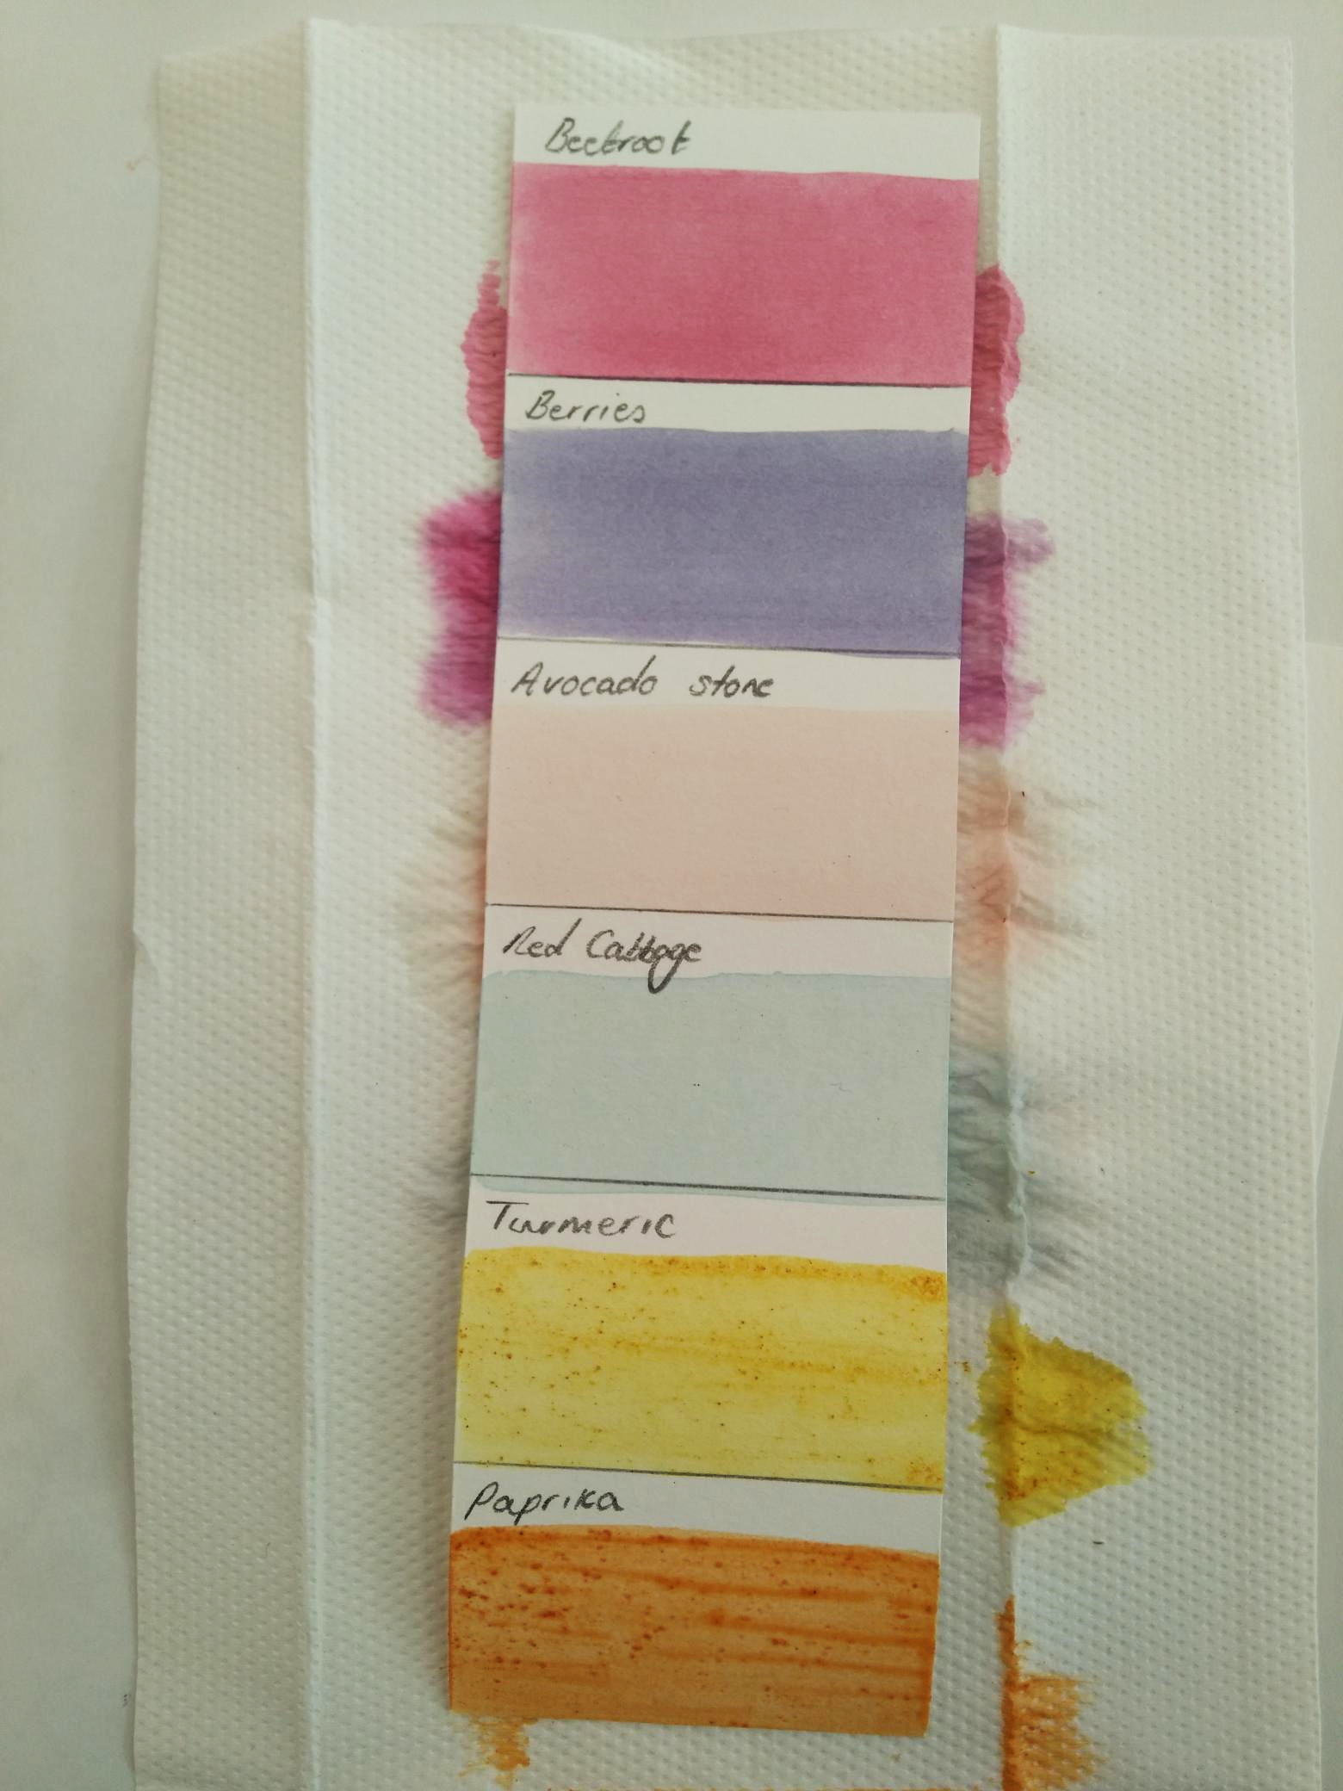

Fran demonstrating domestic dyes and pigments

during our online workshop on 25/10/22.

Photo © Francesca Herrick, 2022