Press Release
22 August 2022

LOST PAINTING BY BRITAIN’S LEADING FEMALE ABSTRACT ARTIST
REDISCOVERED BY STUDENTS AT THE COURTAULD
A Modern Masterpiece Uncovered: Wyndham Lewis, Helen Saunders and Praxitella

New display at The Courtauld Gallery
14 October 2022 – 12 February 2023

DOWNLOAD IMAGES - we.tl/t-LIZqib099y

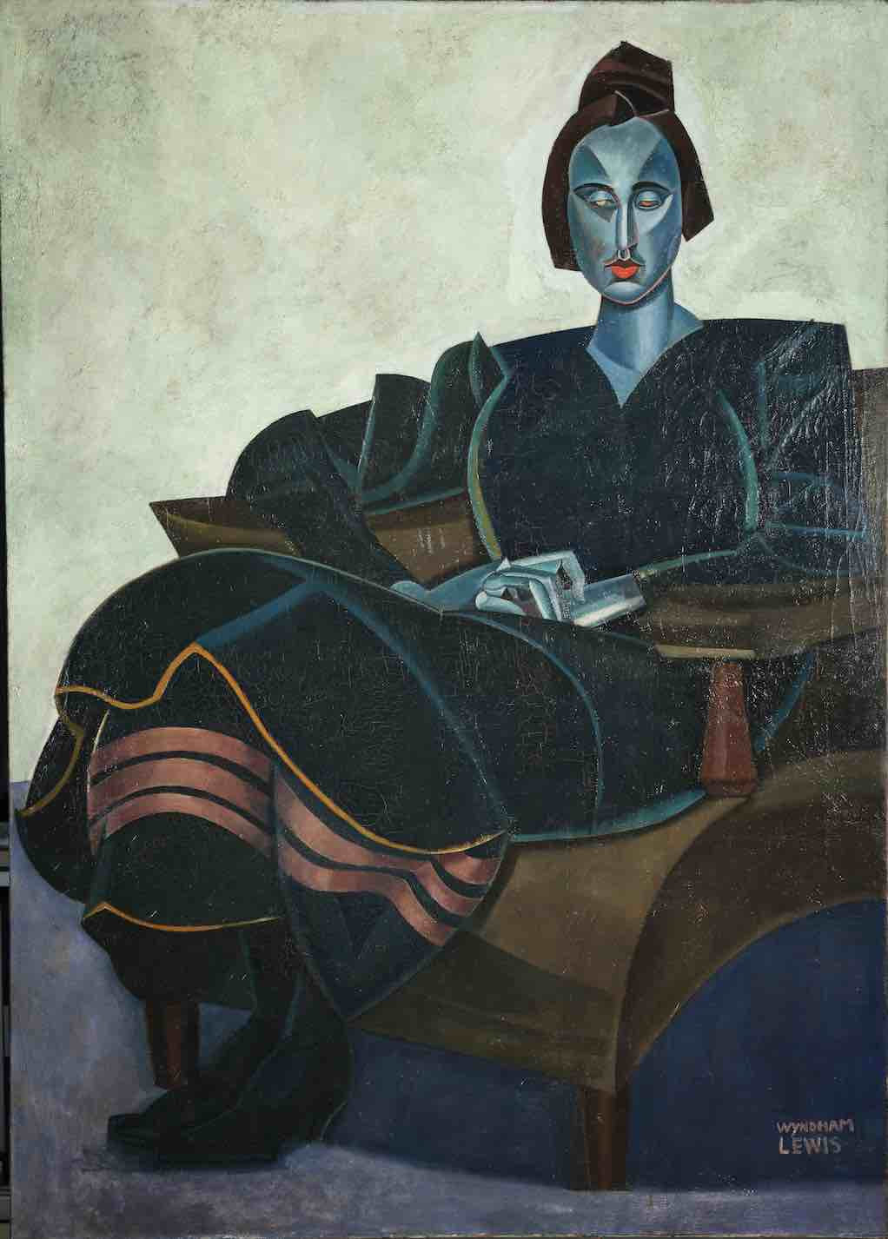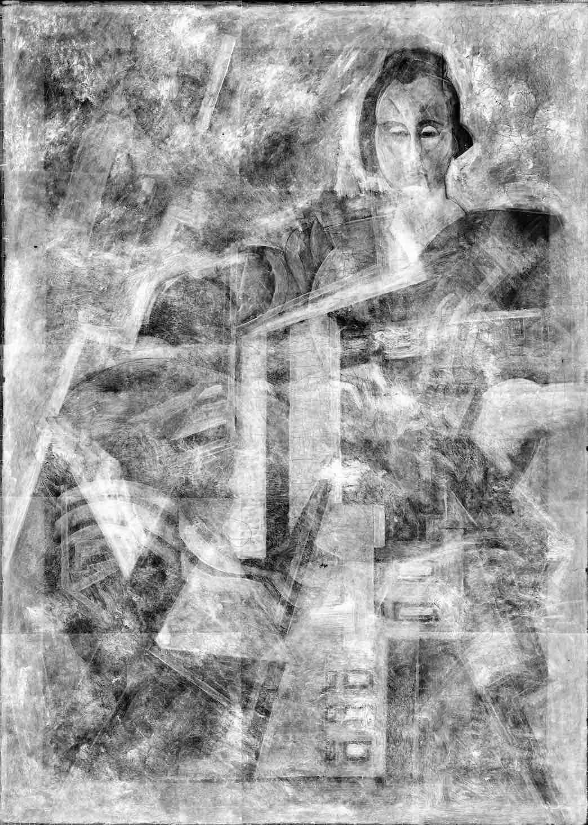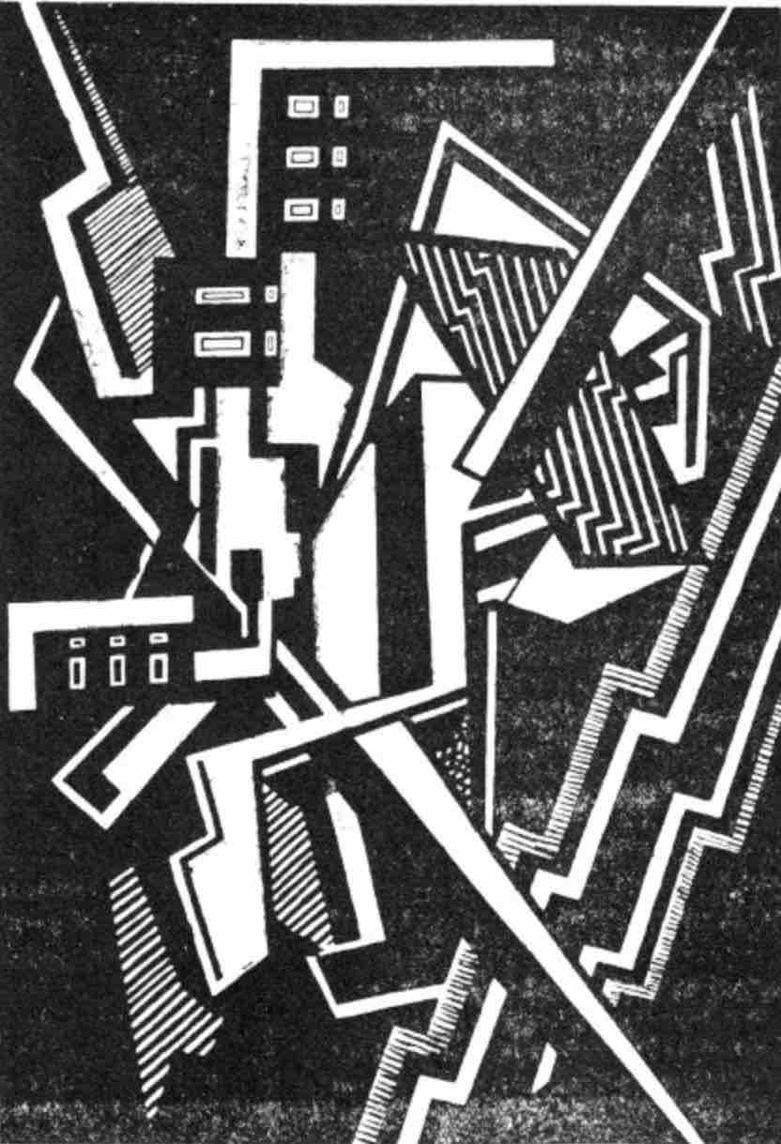

Two students at The Courtauld have rediscovered an important lost masterpiece by one of the early 20th century’s most radical female abstract artists, Helen Saunders (1885-1963) hidden beneath a portrait by the modernist artist Wyndham Lewis (1882 – 1957).

The students were investigating the painting Praxitella (1921) by Wyndham Lewis, one of the highlights of the collection of Leeds Art Gallery, as part of a research project at The Courtauld’s Department of Conservation in 2019. The painting depicts a portrait of pioneering film critic and curator Iris Barry. Scholars have previously suspected that Lewis painted over an earlier composition, as the surface of the painting has an uneven texture and forms lurking underneath, as well as different colours visible through cracks in the paint layers.
X-rays uncovered an ambitious abstract composition totally different from the style of Lewis’ portrait. The students identified the work underneath as a painting not by Lewis but by his friend and colleague Helen Saunders - a fellow member of the radical, short-lived British Vorticist group who was known to have fallen out with him.
The rediscovered work is thought to be Saunders’ lost painting Atlantic City, which depicts a fragmented modern metropolis, painted around 1915. The former students, Rebecca Chipkin and Helen Kohn, made the discovery during a six-month technical analysis of Praxitella where they painstakingly analysed X-rays of the huge canvas, examining the painting’s chemical composition using high-resolution scanning equipment. It was only after they spotted a reproduced image of Atlantic City in Blast, the avant-garde journal of the Vorticist movement, that they identified the artwork beneath Wyndham Lewis’ painting.
All of Saunders’ Vorticist paintings were thought to be lost before now. It is hoped the rediscovery of this major work will spark greater interest in her work and the work of other female painters, whose work has historically been overshadowed by their male contemporaries.

Why Lewis painted over Atlantic City in 1921 is unknown. He may have been turning his back on Vorticism in favour of a new figurative approach. He may have not been able to afford a new canvas. Or his erasure of one of Saunders’ most important paintings may have been the result of the pair’s estrangement in 1919, which caused emotional distress for Saunders.

“We realised that when we turned the image of Atlantic City upside down, it had striking similarities with the composition seen in our X-rays of Praxitella,” Chipkin said.
“We were just flabbergasted. It’s taken nearly a hundred years to rediscover Atlantic City. We hope our findings will spark more interest in Saunders’ work and the work of other female Vorticist painters, who are overshadowed by male Vorticists, such as Wyndham Lewis. It also gives hope that there are other hidden Vorticist paintings waiting to be found.”

A new display in The Courtauld's Project Space will present Lewis’ Praxitella alongside the x-ray and partial colour reconstruction of Atlantic City, as well as a range of technical material to tell the story of this remarkable discovery.

To coincide, The Courtauld’s Drawings Gallery will stage the first exhibition in over 25 years of Helen Saunders featuring a major group of 18 of her drawings, generously presented to The Courtauld in 2016 by the artist’s relation Brigid Peppin. Thanks to this gift, The Courtauld holds the largest public collection of the artist’s work.
THE COURTAULD
Somerset House, Strand, London WC2R 0RN
www.courtauld.ac.uk

SOCIAL MEDIA
Instagram @Courtauld
Twitter @TheCourtauld
YouTube CourtauldInstitute
Facebook @TheCourtauld
#TheCourtauld #courtauldconnects

Notes to Editors

The Courtauld
The Courtauld’s Department of Conservation is one of the very few specialist centres for the training and research in fine art conservation and technical art history and dates back to the mid-1930s.
The Courtauld works to advance how we see and understand the visual arts, as an internationally-renowned centre for the teaching and research of art history and a major public gallery. Founded by collectors and philanthropists in 1932, the organisation has been at the forefront of the study of art ever since through advanced research and conservation practice, innovative teaching, the renowned collection and inspiring exhibitions of its gallery, and engaging and accessible activities, education and events.
The Courtauld cares for one of the greatest art collections in the UK, presenting these works to the public at The Courtauld Gallery in central London, as well as through loans and partnerships. The Gallery is most famous for its iconic Impressionist and Post-Impressionist masterpieces – such as Van Gogh’s Self-Portrait with Bandaged Ear and Manet’s A Bar at the Folies-Bergère. It showcases these alongside an internationally renowned collection of works from the Middle Ages and the Renaissance through to the present day.
Academically, The Courtauld faculty is the largest community of art historians and conservators in the UK, teaching and carrying out research on subjects from creativity in late Antiquity to contemporary digital artforms - with an increasingly global focus. An independent college of the University of London, The Courtauld offers a range of degree programmes from BA to PhD in the History of Art, curating and the conservation of easel and wall paintings. Its alumni are leaders and innovators in the arts, culture and business worlds, helping to shape the global agenda for the arts and creative industries.
Founded on the belief that everyone should have the opportunity to engage with art, The Courtauld works to increase understanding of the role played by art throughout history, in all societies and across all geographies – as well as being a champion for the importance of art in the present day. This could be through exhibitions offering a chance to look closely at world-famous works; events bringing art history research to new audiences; accessible and expert short courses; digital engagement, innovative school, family and community programmes; or taking a formal qualification. The Courtauld’s ambition is to transform access to art history education by extending the horizons of what this is, and ensuring as many people as possible can benefit from the tools to better understand the visual world around us.
The Courtauld is an exempt charity and relies on generous philanthropic support to achieve its mission of advancing the understanding of the visual arts of the past and present across the world through advanced research, innovative teaching, inspiring exhibitions, programmes and collections.
The collection cared for by The Courtauld Gallery is owned by the Samuel Courtauld Trust.

Leeds Art Gallery
First opening its doors to the public in 1888 Leeds Art Gallery is now part of Leeds Museums and Galleries and is generally held to have one of the most significant civic collections of 20th century British Art outside the capital. Wyndham Lewis’s Praxitella has been in the collection since 1945, when it was given via the Contemporary Society by artist Edward Wadsworth, also at one point a Vorticist. Leeds Art Gallery is planning an exhibition about the painting and how these new discoveries impact our understanding of it from May 2023

