Press Release
Tuesday 9 August 2022

HELEN SAUNDERS

BRITAIN’S TRAILBLAZING FEMALE ABSTRACT ARTIST
REDISCOVERED IN NEW EXHIBITION
AT THE COURTAULD

Helen Saunders: Modernist Rebel
14 October 2022 – 29 January 2023

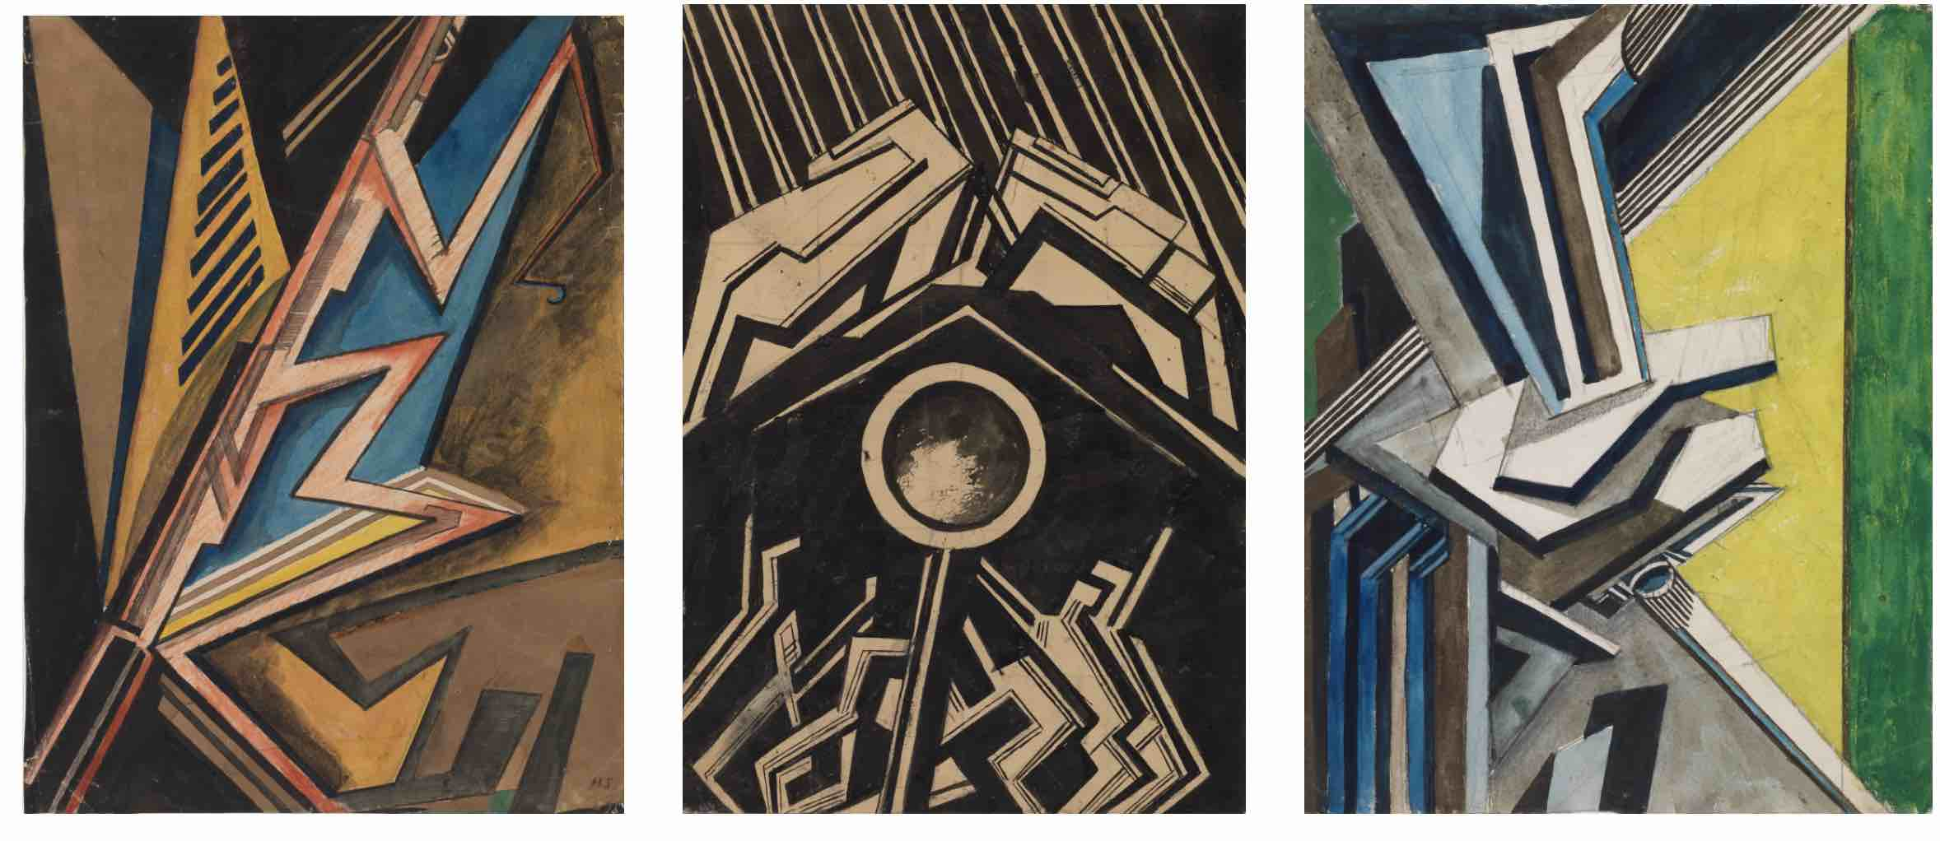
From left to right: Vorticist composition (Black and Khaki) (c.1915), Vorticist composition with Figures, Black and White (c.1915), Vorticist composition, Blue and Green (c.1915). The Courtauld, London (Samuel Courtauld Trust) © Estate of Helen Saunders
To download high-resolution images: https://bit.ly/3oPzVWm

Pioneering artist Helen Saunders (1885 – 1963), one of the first British artists to pursue Abstraction whose work fell into obscurity for years, will be celebrated in a new exhibition in the Gilbert and Ildiko Butler Drawings Gallery at The Courtauld this autumn (opening 14 October 2022).

Helen Saunders was one of only two women to join the Vorticists, a radical but short-lived artistic movement that emerged in London on the eve of the First World War, whose members included Wyndham Lewis and Ezra Pound. Her extraordinary drawings, which reveal her gifts as a colourist and knack for complex literary allusion, captured the dynamism of modern urban life and the horrors of mechanised warfare. In the years that followed the war she turned her back on Vorticism, pursuing her own path and working in a more figurative style.

Due in part to Vorticism’s post-war fall from favour and to the minimising of her contributions, often by other male Vorticists, as well as the loss of almost all her paintings, Saunders fell into obscurity. Only in recent years has her work begun to be rediscovered and recognised as a vital piece in the story of British modern art.

Helen Saunders: Modernist Rebel will be the first monographic exhibition devoted to Helen Saunders in over 25 years. It will showcase a remarkable group of 18 of the artist’s drawings and watercolours, gifted in 2016 by her relative Brigid Peppin, which has transformed The Courtauld into the largest public collection of Saunders’s work in the world.
The drawings trace her artistic development, from glimpses into her early period as an artist in the orbit of Roger Fry and the Bloomsbury Group, to a landmark group of six drawings from her Vorticist period, as well as landscapes created in L’Estaque in the south of France in the 1920s which reveal Saunders response to her environment and to the art of predecessors who had worked there earlier such as Paul Cézanne and Georges Braque.

The exhibition will be presented in The Gilbert & Ildiko Butler Drawings Gallery at The Courtauld from 14 October 2022 – 29 January 2023. It is accompanied by an illustrated catalogue.

Helen Saunders: Modernist Rebel
14 October 2022 – 29 January 2023
The Gilbert & Ildiko Butler Drawings Gallery
Opening Hours: 10.00 – 18.00 (last entry 17.15)
Entry to this display is included in The Courtauld Gallery admission ticket: Weekday £9 / Weekend £11
Friends and Under-18s go free
The Courtauld Gallery
Somerset House, Strand
London WC2R 0RN
MEDIA CONTACTS
The Courtauld
www.courtauld.ac.uk/gallery/press
media@courtauld.ac.uk

Bolton & Quinn
Erica Bolton | erica@boltonquinn.com | +44 (0)20 7221 5000
Daisy Taylor | daisy@boltonquinn.com | +44 (0)20 7221 5000
THE COURTAULD
Somerset House, Strand, London WC2R 0RN
www.courtauld.ac.uk
SOCIAL MEDIA
Instagram @Courtauld
Twitter @TheCourtauld
YouTube CourtauldInstitute
Facebook @TheCourtauld #TheCourtauld
NOTES TO EDITORS
About The Courtauld
The Courtauld works to advance how we see and understand the visual arts, as an internationally- renowned centre for the teaching and research of art history and a major public gallery. Founded by collectors and philanthropists in 1932, the organisation has been at the forefront of the study of art ever since. through advanced research and conservation practice, innovative teaching, the renowned collection and inspiring exhibitions of its gallery, and engaging and accessible activities, education and events.

The Courtauld cares for one of the greatest art collections in the UK, presenting these works to the public at The Courtauld Gallery in central London, as well as through loans and partnerships. The Gallery is most famous for its iconic Impressionist and Post-Impressionist masterpieces – such as Van Gogh’s Self-Portrait with Bandaged Ear and Manet’s A Bar at the Folies-Bergère. It showcases these alongside an internationally renowned collection of works from the Middle Ages and the Renaissance through to the present day.

Academically, The Courtauld faculty is the largest community of art historians and conservators in the UK, teaching and carrying out research on subjects from creativity in late Antiquity to contemporary digital artforms - with an increasingly global focus. An independent college of the University of London, The Courtauld offers a range of degree programmes from BA to PhD in the History of Art, curating and the conservation of easel and wall paintings. Its alumni are leaders and innovators in the arts, culture and business worlds, helping to shape the global agenda for the arts and creative industries.

Founded on the belief that everyone should have the opportunity to engage with art, The Courtauld works to increase understanding of the role played by art throughout history, in all societies and across all geographies – as well as being a champion for the importance of art in the present day. This could be through exhibitions offering a chance to look closely at world-famous works; events bringing art history research to new audiences; accessible and expert short courses; digital engagement, innovative school, family and community programmes; or taking a formal qualification. The Courtauld’s ambition is to transform access to art history education by extending the horizons of what this is and ensuring as many people as possible can benefit from the tools to better understand the visual world around us.

The Courtauld is an exempt charity and relies on generous philanthropic support to achieve its mission of advancing the understanding of the visual arts of the past and present across the world through advanced research, innovative teaching, inspiring exhibitions, programmes and collections.

The collection cared for by The Courtauld Gallery is owned by the Samuel Courtauld Trust.

