Edvard Munch: Masterpieces from Bergen

The Courtauld Gallery, London: 27 May - 4 September 2022

Protection under the under Part 6 of the Tribunals, Courts and Enforcement Act 2007 is sought for the objects listed below:

XMB.001  Artist: Edvard Munch (1863 - 1944)  Summer Night. Inger on the Beach  1889  Height: 124 cm; Width: 162 cm  Frame size: 138.8 x 173.5 x 8 cm  Lender’s name and address:  KODE Art Museums and Composer Homes  Vestre Strømkaien 7  N-5008 Bergen  NORWAY  Lender Number: RMS.M.00240  Provenance: Erik Werenskiold 1889; Rasmus Meyer 1909; Gerda Nyqvist and Finn Koller Meyer 1916; City of Bergen (donation) 1916  This object has a complete history of ownership for the period 1933-45. | 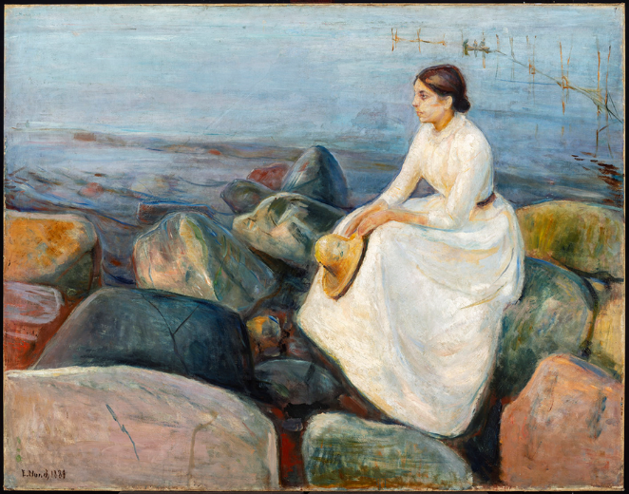
XMB.002

Artist: Edvard Munch (1863 - 1944)

Morning
1884
Height: 96 cm; Width: 104 cm
Frame size: 115 x 124.1 x 8 cm

Lender’s name and address:
KODE Art Museums and Composer Homes
Vestre Strømkaien 7
N-5008 Bergen
NORWAY

Lender Number: RMS.M.00236

Provenance: Frits Thaulow 1884; Alexandra Thaulow 1906; Rasmus Meyer 1907/08; Gerda Nyqvist and Finn Koller Meyer 1916; City of Bergen (donation) 1916

This object has a complete history of ownership for the period 1933-45.

XMB.003

Artist: Edvard Munch (1863 - 1944)

Inger in Sunshine
1888
Height: 73 cm; Width: 46 cm
Frame size: 85.4 x 58.8 x 6.5 cm

Lender’s name and address:
KODE Art Museums and Composer Homes
Vestre Strømkaien 7
N-5008 Bergen
NORWAY

Lender Number: RMS.M.00239

Provenance: Hans Jæger; K.V. Hammer, before 1894; Rasmus Meyer; Gerda Nyqvist and Finn Koller Meyer 1916; City of Bergen (donation) 1916

This object has a complete history of ownership for the period 1933-45.
XMB.004  Artist: Edvard Munch (1863 - 1944)  Moonlight on the Shore  1892  Height: 63 cm; Width: 97 cm  Frame size: 73.7 x 106 x 7.7 cm  Lender’s name and address:  KODE Art Museums and Composer Homes  Vestre Strømkaien 7  N-5008 Bergen  NORWAY  Lender Number: RMS.M.00248  Provenance: Rasmus Meyer 1908 or 1910; Gerda Nyqvist and Finn Koller Meyer 1916; City of Bergen (donation) 1916  This object has a complete history of ownership for the period 1933-45. | 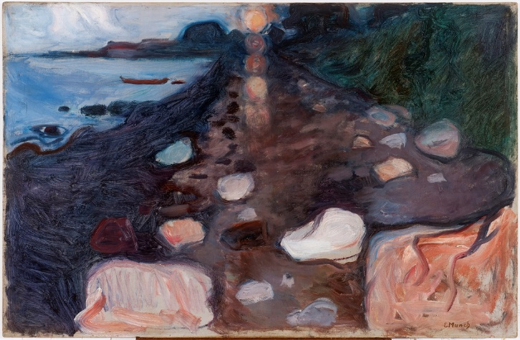
XMB.005  Artist: Edvard Munch (1863 - 1944)  Evening on Karl Johan  1892  Height: 83 cm; Width: 120 cm  Frame size: 104.7 x 142 x 9.1 cm  Lender’s name and address:  KODE Art Museums and Composer Homes  Vestre Strømkaien 7  N-5008 Bergen  NORWAY  Lender Number: RMS.M.00245  Provenance: Rasmus Meyer 1909; Gerda Nyqvist and Finn Koller Meyer 1916; City of Bergen (donation) 1916  This object has a complete history of ownership for the period 1933-45. | 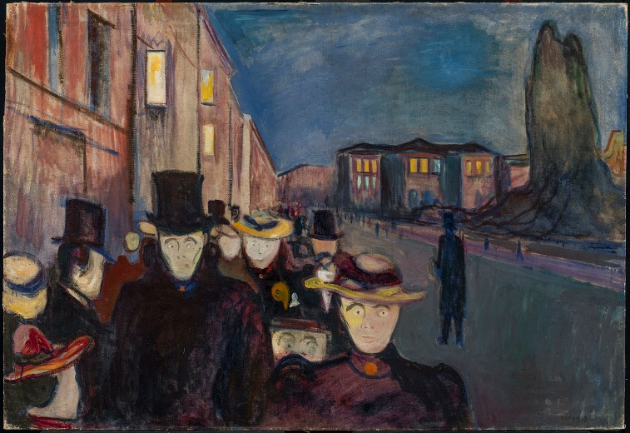
XMB.006  Artist: Edvard Munch (1863 - 1944)  House in Moonlight  1893  Height: 71 cm; Width: 96 cm  Frame size: 81.2 x 107 x 7.2 cm  Lender’s name and address:  KODE Art Museums and Composer Homes  Vestre Strømkaien 7  N-5008 Bergen  NORWAY  Lender Number: RMS.M.00250  Provenance: Rasmus Meyer 1910; Gerda Nyqvist and Finn Koller Meyer 1916; City of Bergen (donation) 1916  This object has a complete history of ownership for the period 1933-45. | 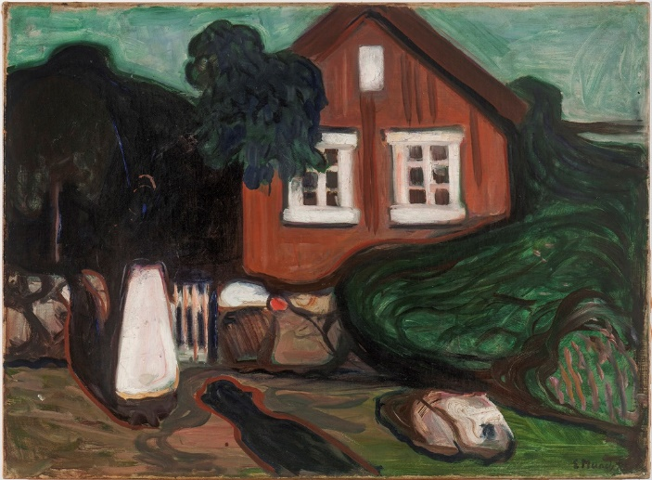
XMB.007  Artist: Edvard Munch (1863 - 1944)  Melancholy  1894 - 1896  Height: 80 cm; Width: 100 cm  Frame size: 91 x 110 x 7 cm  Lender’s name and address:  KODE Art Museums and Composer Homes  Vestre Strømkaien 7  N-5008 Bergen  NORWAY  Lender Number: RMS.M.00249  Provenance: Rasmus Meyer 1909; Gerda Nyqvist and Finn Koller Meyer 1916; City of Bergen (donation) 1916  This object has a complete history of ownership for the period 1933-45. | 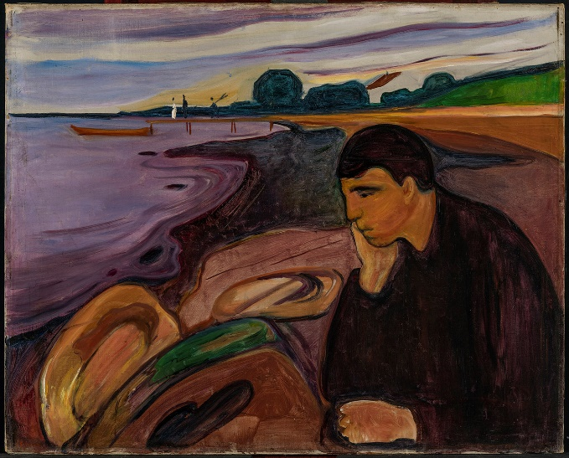
XMB.008  Artist: Edvard Munch (1863 - 1944)  Woman  1894  Height: 165 cm; Width: 251 cm  Frame size: 177.6 x 264.5 x 10 cm  Lender’s name and address:  KODE Art Museums and Composer Homes  Vestre Strømkaien 7  N-5008 Bergen  NORWAY  Lender Number: RMS.M.00252  Provenance: Rasmus Meyer 1909; Gerda Nyqvist and Finn Koller Meyer 1916; City of Bergen (donation) 1916  This object has a complete history of ownership for the period 1933-45. | 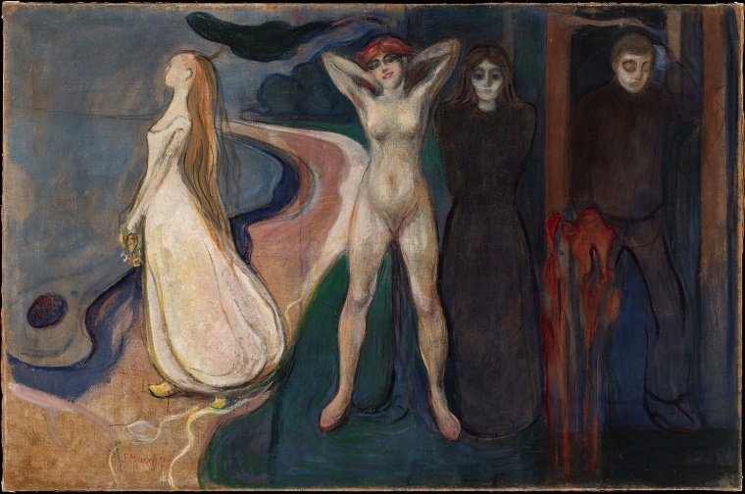
XMB.009  Artist: Edvard Munch (1863 - 1944)  At the Death Bed  1895  Height: 90 cm; Width: 121 cm  Frame size: 111 x 141.5 x 9 cm  Lender’s name and address:  KODE Art Museums and Composer Homes  Vestre Strømkaien 7  N-5008 Bergen  NORWAY  Lender Number: RMS.M.00251  Provenance: Rasmus Meyer 1909; Gerda Nyqvist and Finn Koller Meyer 1916; City of Bergen (donation) 1916  This object has a complete history of ownership for the period 1933-45. | 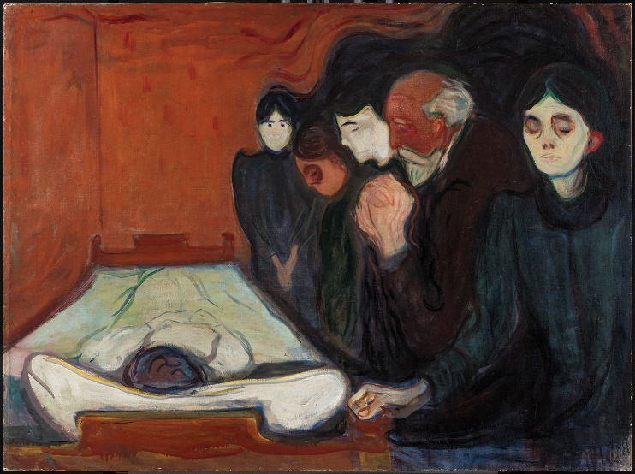
XMB.010  Artist: Edvard Munch (1863 - 1944)  Portrait of Mrs Holmboe  1898  Height: 114 cm; Width: 112 cm  Frame size: 126.9 x 123.1 x 6 cm  Lender’s name and address:  KODE Art Museums and Composer Homes  Vestre Strømkaien 7  N-5008 Bergen  NORWAY  Lender Number: RMS.M.00254  Provenance: Rasmus Meyer 1910; Gerda Nyqvist and Finn Koller Meyer 1916; City of Bergen (donation) 1916  This object has a complete history of ownership for the period 1933-45. | 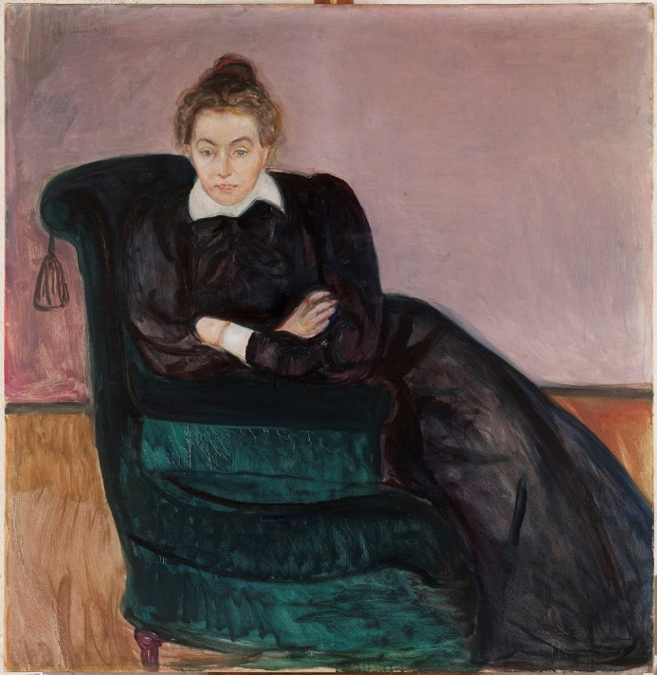
XMB.011  Artist: Edvard Munch (1863 - 1944)  Man and Woman  1898  Height: 61 cm; Width: 100 cm  Frame size: 82 x 122.2 x 11 cm  Lender’s name and address:  KODE Art Museums and Composer Homes  Vestre Strømkaien 7  N-5008 Bergen  NORWAY  Lender Number: RMS.M.00255  Provenance: Rasmus Meyer 1908?; Gerda Nyqvist and Finn Koller Meyer 1916; City of Bergen (donation) 1916  This object has a complete history of ownership for the period 1933-45. | 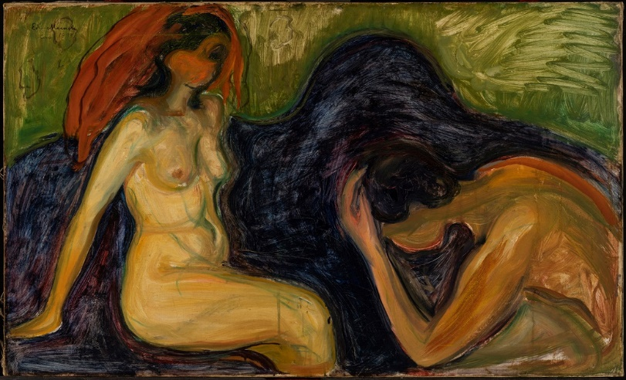
XMB.012  Artist: Edvard Munch (1863 - 1944)  Nude  1898  Height: 92 cm; Width: 75 cm  Frame size: 114.5 x 97 x 8.4 cm  Lender’s name and address:  KODE Art Museums and Composer Homes  Vestre Strømkaien 7  N-5008 Bergen  NORWAY  Lender Number: RMS.M.00256  Provenance: Rasmus Meyer 1910; Gerda Nyqvist and Finn Koller Meyer 1916; City of Bergen (donation) 1916  This object has a complete history of ownership for the period 1933-45. | 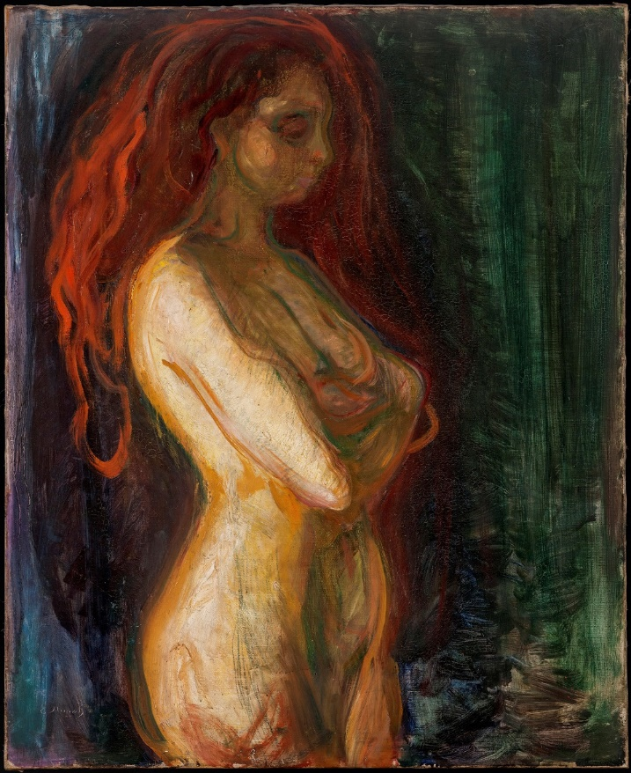
XMB.013  Artist: Edvard Munch (1863 - 1944)  Street in Asgardstrand  1901 - 1903  Height: 75 cm; Width: 89 cm  Frame size: 85.6 x 100 x 7.5 cm  Lender’s name and address:  KODE Art Museums and Composer Homes  Vestre Strømkaien 7  N-5008 Bergen  NORWAY  Lender Number: RMS.M.00258  Provenance: Rasmus Meyer 1909; Gerda Nyqvist and Finn Koller Meyer 1916; City of Bergen (donation) 1916  This object has a complete history of ownership for the period 1933-45. | 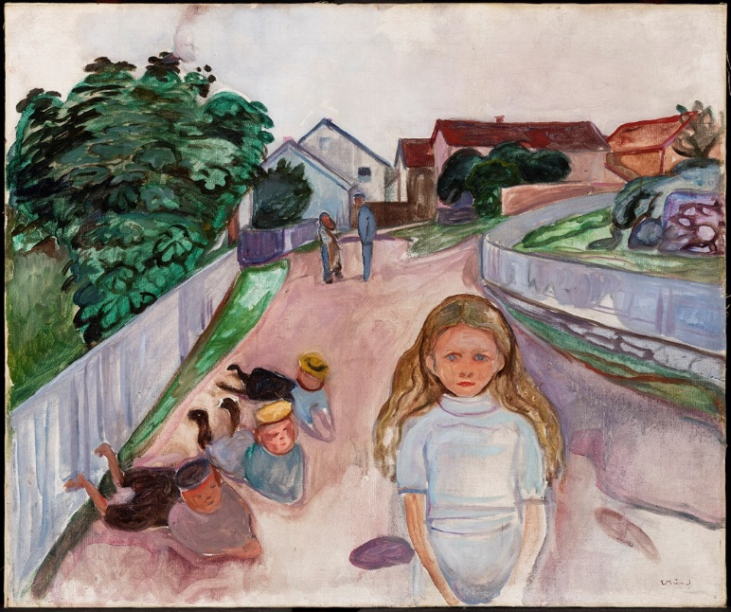
XMB.014  Artist: Edvard Munch (1863 - 1944)  Four Stages of Life  1902  Height: 130 cm; Width: 100 cm  Frame size: 140.6 x 110 x 7.1 cm  Lender’s name and address:  KODE Art Museums and Composer Homes  Vestre Strømkaien 7  N-5008 Bergen  NORWAY  Lender Number: RMS.M.00257  Provenance: Rasmus Meyer 1910; Gerda Nyqvist and Finn Koller Meyer 1916; City of Bergen (donation) 1916  This object has a complete history of ownership for the period 1933-45. | 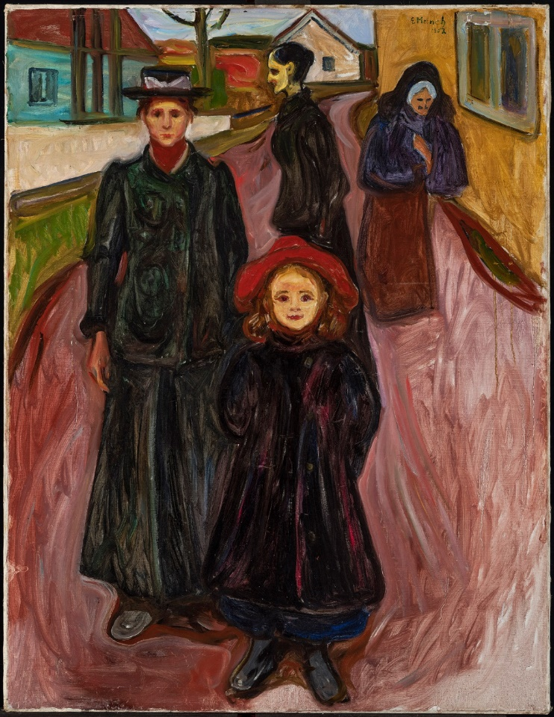
XMB.015  Artist: Edvard Munch (1863 - 1944)  Bathing Boys  1904-1905  Height: 70 cm; Width: 91 cm  Frame size: 81.1 x 102.1 x 6.8 cm  Lender’s name and address:  KODE Art Museums and Composer Homes  Vestre Strømkaien 7  N-5008 Bergen  NORWAY  Lender Number: RMS.M.00263  Provenance: Rasmus Meyer 1909; Gerda Nyqvist and Finn Koller Meyer 1916; City of Bergen (donation) 1916  This object has a complete history of ownership for the period 1933-45. | 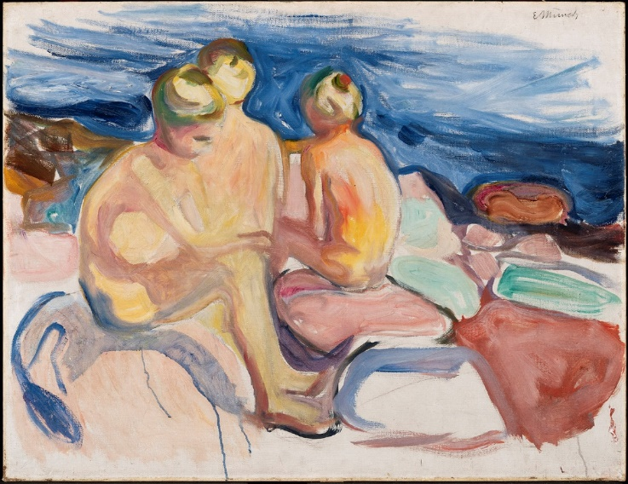
XMB.016  Artist: Edvard Munch (1863 - 1944)  Youth  1908  Frame size: 213.1 x 107.4 x 7.2 cm  Lender’s name and address:  KODE Art Museums and Composer Homes  Vestre Strømkaien 7  N-5008 Bergen  NORWAY  Lender Number: RMS.M.00261  Provenance: Rasmus Meyer 1909; Gerda Nyqvist and Finn Koller Meyer 1916; City of Bergen (donation) 1916  This object has a complete history of ownership for the period 1933-45. | 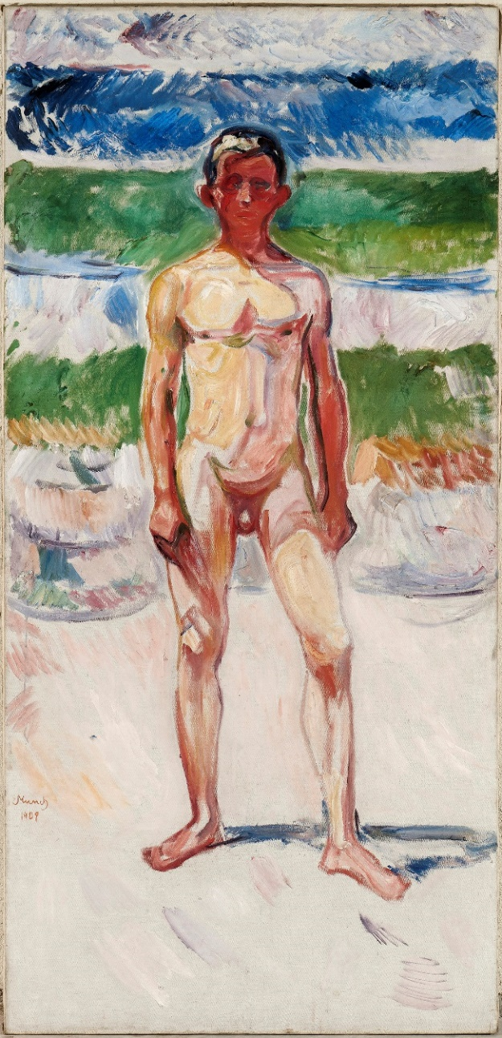
XMB.017  Artist: Edvard Munch (1863 - 1944)  Self-Portrait in the Clinic  1909  Height: 98 cm; Width: 108 cm  Frame size: 212.8 x 108 x 5.2 cm  Lender’s name and address:  KODE Art Museums and Composer Homes  Vestre Strømkaien 7  N-5008 Bergen  NORWAY  Lender Number: RMS.M.00262  Provenance: Rasmus Meyer 1909; Gerda Nyqvist and Finn Koller Meyer 1916; City of Bergen (donation) 1916  This object has a complete history of ownership for the period 1933-45. | 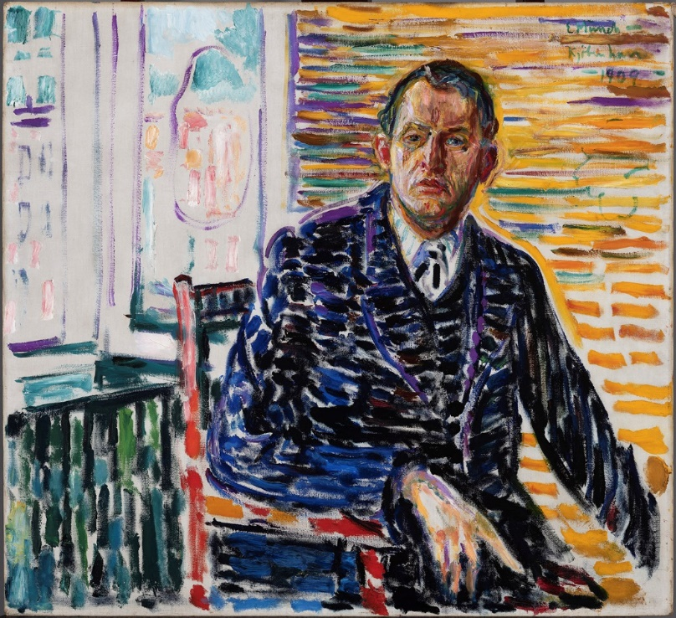
XMB.018

Artist: Edvard Munch (1863 - 1944)

Spring day on Karl Johan
1909
Height: 80 cm; Width: 100 cm

Lender’s name and address:
KODE Art Museums and Composer Homes
Vestre Strømkaien 7
N-5008 Bergen
NORWAY

Lender Number: BB.M.00531

Provenance: Jens Zetlitz M. Kielland; Bergens kunstforening 1925; Bergen Picture Gallery (donation) 1925

This object has a complete history of ownership for the period 1933-45.

