Suggested Preliminary Reading. MA in the History of Art, The Courtauld Institute of Art
Special Option: ‘Victorian Science and Aesthetic Movement Art’, Course tutors: Professor Caroline Arscott and Dr Thomas Hughes. Academic year 2021–2022.
This is a list of items to help you explore as you wish. You are not expected to read all the texts in this list.
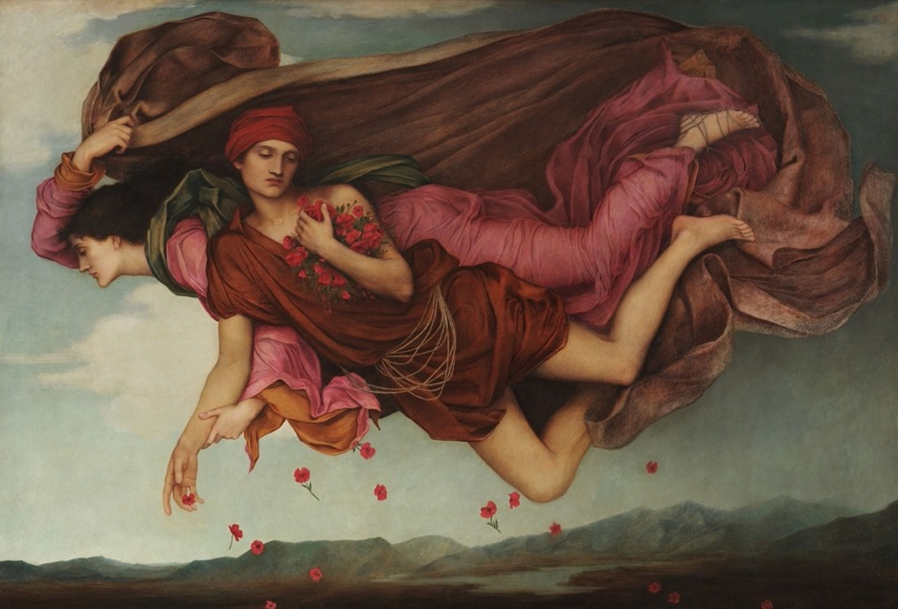
Evelyn de Morgan, Night and Sleep (1878). De Morgan Collection: https://www.demorgan.org.uk/collection/night-and-sleep/.

All these suggested readings are available online. Links are included in each case.

Caroline Arscott, ‘William Morris: The Poetics of Indigo Discharge Printing’, Nonsite, no. 35, May 2021.
https://nonsite.org/william-morris-the-poetics-of-indigo-discharge-printing/

Robyn Asleson, Albert Moore, London: Phaidon, 2004, chapter 3, pp. 76–127.
https://archive.org/details/albertmoore00roby/page/n5/mode/2up

Rosemary Barrow, Lawrence Alma-Tadema, London: Phaidon, 2001, part two ‘Establishment and Success 1870–1887’, pp. 56–129.
https://archive.org/details/lawrencealmatade00barr/mode/2up

Edward Burne-Jones: Victorian Artist-Dreamer, exhibition catalogue edited by Stephen Wildman and John Christian, Metropolitan Museum of Art, New York, 1998, especially catalogue section introductions pp. 141–151; 191–211.
https://www.metmuseum.org/art/metpublications/Edward_Burne_Jones_Victorian_Artist_Dreamer?Tag=Burne-Jones&title=&author=&pt=0&tc=0&dept=0&fmt=0

Julia Margaret Cameron: The Complete Photographs, Los Angeles: Getty Publications, 2003, essays by Colin Ford, ‘Geniuses, Poets and Painters …’ and Julian Cox, ‘To startle the eye…’ pp. 10–78.
https://archive.org/details/juliamargaretcam0000coxj/page/n7/mode/1up

Tamara Ketabgian, ‘The Energy of Belief: The Unseen Universe, and the Spirit of Thermodynamics’, in Lara Karpenko and Shalyn Claggett (eds), Strange Science: Investigating the Limits of Knowledge in the Victorian Age, foreword by Gillian Beer, pp. 254–278. Ann Arbor: University of Michigan Press, 2017.
https://preview.tinyurl.com/ydas7x6x

Walter Pater, Studies in the History of the Renaissance, London: MacMillan & Co., 1873.
https://victorianweb.org/authors/pater/renaissance/preface.html

Wendy Parkins and Peter Adkins, ‘Introduction: Victorian Ecology and the Anthropocene’, 19: Interdisciplinary Studies in the Long Nineteenth Century, 26 (2018).
https://doi.org/10.16995/ntn.818

Roger Smith, ‘The Human Significance of Biology: Carpenter, Darwin and the vera causa’, in U. C. Knoepflmacher and G. B. Tennyson, Nature and the Victorian Imagination, Berkeley and London: University of California Press, 1977, pp. 216–230.
https://archive.org/details/naturevictorian00knoe

Wendy Slatkin, The Voices of Women Artists, Englewood Cliffs: Prentice-Hall, 1993, pp. 79–112.
https://archive.org/details/voicesofwomenart0000slat

Rachel Teukolsky, ‘Walter Pater’s Renaissance (1873) and the British Aesthetic Movement’, BRANCH: Britain, Representation and Nineteenth-Century History, (ed.) Dino Franco Felluga. Extension of Romanticism and Victorianism on the Net.
http://www.branchcollective.org/?ps_articles=rachel-teukolsky-walter-paters-renaissance-1873-and-the-british-aesthetic-movement

Ariane de Waal, ‘Looking Both Ways: Middlemarch, True Skin, and the Dermatological Gaze’, Victorian Network, vol. 9, summer 2020, Victorian Visions.
https://doi.org/10.5283/vn.107

Irena Yamboliev, ‘Christopher Dresser, Physiological Ornamentist’, BRANCH: Britain, Representation and Nineteenth-Century History, (ed.) Dino Franco Felluga. Extension of Romanticism and Victorianism on the Net.
http://www.branchcollective.org/?ps_articles=irena-yamboliev-christopher-dresser-physiological-ornamentist
You might also browse BRANCH.

During the summer, for some further enjoyable reading, feel free to dip into the categories below following your own enthusiasms.

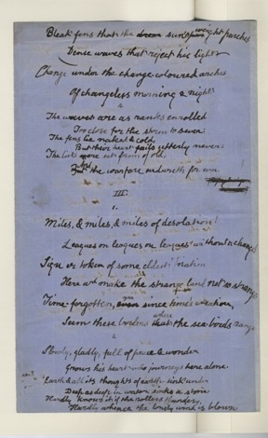
Poetry
Image of Swinburne manuscript page https://www.flickr.com/photos/balliolarchivist/8113540892/in/album-72157631829993536/

- William Morris, The Earthly Paradise, published in parts 1868–1870, ‘August: Pygmalion and the Image’ (1868). http://morrisarchive.lib.uiowa.edu/items/viewer/1866#page/n9/mode/1up
- Dante Gabriel Rossetti, ‘For “The Wine of Circe” by Edward Burne-Jones’, Sonnets for Pictures in D. G. Rossetti, Poems, London: F. S. Ellis, 1870, p. 264. https://archive.org/details/poems09rossgoog
Do read it alongside Burne-Jones’s picture (bw in the Wildman catalogue but here: https://www.eb-j.org/browse-artwork-detail/MTI2MA==).
- Algernon Charles Swinburne, ‘By the North Sea’, in Swinburne, Studies In Song, 1880.
https://victorianweb.org/authors/swinburne/northsea.html

Novels
- Wilkie Collins, The Moonstone, originally published in parts in All the Year Round, 1868.
- Anthony Trollope, The Eustace Diamonds, 1871.
- George Eliot, Middlemarch, originally published in parts 1871–2.
- Thomas Hardy, The Return of the Native, originally published in parts in Belgravia, 1878.
Modern biographies
- Penelope Fitzgerald, Edward Burne-Jones, London: Michael Joseph, 1975; London: Hamish Hamilton, 1989.
- Judith Flanders, A Circle of Sisters: Alice Kipling, Georgiana Burne-Jones, Agnes Poynter and Loiusa Baldwin, London: Penguin, 2002.
- Fiona McCarthy, William Morris, London: Faber and Faber, 1994.

