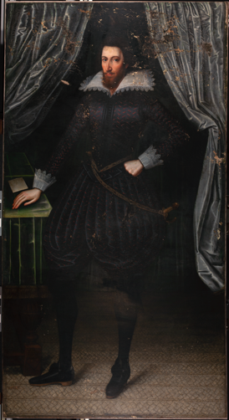
Sir Ralph Bosville of Bradbourne, unattributed, c. 1600s, 215 x 114 cm, oil on canvas, National Trust

Painting Pairs: Art History and Technical Study Report
Melissa Barton (PgDip Conservation of Easel Paintings)
Charlie Spragg (MA History of Art)
The Courtauld Institute of Art
June 2021

Abstract:
The subject of this collaborative technical and art historical investigation is an unattributed full-length portrait of Sir Ralph Bosville of Bradbourne, from the collection of the National Trust site Knole House in Kent. Based on the dates associated with the sitter’s life and the artist’s style, the painting can be dated to the early decades of the seventeenth century. The primary aims of this study have been to get closer to attributing an artist, through a combination of comparative art historical and technical examination; to explore what technical analysis and close examination of this portrait can uncover about urban workshop practices; to see what new information the portrait can reveal about this largely unknown sitter; and to determine how and when Sir Ralph could have reached Knole. Various methods of analysis were undertaken on this painting. The technical examination included x-radiography, infrared reflectography, microscopy and elemental analysis. The predominant art historical approaches were close iconographic and contextual analysis. Conclusions and interpretations were supported by secondary historical research.

Recent scholarship suggests that during the seventeenth-century Kent gentry, as some of the wealthiest and most fashionable patrons in England, typically travelled to London to have their portraits painted, in order to have work of the best quality and in vogue. The findings of this investigation support this narrative. The closest stylistic link between Sir Ralph and any known artist of the period is William Larkin, a portraitist who ran a London-based studio. A combination of historical research, iconographic analysis, x-ray and elemental analysis strongly suggested that the portrait was not produced by Larkin or his studio, but that it was very likely still created in a London workshop. Analysis of Sir Ralph’s clothing and use of ‘props’ revealed a man engaged with contemporary culture, namely being a follower of the ‘melancholic’ movement and a lover of music, reinforcing the image of a fashionable Kent patron. Together, these areas of investigation have illuminated something of the practices of urban artists and their workshops, and contributed to a greater understanding of the artistic patronage of the landed gentry in the early seventeenth century.
Finally, a lead was found in Knole’s inventories that suggests the portrait could have been sold by Sir Ralph’s widowed, heirless daughter to the proprietor of Knole during or prior to 1682, possibly for financial reasons. Sir Ralph would have thus entered Knole as part of an abrupt rise in country-house collecting seen in this period. The record of this exchange has provided an insight into the lives of such portraits of members of the gentry whose estates have long-since been dissolved. Overall, the rich findings of this investigation have demonstrated the rewards of exploring paintings of lesser-known individuals, and the value of art historical and technical collaboration in conducting such research.

