Painting Pairs 2020-21: Ambrose McEvoy, Noli me Tangere, Abstract

Collaborative research focusing on Ambrose McEvoy’s Noli me Tangere (c.1899-1901) was carried out using technical and historical methods to address key questions as part of the 2021 Painting Pairs project supported by The Courtauld Research Forum. This work, from a private collection, is a copy of a painting of the same title by Titian in the National Gallery, London. The painting came to the Courtauld for conservation treatment and research.

The study first considers why McEvoy was interested in Titian’s work in general and in his Noli me Tangere in particular. It explores the factors which caused McEvoy to become interested in historic techniques. A detailed comparison of the two artists’ respective working practices was undertaken to evaluate the extent to which McEvoy was successful in emulating Titian’s technique. The approach included a comparison of the materials used by the two artists, together with analysis of compositional planning and painting techniques. First-hand object based technical study of McEvoy’s painting was undertaken and compared with published technical studies of comparable works by Titian. Particular consideration is given to the likely condition of the pictures at the time that McEvoy decided to copy them, noting that they would not have looked as they do today. The context for McEvoy’s interest in Titian was investigated by looking at other ‘Old Masters’ (as he termed them) whose work he copied and about whom he wrote, and by comparing McEvoy’s attitude to those of his contemporaries.

The final part of the study uses McEvoy’s interest in Titian (and other ‘Old Masters’) to test the prevailing view that McEvoy’s career can be divided into two distinct periods: a promising early career contrasted with his later practice as a successful society portraitist, with a ‘turning point’ in c.1915. In particular, the paper considers how McEvoy’s exploration of Titian’s technique might be relevant to the oil painting method he developed for his portrait practice. It also looks at whether there is a broader legacy from Titian and other Venetian artists of the sixteenth century in McEvoy’s concern for colouristic intensity and the effects of light which is discernible in McEvoy’s later portraits.

Our research has sought to build on a general revival of interest in McEvoy in recent years and has benefited from access to McEvoy’s papers, now archived at The Tate, and from invaluable assistance from McEvoy’s family.

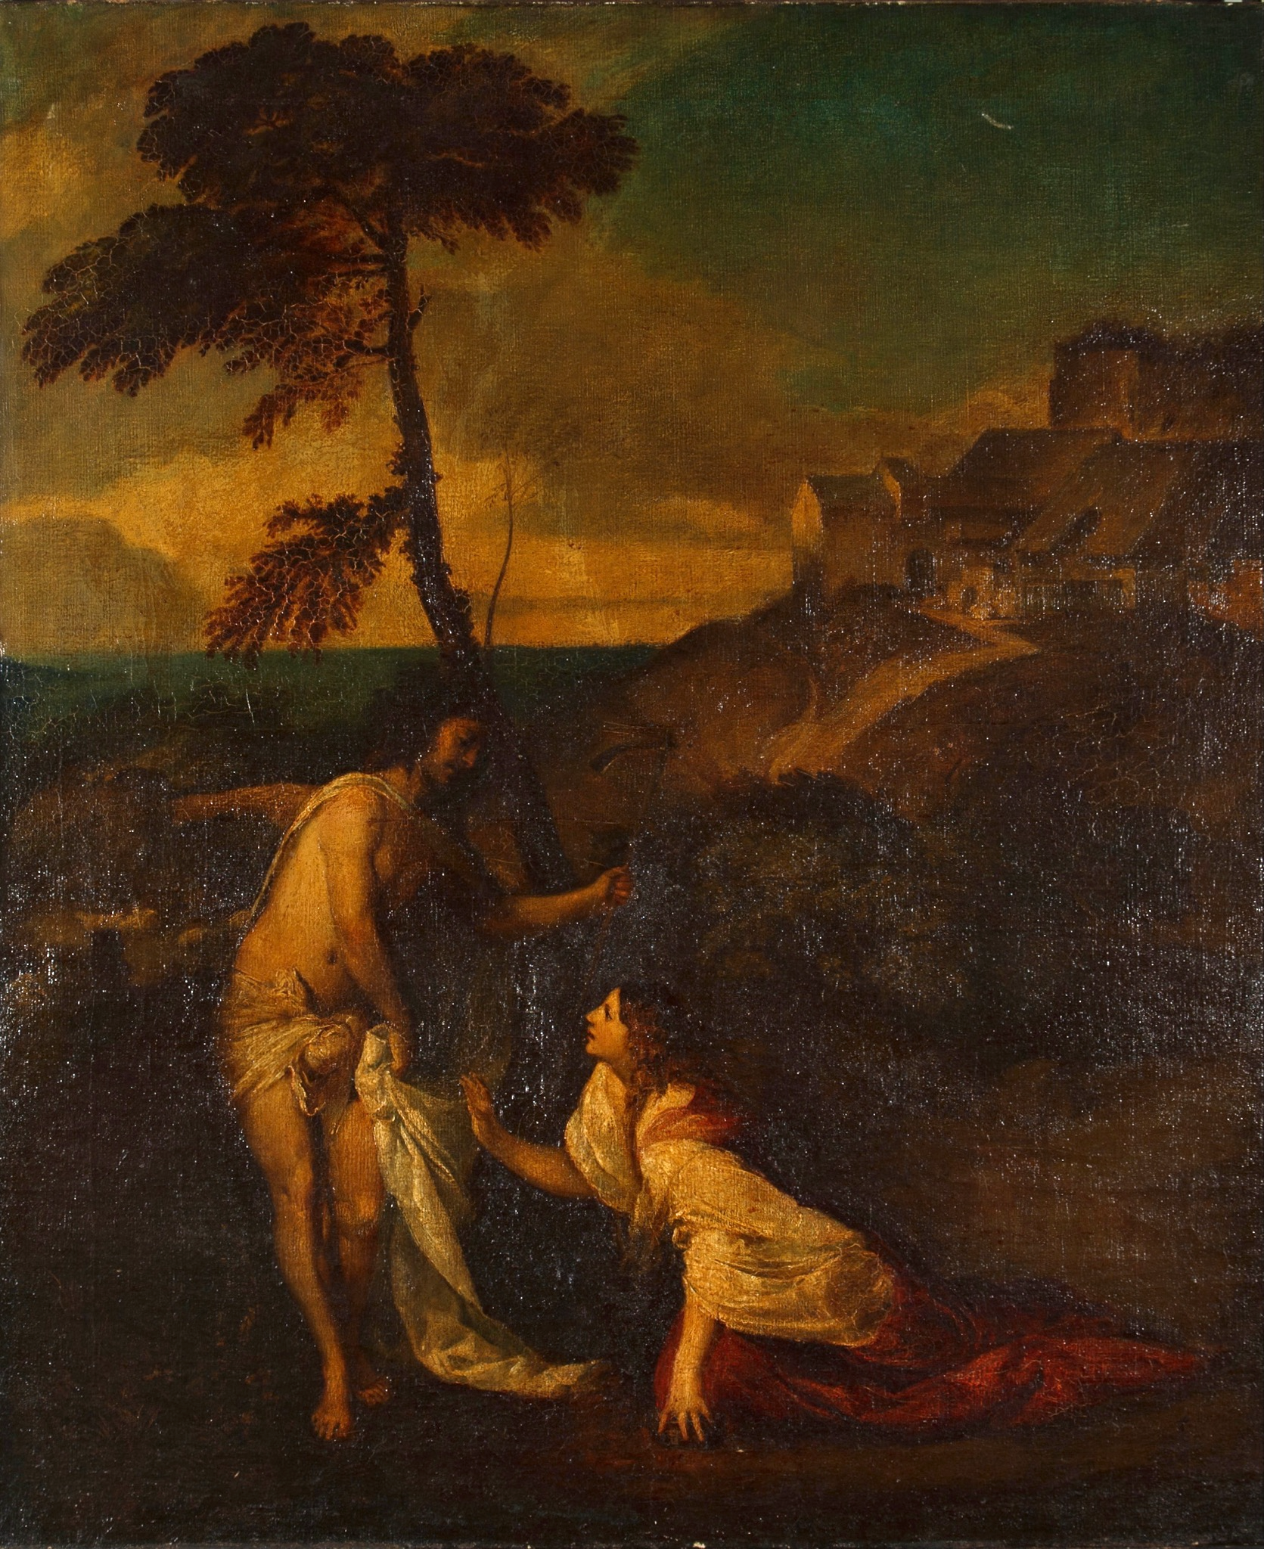
Ambrose McEvoy, Noli me Tangere, oil on canvas, 108 x 90.5 cm, 1899-1901, privately owned

