Abstract: The Rite of Spring; Dionysus of the Dithyramb

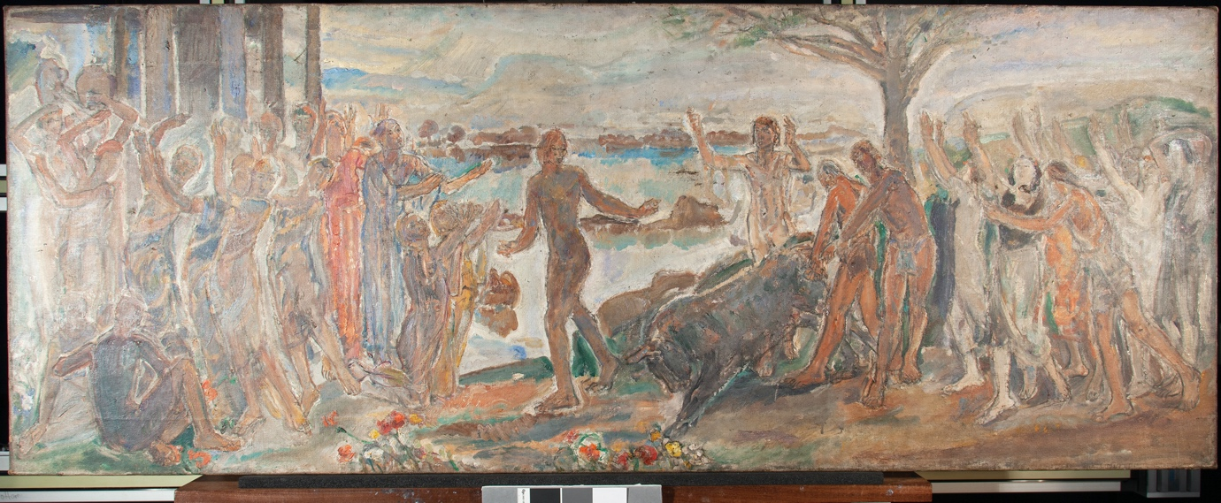
Dame Ethel Walker, The Rite of Spring; Dionysus of the Dithyramb, c.1925, oil on canvas, 62 x 160 x 2.5 cm private collection.
This report is an exploration of Dame Ethel Walker’s Rite of Spring: Dionysus of the Dithyramb using an interdisciplinary array of methods that combine art historical scholarship and technical evidence as a means of interrogating the style, formal qualities and technical attributes of Ethel Walker’s ‘Decoration’.
A technical investigation into Walker’s stylistic development and compositional process, with a particular focus on her use of preparatory sketches, methods of under-drawing and reoccurring compositions across her oeuvre was undertaken. Through this we have found that Ethel Walker reused images of ballet poses across several bas-reliefs and ‘Decorations’, including in the painting of the Rite of Spring. Although Walker’s style developed from descriptive portraiture to evocative and abstract scenes of femineity with a key focus on light and colour, her technique remained consistent throughout her ‘Decorations’, with two painting campaigns being employed in this work similar to her other ‘Decorations’ such as The Excursion of Nausicaa. Her interest in contemporary art movements such as impressionism were reflected in her technique, as her use of expressive brushwork shows, explored in more detail in the technical analysis and treatment of this study.
This approach was complemented by enterprising research into the overarching themes and inspiration behind the Rite of Spring and those that shaped Ethel Walker’s life and career. Several titles were attributed to this painting over the years which we have identified with different recurring themes linked to the iconography and influences present in this work. The title of the Offering which was used when the work was exhibited at the Royal Academy of the Arts in London in 1950 links the painting to the classical Hellenistic legacy which Ethel Walker absorbed whilst studying at the Slade School of Fine Art in London. Alternatively, the title of the Rite of Spring makes her connection to the Ballets Russes and the figure of Vaslav Nijinsky evident. This is reflected in the iconography of the Rite of Spring and Ethel Walker’s other works such as the Plaster Cast of Dancer Figure from c. 1910-1913. The discussion of these works in this report has shown that Ethel Walker was deeply fascinated by the eclectic mix of dance, art and theatre that the innovative Russian dance company of the Ballets Russes represented.
A feminist approach was also employed as a means of exploring Ethel Walker’s identity and sexuality which have been previously overlooked by art historical scholarship. In doing so, this report followed the direction of recent exhibitions such as the Queer British Art (1861-1967) show at the Tate Britain from 2017. The central figure depicted in the Rite of Spring stood out as particularly relevant for this avenue of research, whose androgynous appearance invited an analysis of queer identity and alternative sexuality. Through these methods and areas of research, this report explored the work of this virtually overlooked artist from a novel perspective, placing her work within a broader socio-historical context which demonstrated her relevance to the history of British modern art. Furthermore, the technical analysis provided the reader with a unique insight into her artistic technique and her style.

