Art and Maths in the Courtauld collection Lesson Plans
The following 4 lesson plans support the Art and Maths Learning Resource. The lessons relate to Key Stage 2 Mathematics and Art and Design however, teachers can adapt them for younger or older students.

Lesson 1: Islamic Metalwork and Renaissance Ceramics

Lesson 1 Outline: | Art and Maths: Islamic Metalwork and Renaissance Ceramics
Aims: | - Introduce students to the Courtauld Gallery  - Demonstrate the relevance of Maths to Art and Design  - Give students knowledge of past art and cultures  - Help students to develop their mathematical and artistic vocabularies  - Offer practical activities that explain the rules and processes behind making pattern
Objectives: | - Students look closely at examples of Islamic metalwork and Italian majolica  - Handling objects to help students to contextualise the artworks  - Students identify the main types of pattern used to decorate the artworks  - Show the significance of measuring angles and seeing them as properties of shapes  - Symmetry and rotation are understood as important design principles
Curriculum Links: | Key Stage 2 Mathematics and Art & Design
Materials/Resources: | A4 clipboards and cartridge paper (pre-cut paper circles)  Pencils, rulers  Protractors  Tracing paper  i-pads  Handling objects: Examples of similar metalwork and ceramics, rosewater, thyme, camomile, incense, white clay, pigments, small mirrors, printouts of featured artworks.  Art and Maths in the Courtauld Collection Learning Resource
Duration: | 2 hours

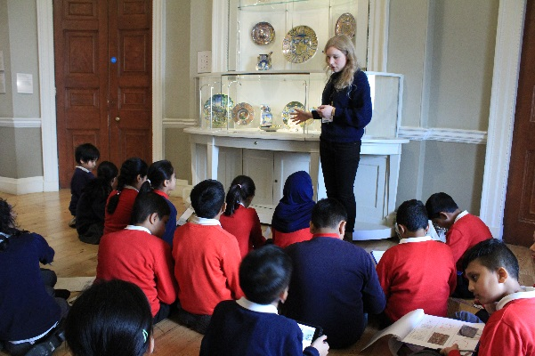
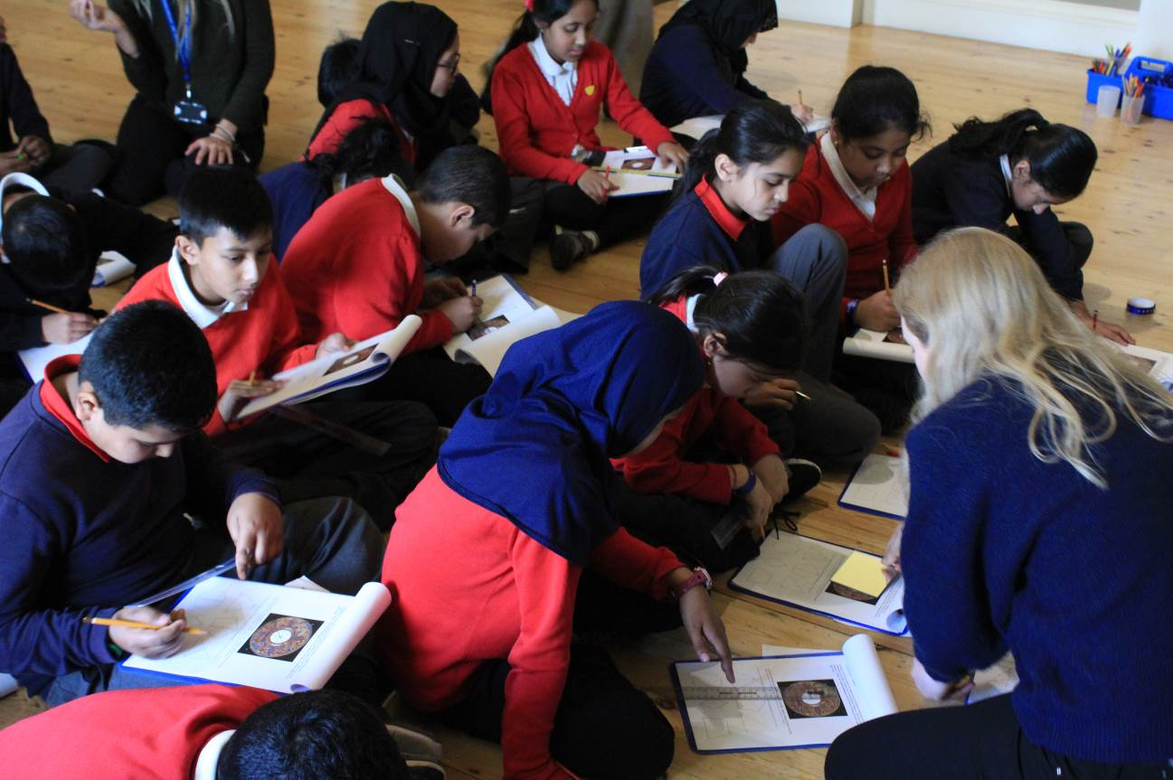

Lesson 1 Plan: | Art and Maths: Islamic Metalwork and Renaissance Ceramics
Introduction/Lead in (10 minutes) | How and when might artists and designers today use Maths? Give some examples.  Do you think it is important that designers are able to make accurate measurements? Why?  What is geometry? Why might artists and designers be interested in this?  Does anyone know what a motif is? What are some simple ways to make patterns?  Can you think of any patterns that you have seen on the way to the Gallery?
Part 1 (20 minutes) | Interactive discussion around selected examples of Islamic metalwork. Explore the contexts in which the artworks were made and what they might have been used for. Bring in handling objects to introduce textures and smells. Use large printouts and details to explain different approaches to surface decoration and pattern.
Part 2 (20 minutes) | Provide students with Activity 1 and 2 (plate design and angles). Use the exercises to explain the three main types of decoration present in Islamic design (calligraphy, scrolling plant forms and geometric shapes). Activity 3 shows how complex motifs and shapes can be generated with just a compass and ruler.
Part 3 (20 minutes) | Interactive discussion around selected pieces of Italian majolica. Talk about how they were made and use pigments to emphasise the importance of getting measurements correct. Provide an overview of the main types of objects on display. Introduce the rose, thyme and camomile scents (used to fragrance water for washing hands).
Part 4 (20 minutes) | Explain the importance of symmetry and rotation. Ask students to pick out examples where these principles have been applied. Point out the main types of decoration (natural forms, classical and fantastical creatures). Students complete Activity 4 and 5 on symmetry and rotation. They can use mirrors and tracing paper if required. Students who complete this quickly can move onto Activity 6 or this could be set as homework.
Part 5 (20 minutes) | Students explore this level of the Gallery in small groups with an adult to find as many examples of pattern as they can. They can sketch these or potentially ask their group leaders to photograph them using the i-pads. Pattern can be found on picture frames, floor grates, fireplaces, stair railings, cornicing etc.
Plenary/Recap (10 minutes) | What types of pattern have we found? What are the most unusual things we have looked at today? What are the most interesting things we have learnt today?

Lesson 2: Pattern in Maths and Nature

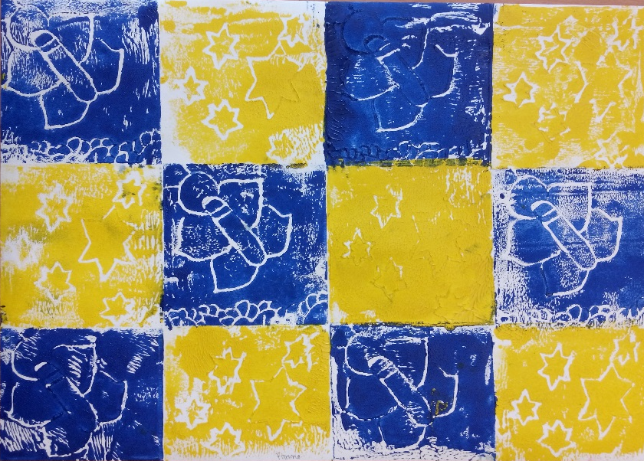
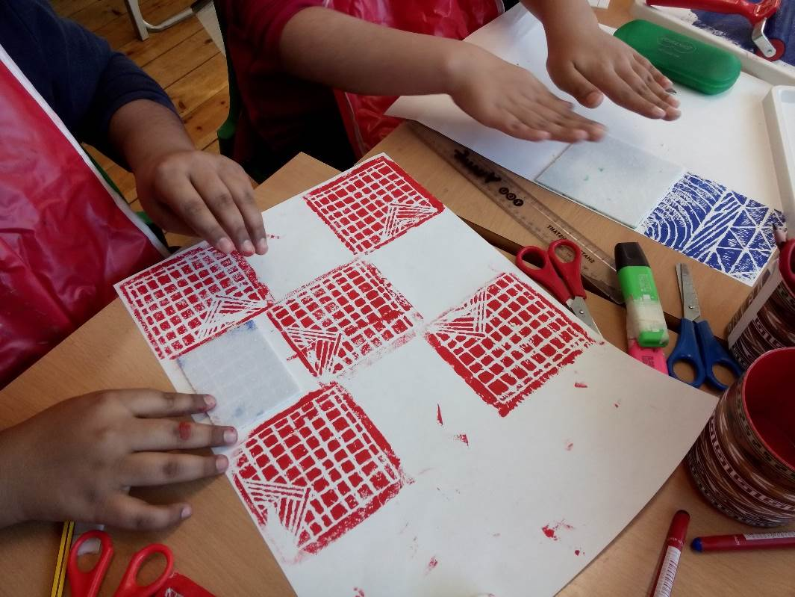
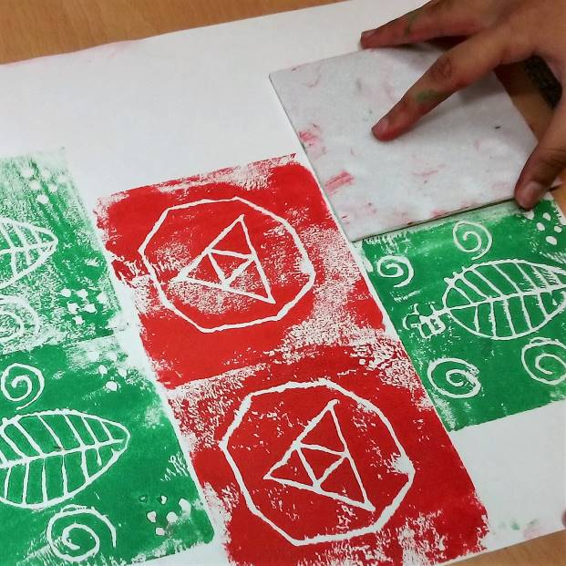
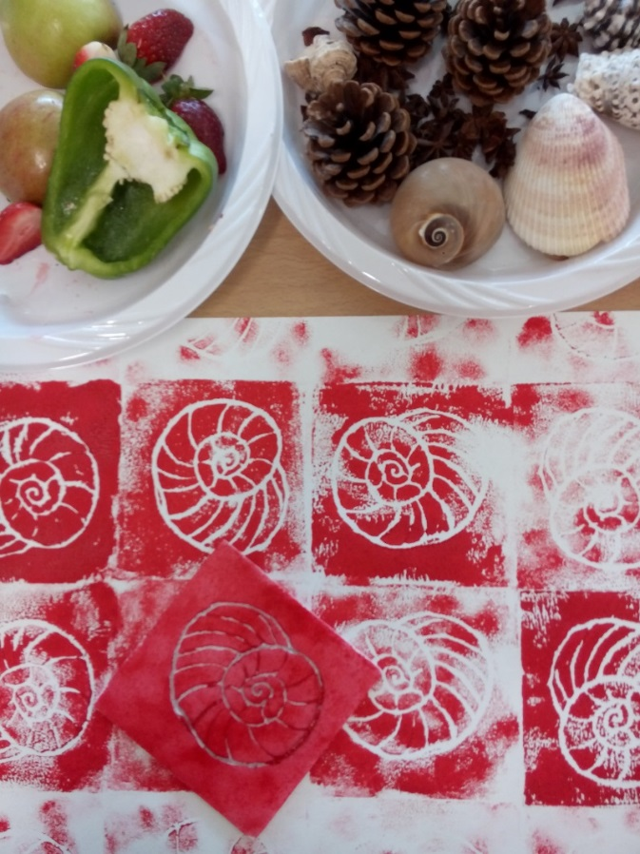
Lesson 2 Outline: | Art and Maths: Pattern in Maths and Nature
Aims: | - Foster curiosity in mathematical relationships that exist in nature  - Investigate the features of regular and irregular polygons  - Work with triangular grids to generate pattern  - Discuss how Islamic and Italian designers made use of construction lines  - Show how colour can also determine the overall effect of a design
Objectives: | - Demonstrate famous mathematical phenomena in nature (Fibonacci sequence)  - Use handling objects to raise questions about why we consider certain features in nature to be beautiful or appealing to the eye  - Move from a discussion of symmetry to look at related properties of shapes  - Students experiment with designs using regular tessellation  - Students produce printed patterns by translating the same motif in different ways
Curriculum Links: | Key Stage 2 Maths and Art & Design
Materials/Resources: | Drawing pencils  Colouring pencils  Rulers  Compasses  Aprons  A3 Cartridge paper  Polystyrene sheets (pre-cut into small squares approx. 10 x 10 cm)  Block printing ink  Rollers (1 between 2)  Ink trays (1 between 2)  Wetwipes  Handling objects: Sliced fruit, vegetables, shells, plants, pinecones
Duration: | 1 hour 30 minutes

Lesson 2 Plan: | Art and Maths: Pattern in Maths and Nature
Introduction/Lead in (20 minutes) | Recap of the objects seen at The Courtauld Gallery. Show students map.  Show and discuss examples of fruit and vegetables that exhibit natural symmetry  Show and discuss natural objects with spiral forms  Show and discuss patterns and sequences that occur in plant stems and flower petals  Use food objects to introduce regular and irregular polygons (e.g. trace around a star anise and join the points to make an octagon, trace around a star fruit and join the points to make a pentagon)
Part 1 (20 minutes) | Consolidate knowledge of circles using Activity 7. Explain the importance of grids to the making of Islamic pattern. Introduce Activity 8 to show students the three regular types of tessellation and allow them to experiment with a triangular grid using the exercises provided.  Use Activity 9 to develop discussion of polygons, and triangles in particular (this could be completed at a later stage or as homework). Just discuss the perimeter and area formulae if the students are not confident in working with mm and decimal places.
Part 2 (10 minutes) | Demonstrate how similar geometric processes can generate different patterns depending on which construction lines the artist chooses to emphasise in the final design. Also show how different colour choices can completely transform a design. Show short video by Eric Broug: https://www.youtube.com/watch?v=vpB4VAqOduo&t=193s
Part 3 (30 minutes) | Students make simple printing blocks from small square polystyrene sheets. They should start with naturalistic designs inspired by the shapes of the fruit and other handling objects brought in. They could also try printing with the fruit itself. Students should aim to make patterns by establishing horizontal and vertical axes and rotating their designs. They could also try half-brick and half-drop repeat patterns.  If possible, divide students into small groups of 4-6 for practical activities to ease supervision and guidance.
Plenary/Recap (10 minutes) | Gather work in one place and admire the different designs. Ask students to identify the translations used in each other’s printed designs. Which ones do they think are particularly successful and why? Are there any other ways that the blocks could be arranged to make patterns?

Lesson 3: Art and Maths: Continuous Patterns

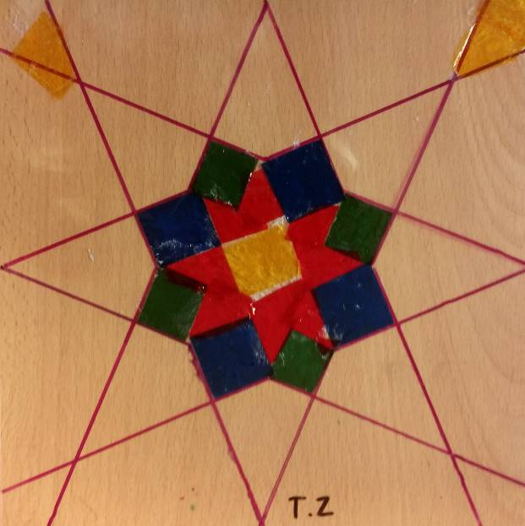
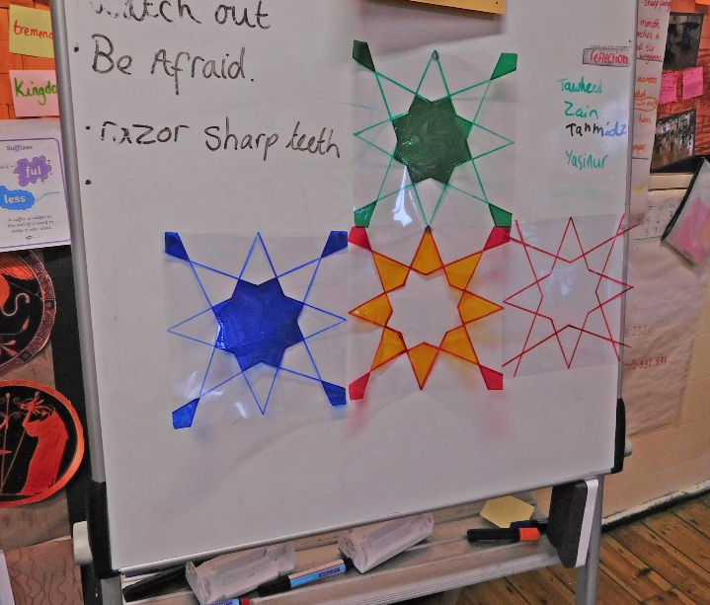
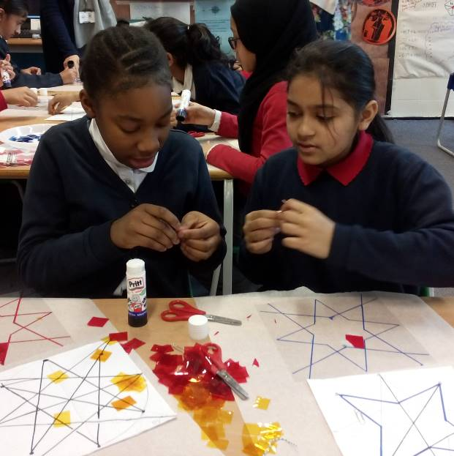
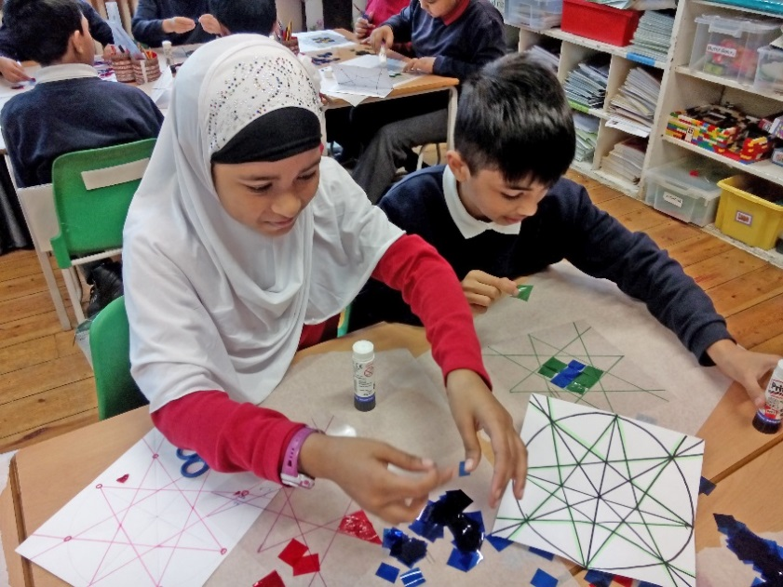
Lesson 3 Outline: | Art and Maths: Continuous Patterns
Aims: | - Introduce discussion about the role of light in Islamic architecture  - Look at the properties of squares and quadrilaterals in more detail  - Reinforce the importance of accurate measurement  - Use existing designs and practical activities to discuss the concept of infinity
Objectives: | - Students continue to experiment with regular tessellation - square grids  - Students follow multi-step instructions to generate a geometric design  - Highlight practical applications of measuring the area of quadrilaterals  - Show students how to scale-up their designs produced on a grid  - Students piece individual artworks together and find satisfaction in producing a potentially infinite surface pattern
Curriculum Links: | Key Stage 2 Maths and Art & Design
Materials/Resources: | Drawing pencils, colouring pencils  Rulers, compasses, scissors, glue sticks  Graph paper, A4 Cartridge paper  Acetate sheets – clear and coloured  Permanent pens/ Sharpies in different colours
Duration: | 1 hour 30 minutes

Lesson 3 Plan: | Art and Maths: Continuous Patterns
Introduction/Lead in (20 minutes) | Group discussion/questions:  Show student’s images of Islamic architecture with latticework screens and stained glass  How might light create/ change patterns?  What does it mean if something is infinite?
Part 1 (20 minutes) | As a group, make the 6-pointed star and the 78pointed star on Activity 10. Allow students to practise using a compass if they need to on the pages provided. Students can make simple patterns using just a square grid and circles on Activity 11. Activity 12 uses a majolica example to show a practical application for regular tessellation and measuring the area of squares (these sheets could be completed at a later stage or as homework).
Part 2 (20 minutes) | Students follow instructions on Activity 13 to make a geometric design on paper – they can use a normal pencil for this. (A template can be photocopied from page 19 of their booklet if this is too difficult). The constructions lines that they need to use for the final design should then be marked out in a different colour (teacher to check this). Students lay acetate on top to trace the final design using coloured marker pens.
Part 3 (30 minutes) | Students customise their acetate designs by sticking small squares of coloured acetate on top to create a stained glass effect (apply glue to the clear acetate). To develop this activity further, students can look back on the designs generated with the triangular and square grids and chose one design each to scale up with the aid of graph paper.
Plenary/Recap (10 minutes) | Gather work in one place (ideally stuck onto a window) and show how the designs link up to make a continuous/ potentially infinite pattern.

Lesson 4: From 2D to 3D
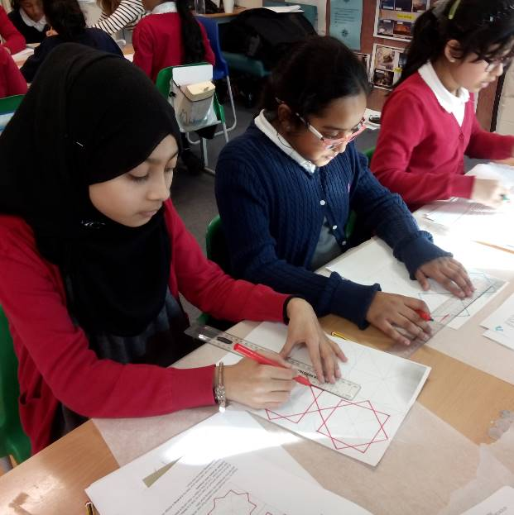
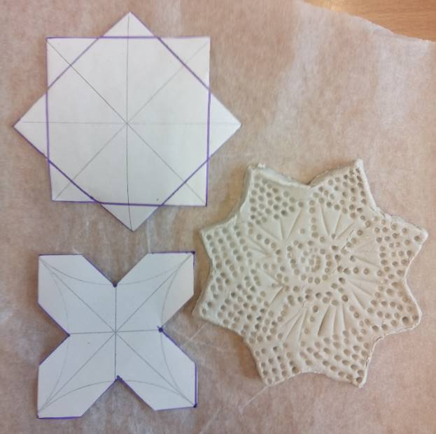
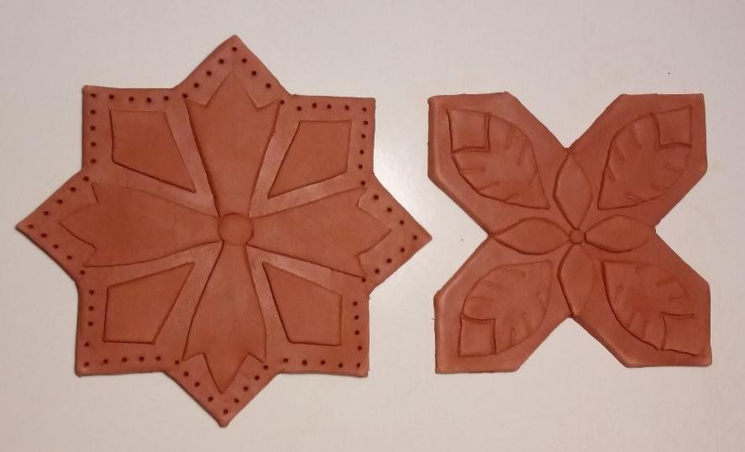
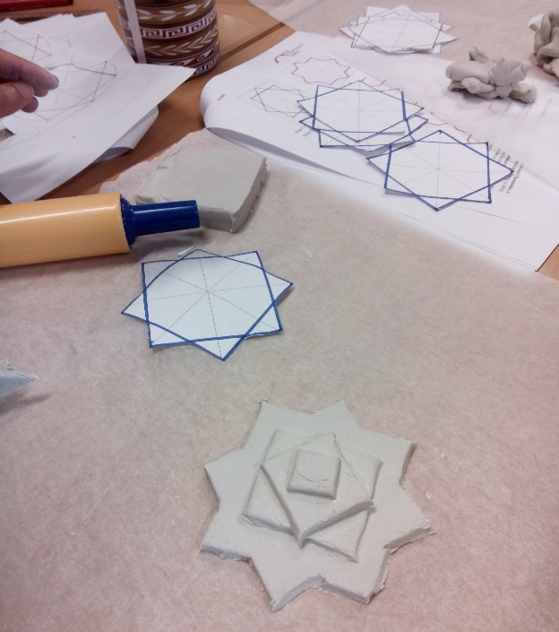
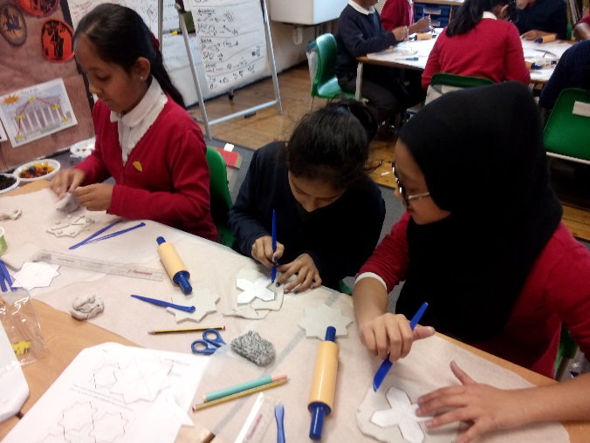
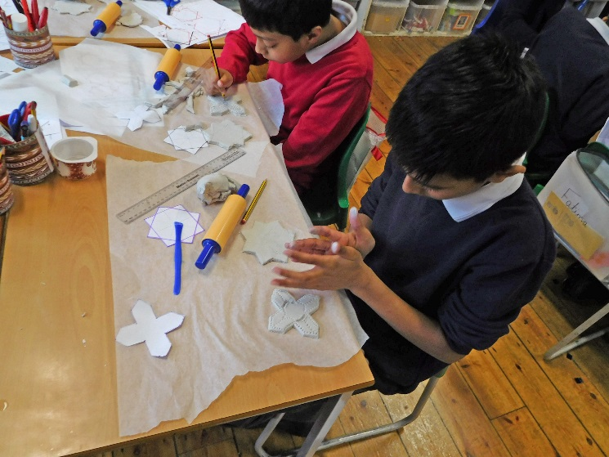

Lesson 4 Outline: | Art and Maths: From 2D to 3D
Aims: | - Move from 2D to 3D design approaches  - Introduce semi-regular tessellation  - Build on geometric principles investigated in previous sessions  - Students have the opportunity to curate and reflect back on their work  - Students compare and discuss different approaches to generating pattern
Objectives: | - Use handling objects to show practical applications of geometry and tessellation  - Students identify and name 3D shapes  - Students feel confident in following instructions to generate geometric designs  - Activities combine careful measurement with more freely creative aspects  - Students produce one collective artwork and review the processes involved
Curriculum Links: | Key Stage 2 Maths and Art & Design
Materials/Resources: | Drawing pencils, coloured pens  Rulers, compasses  A4 Cartridge paper  Baking paper (to stop the clay sticking to the tables)  Das air-drying clay, clay modelling tools (or plastic knives)  Small rolling pins  Handling objects: Different shaped tiles to show tessellation
Duration: | 1 hour 30 minutes

Lesson 4 Plan: | Art and Maths: From 2D to 3D
Introduction/Lead in (20 minutes) | Group discussion/questions:  Show images of Islamic design with tessellation (there are good examples on the British Museum, Louvre, Met and V&A websites)  Pass around samples of tiles that can be pieced together without gaps  Can you think of any examples of tessellation at home/ at school?  How might making a pattern out of 3D shapes be different from making one out of drawn shapes?
Part 1 (20 minutes) | Students construct a geometric design by following the instructions on Activity 14. The resulting diagram can be used to provide the templates for two tiles (a cross and an 8-pointed star). Depending on the group’s level of ability, it may be more time efficient for the teacher to demonstrate making the template and then photocopy it for each student (a template can also be photocopied directly from page 20 of the student booklet).  As a group, name the shapes on Activity 15 to get the students thinking about the properties of 3D objects. This could be completed along with Activity 16 as homework.
Part 2 (45 minutes) | Students roll out clay to a thickness of 1cm (provide rulers) and cut the shapes precisely according to the plan. They can make as many tiles as time will allow and use motifs from previous drawings and activities to decorate them.
Plenary/Recap (15 minutes) | Students carefully place their tiles together to make one collaborative piece and to see how large a surface area they can cover. Discuss the effect this creates.

